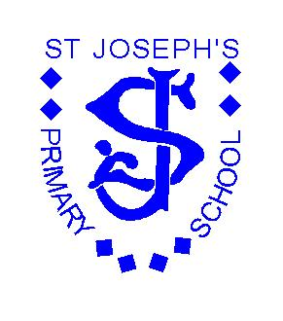
St. Joseph’s R.C. Primary School
UNIFORM POLICY
Introduction
It is our policy that all children should wear school uniform when attending school, or participating in a school-organised event outside normal school hours.

Aims and objectives
Our policy is based on the notion that a school uniform:

- Promotes a sense of pride in the school;
- Encourages a feeling of community and belonging;
- Is practical and smart;
- Identifies the children with the school;
- Is not distracting in class (as fashion clothes might be, e.g. hoodies, leggings, brightly coloured socks/tights, boots);
- Makes children feel equal to their peers in terms of appearance;
- Is regarded as suitable, and good value for money, by most parents;
- Has been designed with health and safety in mind.
- Takes into account the diverse population we serve.

Jewellery
On health and safety grounds we do not allow children to wear jewellery in our school. The exceptions to this rule are ear-ring studs in pierced ears. We ask the children to remove these objects during PE and games.

Footwear
The school wants all children to grow into healthy adults. We believe that it is dangerous for children to wear shoes with platform soles or high heels in school, we do not allow this. Children should wear Black shoes only trainers are not permitted other than for games

School Uniform
Our school uniform consists of:
- Branded navy jumper/cardigan
- Grey dress/skirt/trousers(no jeans or jogging bottoms)
- School tie
- Pale blue shirt
- Black shoes only
- Grey/Black socks/tights
- Headscarf (if required) must be plain navy blue

All hair bobbles/bows to be in uniform colours.
All clothing should be labelled – this helps in sorting out clothing and identifying lost property.

The jumper/cardigan must be branded with the school logo. Rest of the school uniform can be plain.

P.E. Uniform
- Plain navy shorts/jogging bottoms
- White T-shirt
- Pumps or trainers for games

The role of parents
We ask all parents who send their children to our school for their support of the school uniform policy. We believe that parents have a duty to send their children to school correctly dressed and ready for their daily schoolwork. Parents should ensure that their child has the correct uniform, and it is clean and in good repair.

The uniform can be worn all year round; there is no specific item to be worn at certain times of the year.

We have 2 specific retailers for the branded items:

Triple S, 102 Heaton Moor Road, Heaton Moor, Stockport, SK4 4NZ

MCS Stores, 220-222 Fog Lane, Didsbury, Manchester, M20 6EL

Second hand uniform can be purchased at lower cost from school.

Review
October 2022
Next Review Date October 2023
This policy will be enforced in a positive manner and will be reviewed annually.

