

Religious Education

Progression Map and End Points

|  |  |  |
| --- | --- | --- |
|  |  |  |

[Type the company name]

**St Joseph’s RC Primary School**

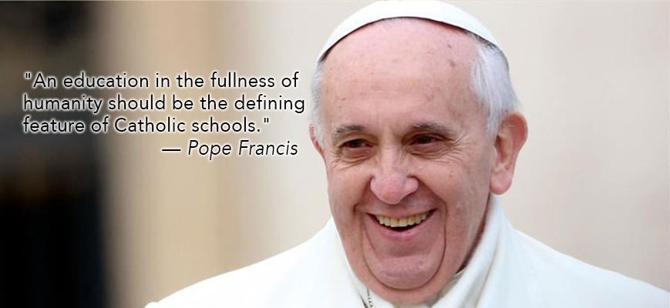

|  |  |  |  |  |
| --- | --- | --- | --- | --- |
| **St Joseph’s RC Primary School**  **RE Curriculum Progression** | | | | |
|  | **End of EYFS** | **End of KS1** | **End of Lower KS2** | **End of Upper KS2** |
| **Know about and understand**  *A1. Describe, explain and analyse beliefs, and practices, recognising the diversity which exists within and between communities;* | * Explore some different beliefs and practices, including festivals e.g. Christmas, Diwali to begin to find out about the meanings behind them | * Recall and name some different beliefs and practices, including festivals, worship, ritual and ways of life, in order to find about the meanings behind them; | * Describe and make growing connections between different features of the religions and world views they study, discovering aspects about celebrations, worship, pilgrimages and the rituals which mark important points in life in order to begin to reflect   on their ideas; | * Describe and make connections between different features of the religions and world views they study, discovering more about celebrations, worship, pilgrimages and the rituals which mark important points in life in order to reflect thoughtfully on their ideas; |
| *A2. Identify, investigate and respond to questions posed by, and responses offered by some of the sources of wisdom found in religions and world views;* | * Talk about some religious and moral stories and identify their own feelings in the stories they hear. Explore some sacred writings and sources of wisdom and the different communities they come from | * Retell and suggest meanings to some religious and moral stories, exploring and discussing sacred writings and sources of wisdom and recognising the communities from which they come | * Describe and understand growing links between stories and other aspects of the communities they are investigating, responding to a range of sources of wisdom and to beliefs and teachings that arise from them in different communities | * Describe and understand links between stories and other aspects of the communities they are investigating, responding thoughtfully to a range of sources of wisdom and to beliefs and teachings that arise from them in different communities |
| *A3. Appreciate and appraise the nature,*  *significance and impact of different ways of life and ways of expressing meaning;* | * Be introduced to some different symbols and actions which show a way of life for a specific community | * Recognise some different symbols and actions which express a community’s way of life, appreciating some similarities between communities | * Explore and describe a range of beliefs and symbols and actions so that they can begin to understand different ways of life and begin to determine ways of expressing meaning; | * Explore and describe a range of beliefs and symbols and actions so that they can understand different ways of life and ways of expressing meaning; |
| *Express and Communicate*  *B1. Explain reasonably their ideas about how*  *beliefs, practices and forms of expression influence individuals and communities;* | * Begin to ask their own questions about belonging to different communities and what that might mean to the individual | * Ask and respond to questions about what communities do, and why, so that they can identify what difference belonging to a community might make | * Observe and understand some examples of religions and world views so that they can begin to explain, with some reasons, their meanings and significance to individuals and communities; | * Observe and understand varied examples of religions and world views so that they can explain, with reasons, their meanings and significance to individuals and communities; |
| *B2. Express with increasing discernment their personal reflections and critical responses to questions and teachings about identity, diversity, meaning and value;* | * Engage in discussions on belonging and how they express their identity in an age appropriate way | * Observe and recount different ways of expressing identity and belonging, responding sensitively for themselves; | * Understand some of the challenges of commitment to a community of faith or belief, suggesting some reasons why belonging to a community may be valuable, both in the diverse communities being studied and in their own lives; | * Understand the challenges of commitment to a community of faith or belief, suggesting why belonging to a community may be valuable, both in the diverse communities being studied and in their own lives; |
| *B3. Appreciate and appraise varied dimensions of religion;* | * Develop understanding that there are similarities and differences between different religions and views | * Notice and begin to respond sensitively to some similarities between different religions and world views; | * Observe and consider some different dimensions of religion, so that they can begin to explore and show some understanding of similarities and differences between different religions and world views; | * Observe and consider different dimensions of religion, so that they can explore and show understanding of similarities and differences between different religions and world views; |
| ***Gain & deploy skills***  *C1. Find out about and investigate key concepts and questions of belonging, meaning, purpose and truth, responding creatively;* | * Discuss questions about belonging and explore their ideas through talk, play and creativity | * Explore questions about belonging, meaning and truth so that they can express their own ideas and opinions in response using words, music, art or poetry; | * Discuss and present their own and others’ views on challenging questions about belonging, meaning, purpose and truth, applying some ideas of their own thoughtfully in different forms including (e.g.) music, art and poetry; | * Discuss and present thoughtfully their own and others’ views on challenging questions about belonging, meaning, purpose and truth, applying ideas of their own thoughtfully in different forms including (e.g.) reasoning, music, art and poetry; |
| *C2. Enquire into what enables different*  *communities to live together respectfully for the wellbeing of all;* | * Explore how and talk about the idea of people who are different co-operating | * Find out about and respond with ideas to examples of co-operation between people who are different; | * Consider and apply some ideas about ways in which diverse communities can live together for the well-being of all, responding to ideas about community, values and respect; | * Consider and apply ideas about ways in which diverse communities can live together for the well-being of all, responding thoughtfully to ideas about community, values and respect; |
| *C3. Articulate beliefs, values and*  *commitments clearly in order to explain*  *reasons why they may be important in their own and other people’s lives* | * Develop their understanding of right and wrong and encourage listening and expressing an opinion | * Find out about questions of right and wrong and begin to express their ideas and opinions in response | * Discuss and apply their own and others’ ideas about simple ethical questions, including ideas about what is right and wrong and what is just and fair, and express their own ideas in response | * Discuss and apply their own and others’ ideas about ethical questions, including ideas about what is right and wrong and what is just and fair, and express their own ideas clearly in response |