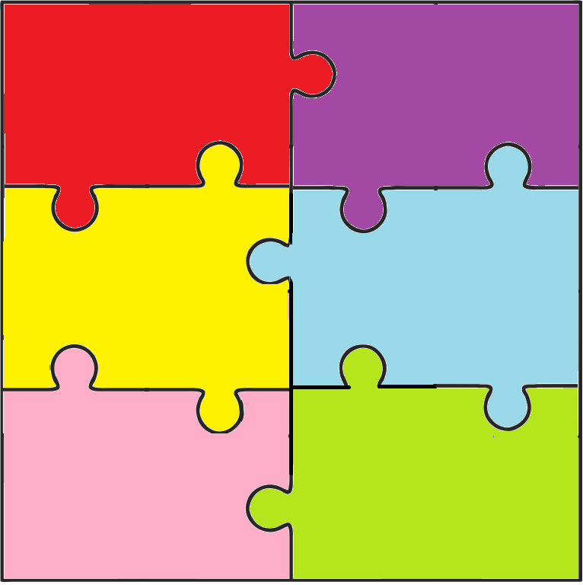

**Theme 6: The Dignity of Work**

**EYFS**

* We are helping to do God’s work

* We use our gifts for each other

* Everybody’s gifts are needed to build up God’s world

* When we build together we can do much more

**KS2**

* Exploring our understanding of work – How does work build us up?

* The many sides of working together to build up community

* Recognising and helping others to find their gift and share it

* Enabling each other to aim high

**KS1**

* Everybody’s work is valuable and important for the community

* Working together to build up community

* Finding my special job – my gift to the world

* Working hard to be the best you can be for others

**KS1**

* Some of God’s family have plenty of food, toys and clothes. Some do not

* Exploring the feelings of those who have plenty and those who have little

* Working together to make our family happy

* Exploring fairness and justice

* Who needs our help? How can we help?

**KS2**

* Why are some parts of our area richer or poorer than others?

* What are the needs of those in a poor area compared with those in a rich area?

* Helping each other to see brothers and sisters, not strangers,, in need.

* Raising awareness locally and nationally

*Being Christ’s voice in our area for those who need us most

**EYFS**

* God’s gifts are for

everyone

* Learning to share our toys and food with our friends so that everybody has enough

* Helping everybody to be happy, playing, sharing and learning together

* Using our gifts

to help others

**Theme 5: Option for the Poor and Vulnerable**

**KS1**

* Happiness is exploring what makes us happy

* Finding happiness with each other

* Helping each other to make the right choices

* Fair shares for all

**KS2**

* Barriers to happiness

* Exploring our responsibilities for each other

* Recognising the difference between rights/responsibilities

* Happiness comes in sharing and giving

**EYFS**

* God wants everyone to

be happy

* God gives

us all we need to be happy

* Making the right choices

* We share all God’s gifts

**Theme 4: Rights and Responsibilities**

**KS2**

* I listen to you with my ears, eyes and mind

* We walk together as people of peace

* We face

challenges together

* Building up our mission team

**KS1**

* We are brothers and sisters – one family – one world

* We learn together

* We build together a community of peace

* We celebrate together

**EYFS**

* We are friends

* We play together in love and peace

* We help each other

* We thank God for each other

**Theme 3: Solidarity and the Common Good**

**KS2**

* What makes community?

* Who is in my community?

* Building up the community

* Building up the kingdom of God

**KS1**

* We are all part of a community

* We look after and care for each other

* I belong to my family and my community

* My community needs me

**EYFS**

* My family is at home

* My school family

* We are all different and we love and care for each other

* We love and look after each other because we are all brothers’ and sisters’ in God’s family

**Theme 2: Family and Community**

**KS2**

* We are all equal in God’s eyes and loved

* I have been given a special gift for the world

* Each person is unique and irreplaceable – everyone matters

* People matter more than possessions

**KS1**

* God loves us equally as His children

* We are all different and amazing

* We love and look after each other because we are brothers and sisters

* Loving each other makes us strong

**EYFS**

* God made me and loves me very much

* God made me and all my friends very beautiful

* We show our love for each other

* We thank God for loving us and our love for each other

**Theme 1: The Dignity of the Human Person**

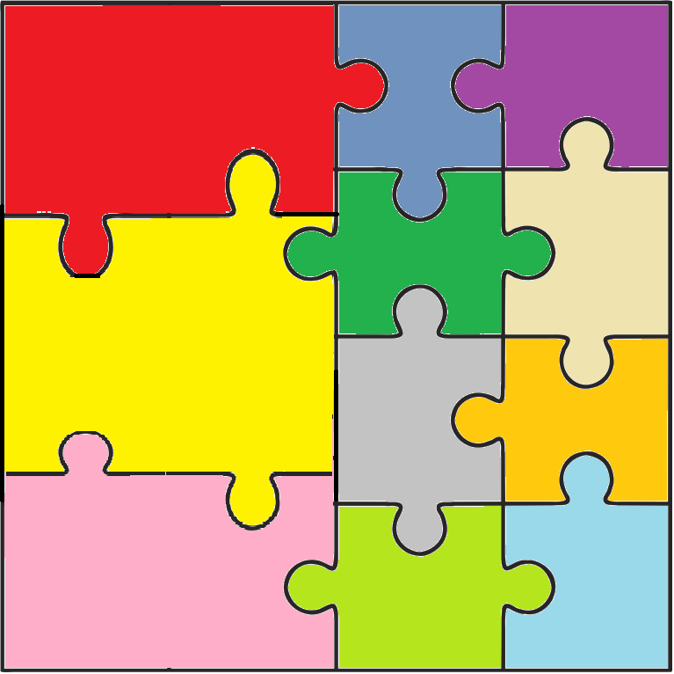

**and Learn To Love**

**Witness**

**Welcome**

**Worship**

**Word**

**Welfare**

**Welcome**

**We Love To Learn**

**As A Family Of God**

**Theme 7: Stewardship**

**KS1**

* Learning from God’s creation (interdependence)

* Making good choices – being responsible

* God’s gardeners

* Celebrating the harvest

**KS2**

* All things are connected

* Enough for everybody’s need, but not evrybody’s greed

* Stewards of God’s world (understanding the concept)

* Seeing God in creation

**EYFS**

* Discovering God’s beautiful creation

* Playing in and caring for creation

* Helping God’s creation grow

* Celebrating God’s crteation