Computing
Progression Map and End Points

[Type the company name]

St Joseph’s RC Primary School

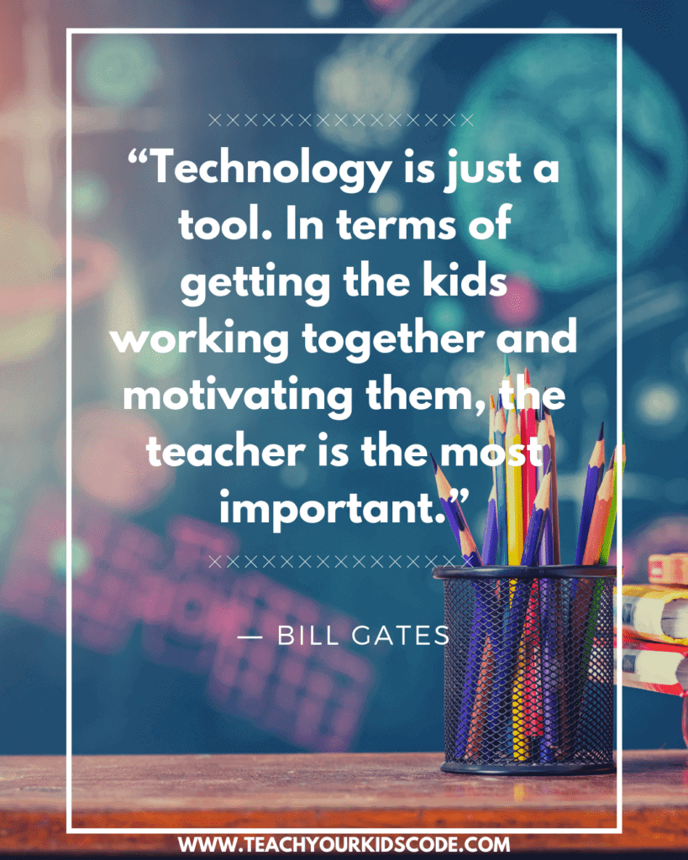

St Joseph’s RC Primary School
Computing Curriculum Progression
 | End of EYFS | End of KS1 | End of Lower KS2 | End of Upper KS2
To Code | - To name items we control in the everyday life.  - To use everyday technology  - To explore on screen activities – by clicking (cause and effect)  - To begin to understand that an algorithm is a set of instruction that can solve a problem  - To create a simple algorithm for a Bee Bot or remote-control toy specifying the direction and number of steps | - Control motion by specifying the number of steps to travel, direction and turn.  - Add text strings, show and hide objects and change the features of an object.  - Select sounds and control when they are heard, their duration and volume.  - Control when drawings appear and set the pen colour, size and shape.  - Specify user inputs (such as clicks) to control events.  - Can explain the nature of events (such as a single event or a loop).  - Understands the concept of an algorithm and can create a short algorithm.  - Understands the term ’Debug’  - Shows independence when debugging problems within a program.  - Understands the term ‘block code.’  - Can name some coding applications. | - Can use specified screen coordinates to control movement.  - Set the appearance of objects and create sequences of changes.  - Create and edit sounds. Control when they are heard, their volume, duration and rests.  - Can use loop commands confidently e.g. Repeat, Forever.  - Use IF THEN conditions to control events or objects.  - Create conditions for actions by sensing proximity or by waiting for a user input (such as proximity to a specified colour or a line or responses to questions).  - Use variables to store a value.  - Use the functions define, set, change, show and hide to control the variables.  - Understands and can recognise inputs/outputs.  - Begins to decompose issues within a program | - Set IF conditions for movements. Specify types of rotation giving the number of degrees.  - Change the position of objects between screen layers (send to back, bring to front).  - Upload sounds from a file and edit them. Add effects such as fade in and out and control their implementation.  - Combine the use of pens with movement to create interesting effects.  - Set events to control other events by ‘broadcasting’ information as a trigger.  - Use IF THEN ELSE conditions to control events or objects.  - Can program using external devices e.g Micro: bit  - Decomposes issues within a program independently  - Applies logical reasoning when building a program.  - Can use variables confidently.  - Shows independence when dealing with issues using abstraction, decomposition and logic.
Digital Literacy | - Can identify a device that uses technology.  - Talk about technology  that is used at home, in school and in the world around them.  - Ask permission before using the Internet.  - Tell an adult if something worrying or unexpected happens whilst using technology.  - To describe ways that some people can be unkind online  - To identify rules that help keep us safe and healthy in and beyond the home when using technology  - To give some simple examples of these rules  - Use a safe part of the  Internet to explore, play & learn | - Recognise that a range of digital devices and products can be considered computers and knows that it can be recognised as this by having inputs/outputs and a processor.  - Recognise the ways in which technology is used in their homes and community.  - Understand that  computers have no intelligence and can do nothing without being programmed.  - Begin to identify some of the benefits to using technology.  - Demonstrate the use of technology responsibly in terms of how we use it and the time we spend using it.  - Understands the benefits of technology.  - Understand why we need passwords.  - Understand that we must keep passwords private.  - Explain what personal information is.  - Understand that we must keep personal information private.  - Knows how to report inappropriate content  - Communicate safely and respectfully online.  - Know what to do when concerned about online content.  - Know what to do if someone tries to contact you online.  - Understand online risks and the age rules for sites. | - Save and retrieve work online, on the school network and their own device.  - Tell you ways to communicate with others online.  - Knows how navigate the web responsibly.  - Can carry out effective web  Searches to collect digital content.  - Think about whether they can use images that they find online in their own work.  - Understand the difference between the Internet and online services such as the World Wide Web, instant messaging and email.  - Tell you whether a resource  - They are using is from the WWW, the school network or their own work.  - Identify key words to use when searching safely on the World Wide Web.  - Explain how to check who  owns photos, text and clipart  - Children consider their responsibilities and actions to others online.  - Children consider that all of the media they see could have been altered.  - Understand how to use a search engine responsibly and safely.  - Understand that media can be edited online for advertising and other purposes.  - Recognise what is acceptable and unacceptable behaviour  - When using technology and online services.  - Children understand how  effective a strong password is and what a strong password looks like. | - Use different online tools for different purposes.  - Use a search engine effectively to find appropriate information and check the reliability of a website.  - Understand how search results are selected and ranked and the algorithms they use.  - Recognise and evaluate different types of information they find on the World Wide Web.  - Think about the reliability of information they read on the World Wide Web or other Internet services (Fake News).  - Explain the Internet services they need to use for different purposes.  - Describe the different parts of a webpage.  - Understands how to construct a website using basic HTML tags.  - Explain what copyright is and acknowledge the sources of information that they find online.  - Understands how data is transmitted across a network.  - Understand what IP is and how it’s used.  - Can explain how networks use the Internet to send and receive data.  - Be aware of their digital footprint understand the dangers of building online relationships.  - Explain what the consequences might be to using technology inappropriately or accessing inappropriate content intentionally.  - Be aware of fake news and how to dissect it.  - Understand the difference between misinformation and disinformation.  - Understand what Copywriting is and using someone else’s work responsibly.  - Manage their conduct and contact appropriately and safely when using technology and online services.
ICT | - Talk about different kinds of information such as pictures, videos, text and sound.  - Use a mouse and touch screen to move objects on a screen.  - Create shapes and text on a screen. | - Talk about the different ways in which information can be shown.  - Use technology to collect information, including photos, videos and sound.  - Sort different kinds of information and present it to others.  - Add information to a pictogram and talk about their findings.  - Use software with support, to create, store and edit digital content using appropriate file and folder names.  - Use the keyboard or a word bank on a device to enter text into a program.  - Understand some of the basic functions on a keyboard (Backspace, Caps Lock, Enter)  - Save information in a specific place and retrieve  - Create a graph or chart using data collected on a specific topic area.  - Talk about the data that is shown in their chart or graph.  - Explain how investigating data can be used to answer a question.  - Use a variety of software to manipulate and present digital content in different ways with increasing independence.  - Talk about the different ways to use technology to collect information, including a camera or sound recorder.  - Use the keyboard on their device to add, delete, edit and format text. • Talk about an online tool that will help them to share their ideas with other people. | - Understand the difference between data and information.  - Talk about the different ways data can be converted into information.  - Search a ready-made database to answer specific questions.  - Collect data to help answer questions about a specific topic or theme.  - Add to and edit an existing database.  - Combine a mixture of text, graphics and sound to share ideas and learning.  - Use appropriate keyboard commands to amend text.  - Be able to effectively use a spell checker.  - Evaluate their work and improve its effectiveness.  - Use an appropriate tool to share their work online. Demonstrate the different ways data can be organised.  - Demonstrate the different ways data can be converted into information.  - Make a branching database.  - Collect data and identify where it could be inaccurate.  - Plan, create and search a database.  - Select the best way to present data to a specific audience.  - Log data using a device.  - Use photos, video and sound to create an atmosphere when presenting to different audiences.  - Be confident to explore new media to extend what they can achieve.  - Change the appearance of text to increase its effectiveness depending on the audience or mood.  - Create, modify and present documents for a particular purpose and audience.  - Use a keyboard confidently and make use of a spellchecker to write and review their work.  - Use an appropriate tool to share their work and collaborate online.  - Be able to evaluate other people’s work and give them constructive feedback to help them improve their work. | - Choose an appropriate tool to help them collect data.  - Present data in an appropriate way depending on the theme or audience.  - Use a spreadsheet and database to collect record and evaluate data.  - Search a database using different operators to refine a search.  - Talk about errors in data and suggest how it could be checked.  - Use text, photo, sound and video editing tools to evaluate and refine their work.  - Be able to use a variety of familiar and unfamiliar software by using a pre-existing skill set.  - Select, use and combine the appropriate technology tools to create effects in media.  - Select an appropriate online or offline tool to create and share ideas.  - Evaluate and improve their own work and support others in improving their work.  - Acknowledges sources of information appropriately.  - Select the most effective tool to collect data for their investigation.  - Check the data they collect for accuracy and plausibility,  - Plan the process needed to investigate a set environment or setting.  - Interpret and present the data they collect.  - Use the skills developed to interrogate a database.  - Uses a range of strategies to increase the accuracy of keyword searches. Makes confident inferences about their effectiveness.  - Talk about audience, atmosphere and structure when planning a particular media outcome.  - Combine a range of media, recognising the contribution of each to achieve a particular outcome.  - Confidently identify the potential of unfamiliar technology and how it can be used effectively.  - Explain why they select a particular online tool for a specific purpose.  - Be digitally discerning when evaluating the effectiveness of their own work and the work of others.  - Recognises the importance of copyright and how to acknowledge the

St Joseph’s RC Primary School
Computing: Unit End Points
EYFS
Aspect | Unit | Endpoint
Computer Science | 0.3 I am a Computer Scientist | Can give a floor robot instruction to make it move.  Uses simple software and explain what you are doing.  Understands what happens when you click a button or touch an icon.
ICT | 0.2 Look What I can do! | Talks about different kinds of information such as pictures, videos, text and sound.  Uses a mouse and touch screen to move objects on a screen.  Creates shapes and text on a screen.
 | 0.1 Super Surfer | Can identify a device that uses technology.  Talk about technology that is used at home, in school and in the world around them.  Uses a safe part of the Internet to explore, play and learn.
Digital Literacy | 0.1 Super Surfer | Asks permission before using the Internet.  Tells an adult if something worrying or unexpected happens whilst using technology.
Year 1
Aspect | Unit | Endpoint
Computer Science | 1.3 Unplugged Algorithms | Can give instructions to a friend and follow their instructions to move around a space.  Begin to predict what will happen for a short sequence of instructions  Understand what an algorithm is and be able to create a simple algorithm.  Begin to use software or applications to create movement and patterns on a screen.
 | 1.4 Programming Robots | Give instructions to a friend and follow their instructions to move around a space.  Describe what happens when buttons are pressed on a robot.  Press buttons in the correct order to make a robot follow a sequence.  Begin to predict what will happen for a short sequence of instructions.  Understand what an algorithm is and be able to create a simple algorithm.
ICT | 1.2 Producing Digital Media | Use technology to collect information, including photos, videos and sound.  Use software with support, to create, store and edit digital content.  Use the keyboard or a word bank on a device to enter text into a program.  Save information in a specific place and retrieve it again.
 | 1.5 Pictograms | To use technology to collect information  Sort different kinds of information and present it to others  To add information into a pictogram and talk about their findings.  To talk about the different ways in which data / information can be shown.
 | 1.6 Presenting Information | Use software to create digital content  Use the keyboard to input text  Understand some of the basic functions of a keyboard (backspace, space etc)
Digital Literacy | 1.1 Basic Computer Skills | Understands why we have passwords  Understands that we must keep passwords private  Use the keyboard or a word bank on a device to enter text into a program.  Understand some of the basic functions on a keyboard (Backspace, Caps lock, Enter.
 | 1.6 Presenting Information | Pupils to discuss how they know if a website is right for them or not.
Year 2
Aspect | Unit | Endpoint
Computer Science | 2.2 Unplugged Algorithms | Use logical reasoning to predict and debug more complex programs.  Can create and debug with improved confidence and efficiency.  Begin to program using simple block code.  Programme a robot or software to do a particular task.  Be able to explain the order needed to do things to make something happen and to talk about it as an algorithm.  Understand what an algorithm is and demonstrate simple linear algorithms.
 | 2.3 Scratch Jnr | Be able to explain the order needed to do things to make something happen and to talk about it as an algorithm.  Programme a robot or software to do a particular task.  Look at a basic program and explain what will happen.  Use programming software and applications to make objects move.  Use logical reasoning to predict and debug more complex programs.  Can create and debug with improved confidence and efficiency.  Begin to program using simple block code.  Begin to predict what will happen for a short sequence of instructions.  Understand what an algorithm is and be able to create a simple algorithm.
ICT | 2.1 What is a computer? | Children can explain why they use technology in the classroom, in their homes and in the community.  Identify the benefits of using technology, such as creating content and communicating efficiently.  Can identify a computer by knowing that it has inputs, a processor and outputs.  Can identify parts of a computer including what an input and output is.  (DL) Can use a computer responsibility in terms of both time and purpose.
 | 2.5 Modifying Text & Images | Demonstrate the use of technology responsibly in terms of how we use it and the time we spend using it.  Know how to report inappropriate content or contact online.  Children can explain why they use technology in the classroom, in their homes and in the community.  Use the keyboard on their device to add, delete, edit and format text.  Save and open files on the device they use from a specific file location.
 | 2.4 Storing and Presenting Data | Identify the benefits of using technology, such as creating content and communicating efficiently.  Create a graph or chart using data collected on a specific topic area.  Talk about the data that is shown in their chart or graph.  Use a variety of software to manipulate and present digital content in different ways with increasing independence
 | 2.6 Presenting Information | Know how to report inappropriate content or contact online.  Use a variety of software to manipulate and present digital content in different ways with increasing independence.  Save and open files on the device they use from a specific file  location
Digital Literacy | 2.1 What is a Computer? | Using a computer responsibility in terms of both time and purpose.
 | 2.4 Storing and Presenting Data | Identifying what personal information is and whom it should be shared with.
Year 3
Aspect | Unit | Endpoint
Computer Science | 3.2 Programming a game | Understands how an algorithm is implemented using a sequence of precise instructions.  Can predict the outcome of a sequence of precise instructions.  Can repeatedly test a program and recognise when they need to debug it.  Detects a problem in an algorithm, which could result in a differentoutcome to the one intended.  Understands what inputs and outputs are, how they can be used.  Provides examples of how to use inputs and outputs effectively.  Designs, writes, executes and debugs programs of increasing complexity that accomplish a specific goal.  Uses logical reasoning to predict and debug more complex programs including inputs and outputs.
 | 3.3 Creating Code with Kodu | Understands how an algorithm is implemented using a sequence of precise instructions.  Can predict the outcome of a sequence of precise instructions.  Can repeatedly test a program and recognise when they need to debug it.  Detect a problem in an algorithm, which could result in a different outcome to the one intended.  Designs, writes, executes and debugs programs of increasing complexity that accomplish a specific goal.  Use logical reasoning to predict and debug more complex programs.
 | 3.5 Inside a Computer | Can identify components within a PC/ Laptop and what each component does.  Understands the basic fundamentals of how a computer works.
ICT | 3.1 Composing Emails | Understands the difference between data and information.  Can effectively use a spell checker.  Considers their responsibilities and actions to others online.  Understand how to use a search engine responsibly and safely.  Save and retrieve work online, on the school network and their own device.
 | 3.4 Altering Digital Media | Considers that all of the media they see could have been altered.  Save and retrieve work online, on the school network and their own device.  Shows awareness of copyright and plagiarism when using images that they find online in their own work.
 | 3.6 Publishing Online Content | Combines a mixture of text, graphics and sound to share ideas and learning.  Uses appropriate keyboard commands to amend text.  Can effectively use a spell checker.  Evaluates their work and improve its effectiveness.  Uses an appropriate tool to share their work online.
Digital Literacy | 3.1 Composing Emails | Considers their responsibilities to others online.
 | 3.4 Altering Digital Media | Considers that all of the media they see could have been altered.
Year 4
Aspect | Unit | Endpoint
Computer Science | 4.2 Repetition and Forever Loops | Designs simple algorithms using loops and repeats, whilst detecting and correcting errors is debugging.  Can write and execute an efficient program, using loops such as forever, repeat & repeat until commands.  Decomposes a problem into smaller parts with some verbal reasoning.  Begins to predict what will happen for a short sequence of instructions.  Understands what an algorithm is and be able to create a simple algorithm.
 | 4.3 Coding with Scratch | Understands how sequencing, using inputs and repetition in programs has specific effects on the output, works with ‘loops’ and understands their effect.  Recognise that an algorithm will help to sequence more complex programs.  Use logical reasoning to predict and debug more complex programs including loops and repeats.
 | 4.5 Networks and Online Services | Understands the difference between the Internet and online services such as the World Wide Web, instant messaging and email.  Tell you whether a resource they are using is from the World Wide Web, the school network or their own work.  Show an awareness of a range of Internet services such as the World Wide Web, email and instant messaging.  Recognise what is acceptable and unacceptable behaviour when using technology and online services.  Understands how effective a strong password is and what a strong password looks like.
ICT | 4.1 Branching Databases | Demonstrates the different ways data can be organised.  Demonstrates the different ways data can be converted into information.  Collect data and identify where it could be inaccurate.  Plan, create and search a database.  Selects the best way to present data to a specific audience.  Log data using a device.
 | 4.4 Creating a Video | Uses photos, video and sound to create an atmosphere when presenting to different audiences.  Shows confidence to explore new media to extend what they can achieve.  Changes the appearance of text to increase its effectiveness depending on the audience or mood.  Creates, modifies and present documents for a particular purpose and audience.
 | 4.6 Spreadsheets | Can use a keyboard confidently and make use of a spellchecker to write and review their work.  Uses an appropriate tool to share their work and collaborate online.  Can evaluate other people’s work and give them constructive feedback to help them improve their work.  Confident to explore new media to extend what they can achieve.
Digital Literacy | 4.4 Creating a Video | Shows how photos/videos can be edited online for advertisement.
 | 4.5 Networks and Online Services | Understands why a password is important and what a good password looks like.
Year 5
Aspect | Unit | Endpoint
Computer Science | 5.2 IF and Else Statements | Designs, write and execute an efficient program, including selection  (IF…THEN) command.  Uses logical reasoning to predict and debug more complex programs including selection.  Decomposes more open-ended problems into smaller parts, provides some reasoning for their choices.
 | 5.3 Creating Music using Code | Understands how sequencing, using inputs and repetition in programs has specific effects on the output, works with ‘loops’ and understands their effect.  Recognises that an algorithm will help to sequence more complex programs.  Use logical reasoning to predict and debug more complex programs including loops and repeats.
 | 5.5 WWW and Internet | Shows awareness of their digital footprint.  Knows difference between Internet and the Worldwide Web  Knows what a network is and be able to identify parts of a network within their school  Understand what an IP address is
ICT | 5.1 Create and search a Databases | Uses a spreadsheet and database to collect record and evaluate data.
 | 5.4 Stop Motion Animation | Selects use and combine the appropriate technology tools to create effects in media.  Selects an appropriate online or offline tool to create and share ideas  Understand the dangers of building online relationships.
 | 5.6 3D Modelling | Shows awareness of different online tools for different purposes.  Uses a variety of familiar and unfamiliar software by using a pre-existing skill set.  Selects, use and combine the appropriate technology tools to create effects in media.
Digital Literacy | 5.4 Stop Motion Animation | Shows awareness of online relationships  Can identify who to trust
 | 5.5 WWW and Internet | Understands what a digital footprint is and understands the reasons technology holds onto our information.
Year 6
Aspect | Unit | Endpoint
Computer Science | 6.2 Using Variables | Uses a variable to increase programming possibilities.  Uses a variable and relational operator (e.g. < = >) within a loop to stop a program.  Evaluates the effectiveness and efficiency of an algorithm while continually testing the programming of that program.  Uses logical reasoning to predict and debug more complex programs including: selection, variables and operators.
 | 5.3 Programming for an audience | Understand the importance of planning, testing and correcting algorithms.  Demonstrates a range of different strategies to solve a problem including: abstraction, decomposition, logic & evaluation.  Understands why sequence & patterns are important when creating simple algorithms that are part of a more complex program.  Gives reasoning for each step within algorithms and applying them to a program.  Uses a variable to increase programming possibilities.  Uses a variable and relational operator (e.g. < = >) within a loop to stop a program.  Evaluates the effectiveness and efficiency of an algorithm while continually testing the programming of that program.  Uses logical reasoning to predict and debug more complex programs including: selection, variables and operators
 | 6.6 HTML | Describes the different parts of a webpage.  Understands how to construct a website using basic HTML tags.  Evaluates the effectiveness and efficiency of an algorithm while continually testing the programming of that program.
ICT | 6.1 Creating Formula | Enters and organise data appropriately  Uses the ‘Formula’ method to make calculations  Interprets and present the data they collect.  Uses the skills developed to interrogate a spreadsheet
 | 6.4 Plan and Compose Music | s about audience, atmosphere and structure when planning a particular media outcome.  Combines a range of media, recognising the contribution of each to achieve a particular outcome
 | 6.5 How Data is Stored | Understands how data is transmitted across a network.  Understands what IP is and how it’s used.  Can explain how networks use on the Internet to send and receive data.
Digital Literacy | 6.4 Plan and Compose Music | Shows awareness of copywriting and using someone else’s work responsibly
 | 6.6 HTML | Pupils learn about fake news and how it can be used as click bait.

