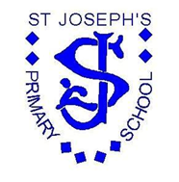
St Joseph’s RC Primary School
School Meals
Policy
Review Date: October 2022
Next Review Date: October 2023

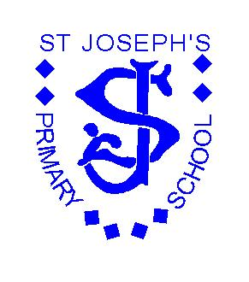
School Meals Policy

School Meals Payment Policy

Introduction

This policy concerns the collection of school meals money and the approach to be taken in the cases of debts arising when parents/carers fail to pay for school meals. As a result the school budget will have to directly fund any outstanding debts that cannot be recovered thereby directly affecting the amount of money that is available to provide education to all pupils. Parents/carers will be advised a copy of this policy is on the school website.

General Principle
School meals must be paid for in advance. If a pupil is to have meals for the duration of the week monies must be received before the start of that week or in exceptional circumstances if the pupil is having an occasional meal, monies must be received on the day of the meal.
If debts are incurred, then the school budget has to pay for them. This means that money which should be spent on all pupils' education in school is used to pay for debts incurred by individual parents / carers. The governing body see this as unacceptable and request that all parents / carers give this policy their full support.

Free School Meals Entitlement

Pupils will not be provided with a school meal unless it is paid for, except those confirmed as entitled to free school meals. If parents/carers believe that their child (children) may qualify for entitlement to Free School Meals they should contact the school office where they will be given a form to fill out. As this allowance is a statutory right for qualifying pupils it is important that parents/carers make use of it. The school is only allowed to provide free school meals to pupils where this is officially approved and informed via the on-line portal for free school meals. This also allows the school extra income (Pupil Premium)

Provision of School Meals

At St. Joseph’s RC Primary School, our meals are prepared in the school kitchen by our catering staff.

All children in Reception, Year 1 and Year 2 are entitled to a universal free school meals (UFSM) for which there is no need to complete a form. However, if you meet any of the criteria above (Free School Meal Entitlement) you should still apply in order that the school can benefit from Pupil Premium. This is extra money paid directly to schools to support the education of children of parents and carers on low income.

School meals are available to pupils at a cost of £2.20 per day. – Please see how to apply for free school meals if you think you may be entitled.

Payment of School Meals

In order to assist with the efficient ordering and planning of school meals, please pay for meals in advance, on a weekly, monthly or termly basis. The payment of school meals can be completed through our online payment system (ParentPay) using parent’s log on. We encourage all parents to sign up to this payment system as we operate a cashless office.

If a child’s school meal has been paid for in advance but they are absent, the cost of the meal will be credited against future payments.

We encourage payment to made at the beginning of each week.

Management of School Meal Debt and Procedure for Collection of Arrears

The school understands that there may be unforeseen circumstances that result in school meal payment arrears, however in order to apply this policy fairly and transparently the following procedure will be adopted for all non-payment.

Week 1
If your child has had school meals and they have not been paid for then an email (via ParentPay) will be sent as a reminder of the exact amount owing.

Week 2
If payment has not been received before the end of the week a phone call will be made as a gentle reminder and to ascertain if there are any problems we can help with.

Week 3
If payment has still not been received a letter will sent to the parent outlining the schools intention to stop providing school meals until the debt has been cleared. The parent must provide a pack lunch from home.

Week 4
If payment has still not being cleared a further letter will be sent outlining the schools intention to pursue the debt through our legal department via the small claims court.

Monitoring School Meals Debt

The Headteacher will provide the Governing Body with details of any outstanding dinner money debt and the current position with regard to such debt six times a year at the Staffing & Budget committee meeting of the Governing Body. It is the Governing Body’s responsibility to ensure that this policy is applied fairly and consistently in order that the school budget is used to provide for children’s learning and not to pay cost incurred by non-payment of school dinners.

Review
Reviewed: October 2022
This policy will be reviewed annually by the Governors of the Staffing & Budget Committee and ratified by the Full Governing Body.
Next Review Date: October 2023

