**School Mission Statement**

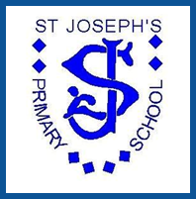

St Joseph’s is proud to be a Catholic school.

Our aim is to teach the children all they need to ‘live life to the full’. Each day we strive to create a loving school where children can learn in an environment where they feel welcome, content and secure. Through this Catholic ethos where patience, respect, friendship, hope and happiness are celebrated, we aim to give everyone the opportunity to develop and grow their own unique gifts and talents. In partnership with parents, children, staff and the wider parish family we want each child to ‘be the best that they can be’.