St Joseph’s RC Primary School

Presentation and

Marking Policy



**Review Date:** January 2024

**Next Review Date:** January 2025

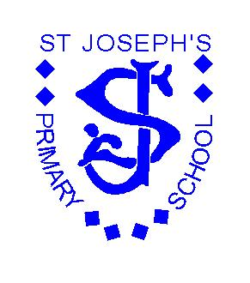

Presentation and Marking Policy

**Presentation of Work**

* All pupils must be encouraged to present their best work at all times.
* Pupils must apply what they have practised and learnt in their handwriting books to their work in all other books.
* Full date (day/month/year) in all subjects except maths, spelling tests and times tables books, which will be the short date.
* The WALT will be on the next line.
* The date and WALT will be underlined using a ruler with the next line missed before work begins.
* All WALTs must be clear and precise.
* Finished work must be underlined with a ruler and followed underneath by the next piece of work.
* All responses to marking must be **green pen**.

**Writing**

* KS1 – tickled pink and green pen is used for the growing system, followed with a **Can you… ?** question for the majority of children where appropriate at the end of an extended piece of writing. The children need to respond in **green pen**.
* KS2 – the success criteria will be ticked. A **Can you…?** question to help move the children on with their learning where appropriate and on extended pieces of writing. The children need to respond in **green pen**.
* Independent write (no success criteria) needs to have some marking and a general comment. (Writing assessment grid to be completed by the teacher and added to the writing moderation file.)

(All green **pen needs** to be acknowledge by an adult with a minimum of a tick)

~~~~~ indicates a spelling correction. (The children will be given the correct spelling in the margin and/or in KS2 use a dictionary in all books.)

__ indicates a missing capital letter.

_________________ indicates wrong use of tense/sense.

[ indicates a new paragraph.

^ indicates a missing word.

**P** indicates missing punctuation**.**

indicates independent writing

Paragraphs will be marked with a missing line.

**Maths**

* KS1 – Corrections to be completed in **pencil.**
* KS2 – Corrections completed in green **pen.**
* If there are no corrections a couple of examples of the next step will be given for all the children to complete in green pen.
* E.g. if working on addition in ten and units then the next steps would be hundreds, tens and units.

**Religion**

* Use the same system as for writing and every piece of work has a **Can you…?**

**Foundation Subjects**

* Foundation subjects and all other books can be marked using the same policy. E.g. Can you …? Where appropriate to move the learning on.

REMEMBER whenever extended writing occurs success criteria and marking scheme needs to be the same as that used in the writing books.

***Review***

*Reviewed: January 2024*

*Next Review date January 2025*

*This policy is reviewed annually*