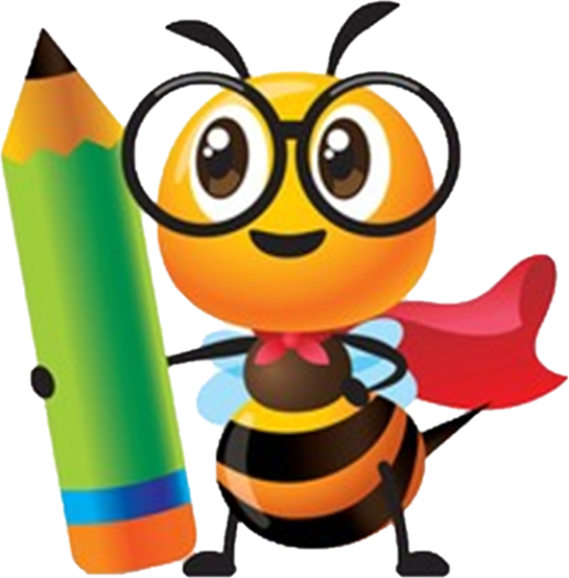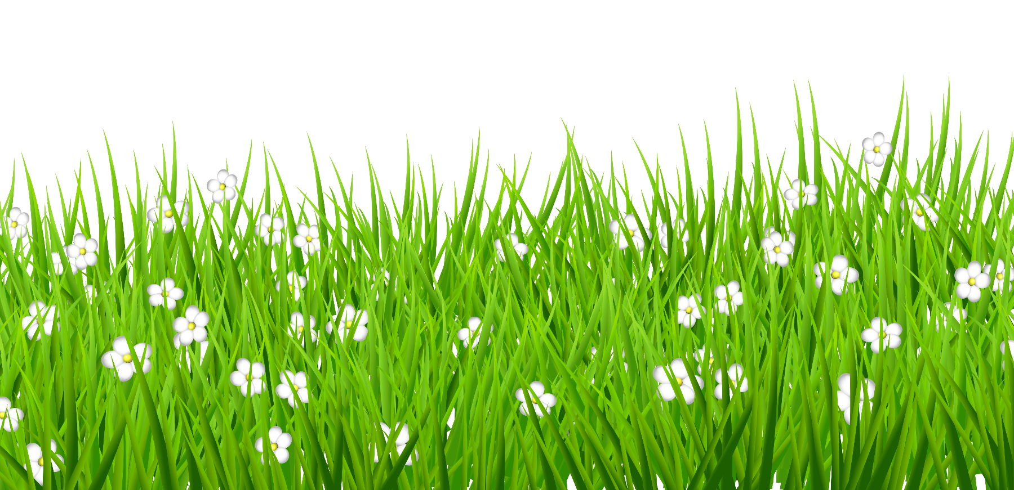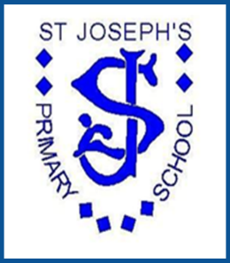

**Be the best that you can be**

***St Joseph’s Primary School***

**Art**

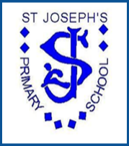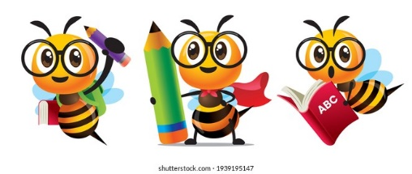

Art at St Joseph’s

**Intent**

At St Joseph’s it is our aim to develop our children’s creativity and give them opportunities to explore their imagination and develop their artistic skills. Our Art and Design curriculum has been specifically tailored to meet the unique context of our school which is a diverse community in inner city Manchester. We follow the National Curriculum programme of study beginning with opportunities for pupils to start developing their talents and skills from Nursery through to the end of Key Stage 2. Our curriculum is designed to be broad and balanced, providing all pupils with the opportunity to meet the aims of the National Curriculum so that they have opportunities to explore their ideas, plan, create and evaluate their own work and that of other great artists and designers, to explore the work of other artists and understand how art and design have reflected and shaped our history.

At St Joseph’s we aim to give our children the tools and skills they need to invent and create their own masterpieces.

**Implementation**

We will give our pupils opportunities to learn about art and design and to build high levels of competence in the subject specific skills of:

* Exploring, investigating and developing ideas
* Exploring and evaluating their work
* Drawing
* Painting
* Printing
* Sculpture and collage
* Knowledge of significant artists and designers and how their work has shaped our world and contributed to culture
* Art skills: selecting and using appropriate tools; using tools to create different forms of art, manipulating materials,

The National Curriculum for art and design is used as the basis for our curriculum planning and the development of units of work which are progressive and ensure continuity of learning across the key areas above. The pupils are also taught to plan, create and evaluate their work. Pupils learn about great artists and designers which will also be stimuli for their own creative work. From EYFS to the end of Key Stage 2, the units in art and design are linked with learning across the wider curriculum and complement the learning in RE, Science, D & T, History and Geography.

A curriculum coverage file is kept for each class which enables both class teachers and the subject leader to monitor coverage and identify progress. Art and Design is taught in block units each half term.

Resources are located in an Art storage area, with additional resources ordered throughout the year as they are required.

Assessments are carried out in various forms:

* Formative assessment during lessons
* Assessment of final pieces of work at the end of each term
* Whole-class assessment based on AREs.

Outcomes from these assessments are used to inform teacher about their planning, which areas have been covered and to what extent the pupils are meeting the AREs. This, combined with other forms of monitoring, helps to inform the subject leader’s action plan in art and design for the following school year and to inform aspects of learning that need to be strengthened to improve the quality of provision and to enhance pupil progress.

**Impact**

Children will:

* produce creative work using the skills they have learnt
* explore their ideas and record their experiences
* become skilled in drawing, painting, sculpture and other art, craft and design techniques
* evaluate and analyse creative work from a range of artists and designers
* know about great artists, and designers

A high quality of art and design education will also develop a range of skills that are transferable to other curriculum areas, particularly Science, History and geography.

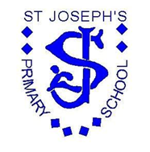

Art and Design

Progression Map and End Points

|  |  |  |
| --- | --- | --- |
|  |  |  |

[Type the company name]

**St Joseph’s RC Primary School**

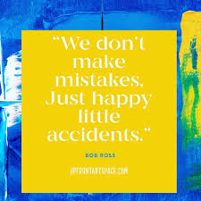

|  |  |  |  |  |
| --- | --- | --- | --- | --- |
| **St Joseph’s RC Primary School**  **Art Curriculum Progression** | | | | |
|  | **End of EYFS** | **End of KS1** | **End of Lower KS2** | **End of upper KS2** |
| **To Develop Ideas** | * Create collaboratively * Share ideas, resources and skills. * Explore, use and refine a variety of artistic effects to express their ideas and feelings. | * Respond to ideas and starting points. * Explore ideas and collect visual information.   Explore different methods and materials as ideas develop. | * Develop ideas from starting points throughout the curriculum. * Collect information, sketches and resources. * Adapt and refine ideas as they progress. * Explore ideas in a variety of ways.   Comment on artworks using visual language. | * Develop and imaginatively extend ideas from starting points throughout the curriculum. * Collect information, sketches and resources and present ideas imaginatively in a sketchbook. * Use the qualities of materials to enhance ideas. * Spot the potential in unexpected results as work progresses. * Comment on artworks with a fluent grasp of visual language. |
| **To Master Techniques** | **Painting**   * Continue to explore colour and colour mixing using appropriate techniques. * To know the primary colours and that mixing these will create a new colour * Explore using different tools for painting   **Sculpture**   * To know how to join materials to create a model and use material to finish the design * To know how to mould different resources to make a sculpture e.g. clay * Use techniques such as paper folding, rolling and cutting   **Drawing**   * To know a pencil can create different lines * To draw with increasing complexity and detail * To explore coloured pencils for different effects   **Print**   * Explore the use of repeating or overlapping shapes. * Use print from the environment (e.g. wrapping paper) as a stimulus * Explore using objects to create prints * Explore techniques to make prints e.g. rub and stamp | **Painting**   * Use thick and thin brushes. * Mix primary colours to make secondary. * Add white to colours to make tints and black to colours to make tones. * Create colour wheels.   **Sculpture**   * Use a combination of shapes. * Include lines and texture. * Use rolled up paper, straws, paper, card and clay as materials. * Use techniques such as rolling, cutting, moulding and carving.   **Drawing**   * Draw lines of different sizes and thickness. * Colour (own work) neatly following the lines. * Show pattern and texture by adding dots and lines. * Show different tones by using coloured pencils.   **Print**   * Use repeating or overlapping shapes. * Mimic print from the environment (e.g. wallpapers). * Use objects to create prints (e.g. fruit, vegetables or sponges). * Press, roll, rub and stamp to make prints. | **Painting**   * Use a number of brush techniques using thick and thin brushes to produce shapes, textures, patterns and lines. * Mix colours effectively. * Use watercolour paint to produce washes for backgrounds then add detail. * Experiment with creating mood with colour.   **Sculpture**   * Create and combine shapes to create recognisable forms (e.g. shapes made from nets or solid materials). * Include texture that conveys feelings, expression or movement. * Use clay and other mouldable materials. * Add materials to provide interesting detail.   **Drawing**   * Use different hardness of pencils to show line, tone and texture. * Annotate sketches to explain and elaborate ideas. * Sketch lightly (no need to use a rubber to correct mistakes). * Use shading to show light and shadow. * Use hatching and cross hatching to show tone and texture.   **Print**   * Use layers of two or more colours. * Replicate patterns observed in natural or built environments. * Make printing blocks (e.g. from coiled string glued to a block). * Make precise repeating patterns. | **Painting**   * Sketch (lightly) before painting to combine line and colour. * Create a colour palette based upon colours observed in the natural or built world. * Use the qualities of watercolour and acrylic paints to create visually interesting pieces. * Combine colours, tones and tints to enhance the mood of a piece. * Use brush techniques and the qualities of paint to create texture. * Develop a personal style of painting, drawing upon ideas from other artists.     **Sculpture**   * Show life-like qualities and real-life proportions or, if more abstract, provoke different interpretations. * Use tools to carve and add shapes, texture and pattern. * Combine visual and tactile qualities. * Use frameworks (such as wire or moulds) to provide stability and form.   **Drawing**   * Use a variety of techniques to add interesting effects (e.g. reflections, shadows, direction of sunlight). * Use a choice of techniques to depict movement, perspective, shadows and reflection. * Choose a style of drawing suitable for the work (e.g. realistic or impressionistic). * Use lines to represent movement.   **Print**   * Build up layers of colours. * Create an accurate pattern, showing fine detail. * Use a range of visual elements to reflect the purpose of the work. |
| **To take inspiration from the greats (classic and modern)** | **Making**   * Explore the work of some famous artists e.g. Van Gogh & Henri Matisse and use these pictures as a stimulus | **Making**   * Describe the work of notable artists, artisans and designers. * Use some of the ideas of artists studied to create pieces. | **Making**   * Replicate some of the techniques used by notable artists, artisans and designers. * Create original pieces that are influenced by studies of others. | **Making**   * Give details (including own sketches) about the style of some notable artists, artisans and designers. * Show how the work of those studied was influential in both society and to other artists. * Create original pieces that show a range of influences and styles. |

|  |  |  |  |
| --- | --- | --- | --- |
| **St Joseph’s RC Primary School**  **Art End Points** | | | |
| **Year 1** | | | |
| Pupils can use a developing range of materials creatively to design and make products | Pupils can begin to use colour, pattern, texture, line, shape and form and space within their artwork | Pupils can make links to their own artwork from observing other artists work | Pupils can draw, paint and sculpture with some imagination |
| Pupils can begin to talk about a range of artist, craft makers, and designers | Pupils can share some of their ideas and experiences through art | Pupils can describe some similarities and differences between artwork |  |
| **Year 2** | | | |
| Pupils can use an increasing range of materials creatively to design and make products | Pupils can draw, paint and sculpture with increased imagination | Pupils can confidently share their ideas and experiences through art | Pupils can use colour, pattern, texture, line, shape and form and space within their artwork with effect |
| Pupils can make links to their won artwork from observing other artists work | Pupils can talk about a range of artist, craft makers and designers | Pupils can describe similarities and differences between practices and disciplines artwork |  |
| **Year 3** | | | |
| Pupils can use a sketchbook to record observations | Pupils can begin to demonstrate confidence in drawing, painting and sculpture using a range of materials | Pupils ca talk about some great artists, architects and designers in history | Pupils an use a sketchbook to review and revisit ideas |
| Pupils can make links to historic periods and artwork | Pupils can say when and why they would use different art media e.g. pencil, charcoal, paint etc. | Pupils can explain why they have combined different tools to create their drawings | Pupils can identify links of how art and design both reflect and shape history |
| **Year 4** |  |  |  |
| Pupils can continue to use sketchbooks increasingly well to record observations and use them to review and revisit ideas | Pupils can organise line, tone shape and colour to represent figures and forms in movement | Pupils can make a record about the styles and qualities in their work | Pupils can experiment, invent and create their own works of art, craft and design |
| Pupils can discuss how art and design both reflect and shape our history | Pupils can show improvement in their mastery of art and design techniques, including drawing, painting and sculpture | Pupils can justify the materials they have chosen and explain why |  |
| **Year 5** | | | |
| Pupils can continue to use sketchbooks increasingly well to record observations and use them to review and revisit ideas | Pupils can confidently discuss how art and design both reflect and shape our history | Pupils can explain why they have combined different techniques to create their artwork | Pupils can create models on a range of scales |
| Pupils can say what their work is influenced by | Pupils can talk confidently about great artists, craft designers and understand the historical and cultural development of their art forms | Pupils can produce creative work, exploring their ideas and recording their experiences | Pupils can proficiently draw, paint, sculpt and use other art and craft design techniques |
| Pupils can evaluate and analyse creative artworks using the language of art, craft and design |  |  |  |
| **Year 6** | | | |
| Pupils can continue to use sketchbooks increasingly well to record observations and use them to review and revisit ideas | Pupils can explain how art and design contribute to the culture, creativity and wealth of our nation | Pupils can show confidence in their mastery of art and design techniques, including drawing, painting and sculpture | Pupils can organise line, tone, shape and colour to maximise their artwork |
| Pupils can confidently discuss how art and design both reflect and shape our history | Pupils can talk about a range of artists, architects and designers in history confidently | Pupils can make a record about the styles and qualities in their work | Pupils can include both visual and tactile elements in their work |

|  |  |  |  |  |  |  |
| --- | --- | --- | --- | --- | --- | --- |
| **Art and Design Long Term Plan**  **(AccessArt)** | | | | | | |
|  | **Autumn 1** | **Autumn 2** | **Spring 1** | **Spring 2** | **Summer 1** | **Summer 2** |
| **Nursery** | Understanding identity and exploring relationships | Understanding identity and exploring relationships | Explore the Power of Creativity | Explore the Power of Creativity | Exploring the Natural World | Exploring the Natural World |
| **Reception** | Understanding identity and exploring relationships 1  (finger puppets) | Understanding identity and exploring relationships 2  (Self-portraits) | Exploring the power of creativity 1 (Cavemen and spirals) | Exploring the power of creativity 2 (Spirals and print making) | Exploring the Natural World 1 (using plants to make textures and colours) | Exploring the Natural World 2 (using plants to make textures and colours) |
| **Year 1** | Wax Resist Autumn Leaves / Squiggle Drawing |  | Drawing Feathers / Making Sculptural Birds |  | Plasticine Print Making |  |
| **Year 2** | Still life compositions |  | Creating repeating patterns |  | DrawAble: Exploring through watercolour |  |
| **Year 3** | Gestrical drawing with charcoal |  | Working with shape and colour (collage and print making) |  | Making animal drawings |  |
| **Year 4** | Wax Resist with Coloured Inks |  | Drawing Nests |  | Drawing with scissors: Inspired by Matisse |  |
| **Year 5** | Sketching |  | Printmaking |  | Sculpture |  |
| **Year 6** | Creating a 3D sculpture from a 2D drawing |  | Exploring artists and their techniques to show their identity |  | Exploring how artists use light, form and colour to create immersive environments |  |