Class Novel Overview

 | Autumn Term |  | Spring Term |  | Summer Term
Nursery | Each Peach Pear Plum  The Tiger Who Came to Tea  Where’s Spot?  We Are Going on A Bear Hunt  The Gruffalo  Peppo Baby  Sheep in a Jeep  What the Ladybird Heard  The Snowman  The Snowy Day  Once Upon an Alphabet  Handa’s Surprise  Flotsam  Dear Zoo |  | Whatever Next  Hoot Owl  If You Take a Pencil  Owl Moon  Curious George  Harold and The Purple Crayon  Shark in the Park  Last Stop on Market Street  Corduroy  Guess How Much I Love You  There was an Old Lady Who Swallowed a Fly  The Story of Babar  The Name Jar – Beijing  The Elephant and the Bad Baby  Lost and Found  Traditional tales (3 little pigs, bill goats gruff and little red riding hood) |  | The Lorax  Olivia  A Cautionary Tale – Jim  Jack and the Flum Flum Tree  Avocado Baby  Peek A Who  Room on a Broom  Dig Dig Digging  The Hungry Caterpillar  The Queen’s Hat  The Adventures of Mrs. Pepper Pot  Look What I’ve Got  I Will Never Not Eat a Tomato  Horary for Anna Hibiscus  Whoever you are!  Oliver’s Garden  Jasper’s Beanstalk  The enormous turnip  Kipper’s toy box
Reception | No, David  This is London  Little Owl’s Night  I want My Potty  Funny Bones  Zen Shorts  Pumpkin Soup  Good Night Gorilla  Perfectly Norman  Oh the Places You’ll Go  The Something  Dreaming Up  Lemonade in Winter  Owl Babies  My Friend Bear  Not Now Bernard  We’ve All Got Belly Bottons  Usborne: Pepp inside night time  We’re Going on a Bear Hunt  Night Monkey, Day Monkey  Can’t You Sleep Little Bear  Bear Snores On  Gruffalo’s Child |  | Topsy and Tim collection – People who help us  Dr Raj – superhero like you!  StellaLuna  The Three Robbers  My Grandpa  Daddy Lion’s Tea Party  Peace at Last  Cinnamon  A Bear Called Paddington  Cops and Robbers  Hairy Maclary & Donaldson’s Dairy  Colours of Us  Thunder Boy Jnr.  Beegu  In the castle  Gracias Thanks  The Enormous Watermelon  Baby Goz  A first Book of Nature  Follow the yellow Line |  | You Can’t Take an Elephant on a Bus  Penguin  You Choose  There’s Commotion in the Ocean  The Bad Tempered Ladybird  The Hungry Caterpillar  The Emerald Forest  Rumble in the Jungle  A very Busy Spider  Meerkat Mail  Fiona the Fruit Bat  Sing Like a Whale  Giraffes can’t dance  Hey, Little Ant  Mad about Minibeasts  My First book of garden beasts  We’re going on a bear Hunt  Luna loves Gardening  Dear Zoo  Fran’s flower  Jack and the Beanstalk  Monkey puzzle  Walking through the jungle
 | Autumn 1 | Autumn 2 | Spring 1 | Spring 2 | Summer 1 | Summer 2
Year 1 | The Jungle Book by R. Kipling  (Classic)  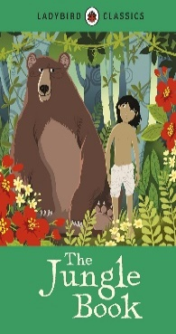 | The Owl who was afraid of the Dark by Jill Tomlinson  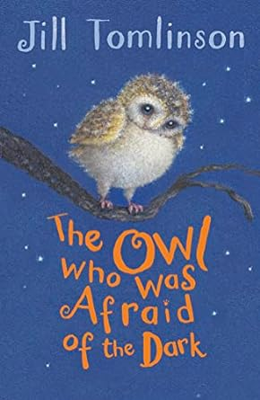 | The Enormous Crocodile by Roald Dahl  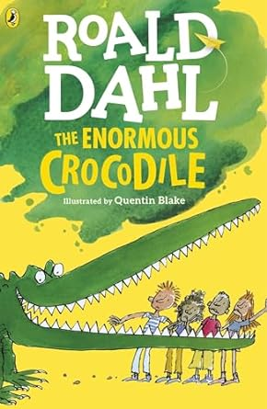 | The World According to Humphrey  By Betty G. Birney  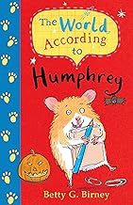 | Flat Stanley by Jeff Brown  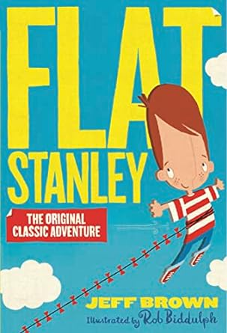 | Ruby Lu, Brace and True By Lenore Look  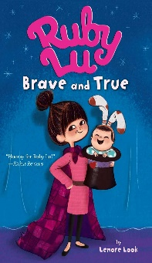
Year 2 | The Worries by Jion Sheibani  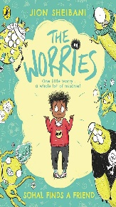 | A Christmas Carol by Charles Dickens  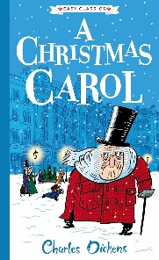  (Classic) | Too Small Tola By Atinuke  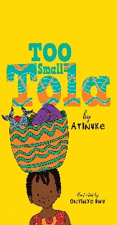 | Rabbit and Bear by Julian Gough & Jim Field  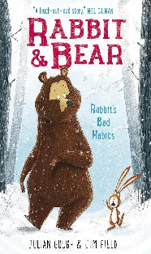 | The Princess in Black by Shannon Hale  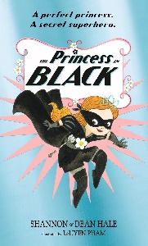 | Harry Potter and the Philosopher’s Stone by JK Rowling  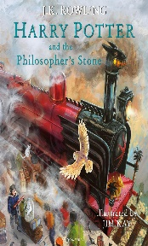
Year 3 | Secret Garden by Frances Hodgson Burnett  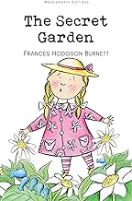  (Classic) | Thirteen Story Treehouse by Andy Griffins & Terry Denton  (Class Set)  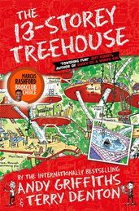 | Ironman by Ted Hughs  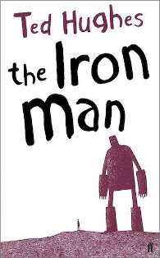 | My Brother is a Superhero  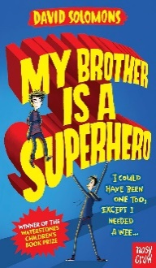 | The Twits by Roald Dahl  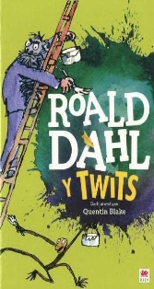 | The Boy in the Jar by Joyce Dunbar  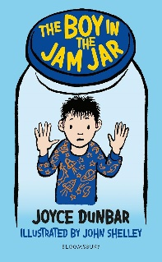
Year 4 | Treasure Island by R. S, Stevenson  (Classic)  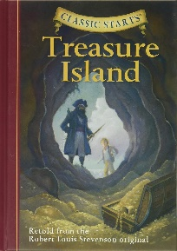 | Dead Good Detectives by Jenny Mclachlan  (Class Set)  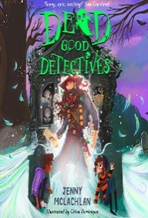 | The Sheep-Pig by Dick-King Smith  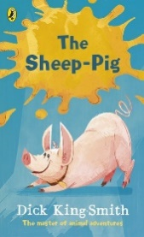 | Charlottes Web by E.B, White  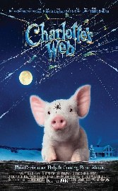 | CliffHanger by Jacqueline Wilson  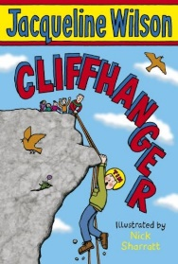 | Fred Wizard in Training by Simon Philip  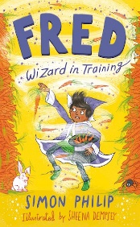
Year 5 | The Lion, the Witch and the Wardrobe by C. S. Lewis  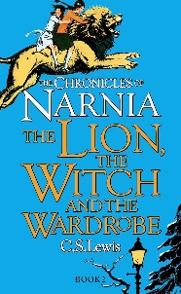  (Classic) | In the Mouth of the Wolf  by Michael Morpurgo  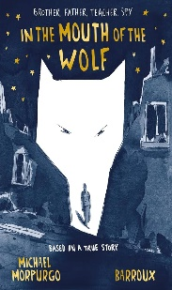  (Class Set) | The Boy at the Back of the Class  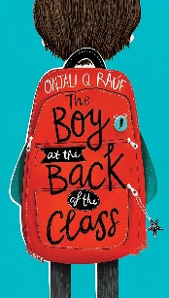  by Onjali Rauf | War Horse by Michael Morpurgo  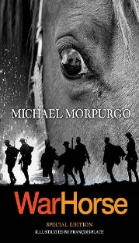 | 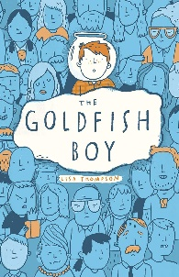  The Goldfish Boy by Lisa Thompson | Brightstorm by  Vashti Hardy  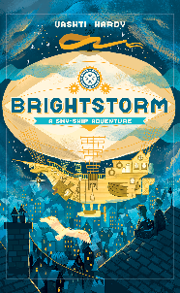
Year 6 | Oliver Twist by Charles Dickens  (Classic)  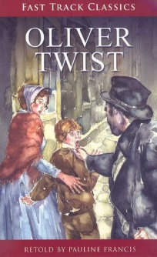 | Boy Everywhere by A. M. Dassu  (Class Set)  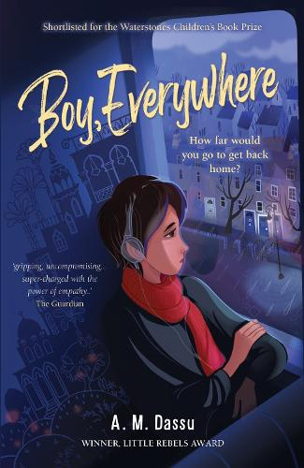 | Letters from the Lighthouse by Emma Carroll  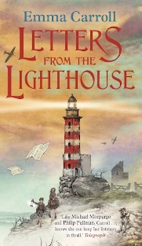 | Cogheart by Peter Bunzl  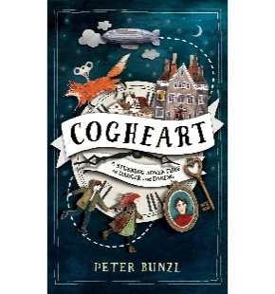 | Who Let the God’s Out by Max Evans  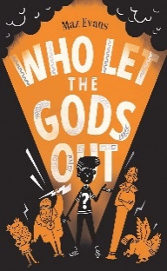 | The Nowhere Emporium by Ross Mackenzie  