Be the best that you can be

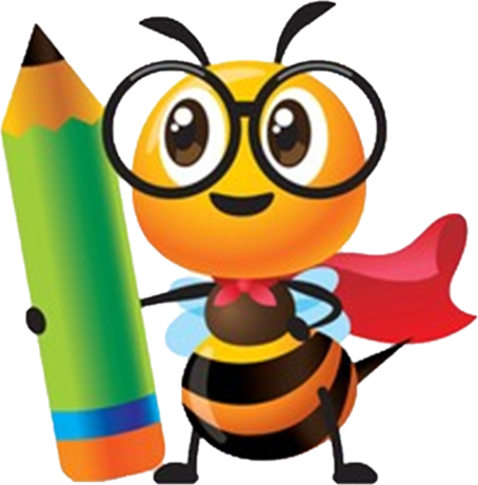

Welcome to Early Years



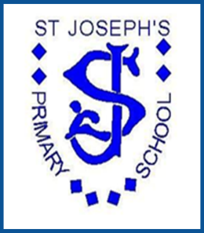
St Joseph’s Primary School
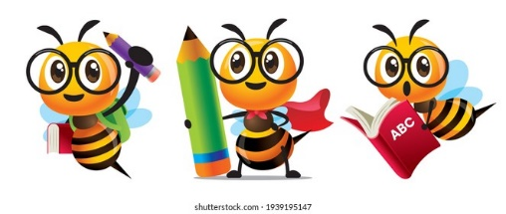
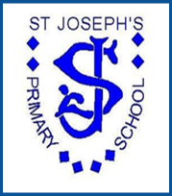
Early Years Foundation Stage
at St Joseph’s

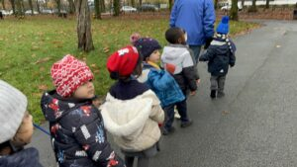

Contents

- Context of our setting
- Purpose
- Aims of EYFS Curriculum and Child experiences
- Overarching Principles of the EYFS Curriculum
- The Areas of Learning & Development
- Educational Programmes (takes from Statutory Framework)
- Early Learning Goals
- Impact of our Curriculum
- Assessment
- Safeguarding
- A Day in Nursery & Reception
- Closing the Word Gap
- Getting Year One Ready!
- Progression in Core Areas
- Long Term Plans

Appendices

- Non Negotiable/ Learn off by heart texts
- Learn off by heart Nursery Rhymes

Context

St Joseph’s RC Primary School is located in Manchester were two in every five children live in poverty and 29.7% of Manchester children affected by families living in income deprivation. The school is in one of the most highest areas of deprivation within Manchester. There is a significantly high number of children enter EYFS in St Joseph’s RC Primary school with low starting points, especially in communication and language and literacy and personal, social and emotional skills.
The children also arrive as a high majority from other countries where they have spent their first few years and are new to the UK. With early identification of children who are falling behind and or lacking in wider experiences and pre-schooling; teachers eliminate these barriers to writing and reading by immersing the children in a rich and varied literary environment with strong focuses on relationship building and broadening life experiences. This is all taught through the rich culture of our catholic faith which underpins the love, care and social teaching across the curriculum.
With this in mind, our EYFS curriculum has been designed to help tackle the effects of deprivation and build a range of significant early experiences for the children that have a high impact, whilst equipping all children with the knowledge and cultural capital they need to succeed in life and when reaching the start of the national curriculum in year 1.

Intent

The bespoke curriculum for Early Years follows the statutory framework and uses Development Matters 2021 as guidance for children’s development and support in the delivery of our EYFS curriculum. At St Joseph’s RC, we believe that the teaching in the Early Years is paramount in developing children’s communication and language skills to be successful in all areas of the curriculum, the EYFS is rich in language!
Children learn through the delivery of a progressive curriculum that is adult led with teaching that is sharply focused on teaching skills in language and communication, vocabulary, phonics, reading, writing and Maths. We provide opportunities for children to consolidate and deepen their learning through child initiated play activities, enabling children to transfer experiences into their long term memory.
The curriculum is coherently planned and sequenced. It builds on what our children know and can do, towards cumulatively sufficient knowledge and skills for their future learning at St Joseph’s and beyond.
The teaching staff pride themselves on developing relationships with the children that enable them to tailor the curriculum to children’s interests. Individuality is celebrated and staff work hard to instil self-belief in all children, (Always child, weekly achievable challenges, All about Me booklets, Whole class Learning Journey Files). Wow moments are recognised through the giving of class dojos and shared with parents virtually. We also hold personal development ceremonies where we recognise the characteristics of learning that children have developed to further their metacognition and executive functioning.
The focus from the start of Nursery is on the Prime Areas of learning and children’s personal, social and emotional development. Adults model behaviour and create role play scenarios for children to develop their awareness of others. We also use the Think Equal approach to PSE which is working on developing those early links of empathy and positive behaviour patterns. Achievement is celebrated in EYFS with the ‘Pupil of the Week’ and the completion of their own individual challenges and becoming challenge champions. Children’s achievements are also celebrated on class dojo with parents. Relationships between children and adults are strong and this motivates children to join in and respect each other.
The St Joseph’s EYFS curriculum interlinks core daily teaching of maths, reading and writing with experience led learning and child initiated learning. The balance of these three aspects allows for sequenced lessons, enabling children to build on prior learning within provision based opportunities. Skills and knowledge are introduced through thinking and finding out sessions reflecting the seasons, festivals and themed topic based learning. Opportunity to learn through play is vital, allowing children time to practice and apply new skills and knowledge within the range of the classroom environment. We plan through a topic based approach on an annual basis, but these plans are adapted and amended to address the ever growing and changing needs and interests of all our children. Enrichment takes place through trips and visitors to school (see long term plan), for example “Bug ball”, “Stay and play” and trips throughout EYFS to the park, the zoo, Legoland, the garden centre, the local Chinese restaurant etc.
Progression documents detail what the children will learn in the seven areas of learning throughout the EYFS and these documents provide checkpoints for children in EYFS for specific times throughout the academic year. Knowledge and skills are progressive throughout the early years and curriculum and strands run through the areas. EYFS leaders work with subject leaders to ensure the EYFS curriculum leads into the curriculum in KS1 and KS2 and the Early Years Curriculum provides the foundations of learning.

Purpose of Study

“No job is more important than working with children in the early years!”
Development Matters 2021

At St Joseph’s RC Primary School, we provide an effective, nurturing environment for all, where children can grow into an independent, self-confident and caring member of the community we live in. This is an important time for every child as they develop their personalities, expand their minds and learn about themselves. We pride ourselves in our provision of challenging, stimulating and motivational indoor and outdoor learning opportunities.
Children learn through the delivery of a progressive curriculum that is adult led with teaching that is sharply focused on teaching skills in language and communication, vocabulary, phonics, reading, writing and maths. We provide opportunity for children to consolidate and deepen their learning through child initiated play activities, enabling children to transfer experiences into their long term memory. The curriculum offered is ambitious, designed to provide children with knowledge, skills and the cultural capital they need to succeed in life. The curriculum is coherently planned and sequenced. It builds on what our children know and can do, towards cumulatively sufficient knowledge and skills for their future learning.
We follow the Statutory Framework for the Early Years Foundation Stage.
Every child deserves the best possible start in life and the support that enables them to fulfil their potential. Children develop quickly in the early years and a child’s experiences between birth and age five have a major impact on their future life chances. A secure, safe and happy childhood is important in its own right. Good parenting and high quality early learning together provide the foundation children need to make the most of their abilities and talents as they grow up.
The Early Years Foundation Stage (EYFS) sets the standards that all early years’ providers must meet to ensure that children learn and develop well and are kept healthy and safe. It promotes teaching and learning to ensure children’s ‘school readiness’ and gives children the broad range of knowledge and skills that provide the right foundation for good future progress through school and life.
Our EYFS seeks to provide:
- quality and consistency in all early years settings, so that every child makes good progress and no child gets left behind
- a secure foundation through planning for the learning and development of each individual child, and assessing and reviewing what they have learned regularly
- partnership working between practitioners and with parents and/or carers
- equality of opportunity and anti-discriminatory practice, ensuring that every child is included and supported
The EYFS specifies requirements for learning and development and for safeguarding children and promoting their welfare.
The learning and development requirements cover:
- the areas of learning and development which must shape activities and experiences (educational programmes) for children in all early years settings
- the early learning goals that providers must help children work towards (the knowledge, skills and understanding children should have at the end of the academic year in which they turn five)
- assessment arrangements for measuring progress (and requirements for reporting to parents and/or carers)
The safeguarding and welfare requirements cover the steps that providers must take to keep children safe and promote their welfare. (see safeguarding section.)

Aims of our Early Years Curriculum
“At St Joseph’s RC, we aim for children ‘To be the best that they can be.”
This runs through everything we do, from lessons, our learning environment both indoors and outdoors to visits and visitors. Our school is an amazing place to be and the staff and children are all very proud to be part of our school community.
Children feel valued and loved in school and staff pride themselves on building strong relationships with both parents/carers and children. We teach literacy and maths to a high standard and children make excellent progress throughout the EYFS. We treat every child as an individual and are committed to the development of the ‘whole child’.
We want children to enter KS1 happy, self-assured, independent learners with a thirst to learn and the confidence to know that they can do anything they want to do and that we will support them on their journey!

Overarching Principles of Our Early Years

This diagram shows how the Early Years curriculum is organised. This show the emphasis on Communication and Language.
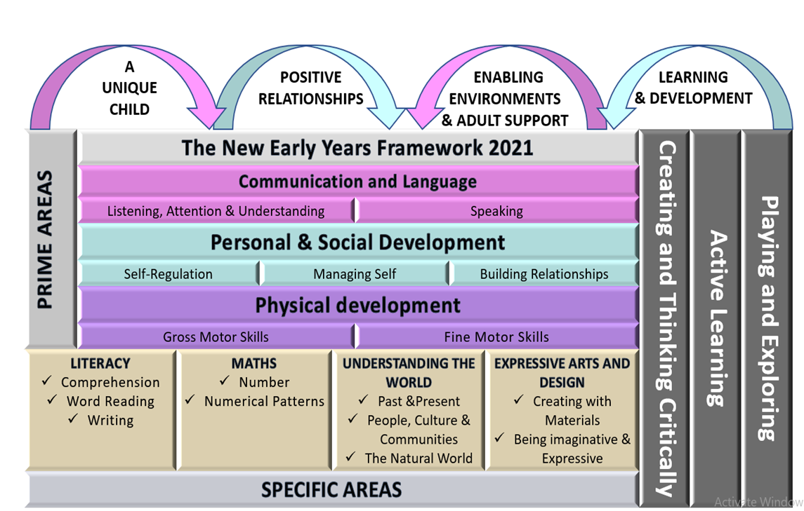

Four guiding principles should shape practice in early year’s settings. These are:
- every child is a unique child, who is constantly learning and can be resilient, capable, confident and self-assured
- children learn to be strong and independent through positive relationships
- children learn and develop well in enabling environments with teaching and support from adults, who respond to their individual interests and needs and help them to build their learning over time. Children benefit from a strong partnership between practitioners and parents and/or carers.
- importance of learning and development. Children develop and learn at different rates. (See “the characteristics of effective teaching and learning” at paragraph 1.15). The framework covers the education and care of all children in early year’s provision, including children with special educational needs and disabilities (SEND).

The Areas of Learning and Development
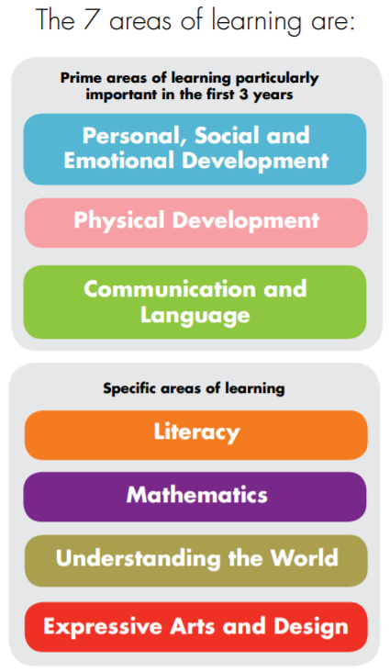

There are seven areas of learning and development that must shape educational programmes in early year’s settings. All areas of learning and development are important and inter-connected.
Three areas are particularly important for building a foundation for igniting children’s curiosity and enthusiasm for learning, forming relationships and thriving.
These are the prime areas:
- communication and language
- physical development
- personal, social and emotional development
Providers must also support children in four specific areas, through which the three prime areas are strengthened and applied.
The specific areas are:
- literacy
- mathematics
- understanding the world
- expressive arts and design
Educational Programmes

Communication and Language
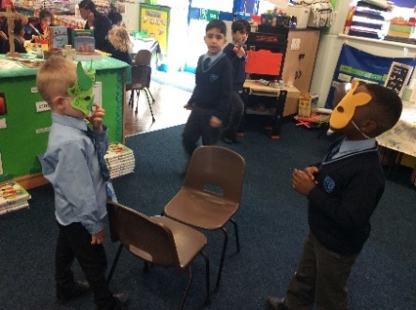
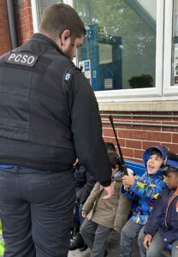

The development of children’s spoken language underpins all seven areas of learning and development. Children’s back-and-forth interactions from an early age form the foundations for language and cognitive development. The number and quality of the conversations they have with adults and peers throughout the day in a language-rich environment is crucial. By commenting on what children are interested in or doing, and echoing back what they say with new vocabulary added, practitioners will build children's language effectively. Reading frequently to children, and engaging them actively in stories, non-fiction, rhymes and poems, and then providing them with extensive opportunities to use and embed new words in a range of contexts, will give children the opportunity to thrive. Through conversation, story-telling and role play, where children share their ideas with support and modelling from their teacher, and sensitive questioning that invites them to elaborate, children become comfortable using a rich range of vocabulary and language structures.

Personal, Social and Emotional Development
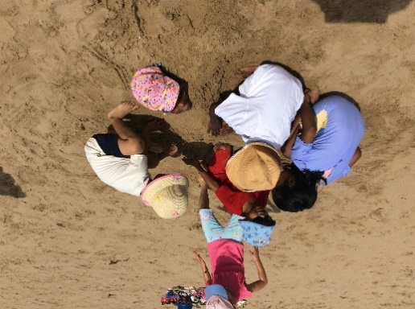
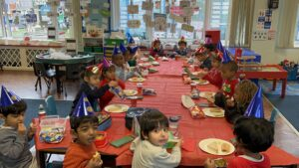

Children’s personal, social and emotional development (PSED) is crucial for children to lead healthy and happy lives, and is fundamental to their cognitive development. Underpinning their personal development are the important attachments that shape their social world. Strong, warm and supportive relationships with adults enable children to learn how to understand their own feelings and those of others. Children should be supported to manage emotions, develop a positive sense of self, set themselves simple goals, have confidence in their own abilities, to persist and wait for what they want and direct attention as necessary. Through adult modelling and guidance, they will learn how to look after their bodies, including healthy eating, and manage personal needs independently. Through supported interaction with other children, they learn how to make good friendships, co-operate and resolve conflicts peaceably. These attributes will provide a secure platform from which children can achieve at school and in later life.
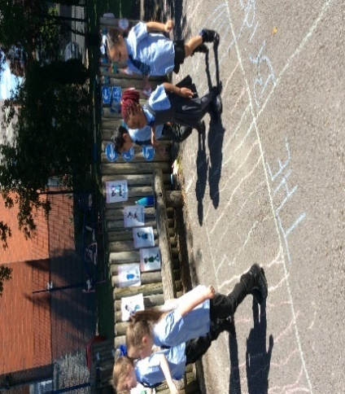
Physical Development
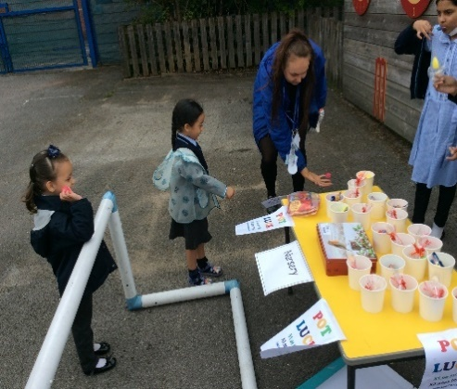

Physical activity is vital in children’s all-round development, enabling them to pursue happy, healthy and active lives. Gross and fine motor experiences develop incrementally throughout early childhood, starting with sensory explorations and the development of a child’s strength, co-ordination and positional awareness through tummy time, crawling and play movement with both objects and adults. By creating games and providing opportunities for play both indoors and outdoors, adults can support children to develop their core strength, stability, balance, spatial awareness, co-ordination and agility. Gross motor skills provide the foundation for developing healthy bodies and social and emotional well-being. Fine motor control and precision helps with hand-eye co-ordination, which is later linked to early literacy. Repeated and varied opportunities to explore and play with small world activities, puzzles, arts and crafts and the practice of using small tools, with feedback and support from adults, allow children to develop proficiency, control and confidence.

Literacy
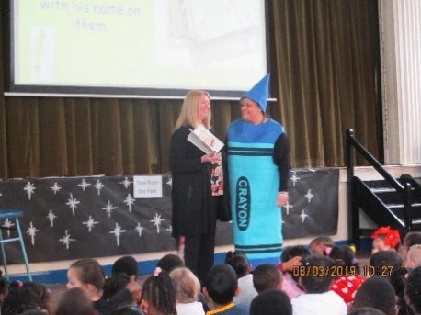
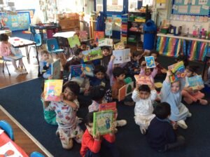

It is crucial for children to develop a life-long love of reading. Reading consists of two dimensions: language comprehension and word reading. Language comprehension (necessary for both reading and writing) starts from birth. It only develops when adults talk with children about the world around them and the books (stories and non-fiction) they read with them, and enjoy rhymes, poems and songs together. Skilled word reading, taught later, involves both the speedy working out of the pronunciation of unfamiliar printed words (decoding) and the speedy recognition of familiar printed words. Writing involves transcription (spelling and handwriting) and composition (articulating ideas and structuring them in speech, before writing).

Mathematics
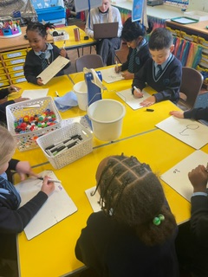
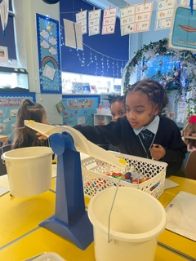
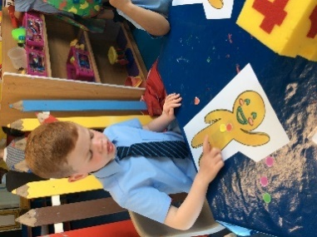

Developing a strong grounding in number is essential so that all children develop the necessary building blocks to excel mathematically. Children should be able to count confidently, develop a deep understanding of the numbers to 10, the relationships between them and the patterns within those numbers. By providing frequent and varied opportunities to build and apply this understanding - such as using manipulatives, including small pebbles and tens frames for organising counting - children will develop a secure base of knowledge and vocabulary from which mastery of mathematics is built. In addition, it is important that the curriculum includes rich opportunities for children to develop their spatial reasoning skills across all areas of mathematics including shape, space and measures. It is important that children develop positive attitudes and interests in mathematics, look for patterns and relationships, spot connections, ‘have a go’, talk to adults and peers about what they notice and not be afraid to make mistakes.

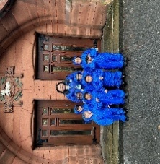
Understanding the World
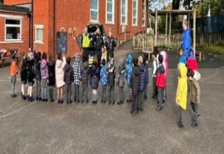
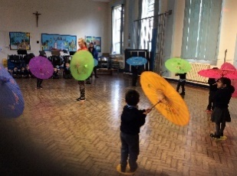
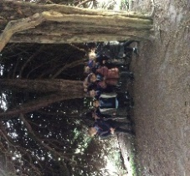
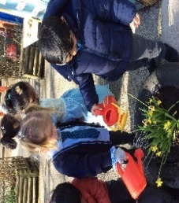

Understanding the world involves guiding children to make sense of their physical world and their community. The frequency and range of children’s personal experiences increases their knowledge and sense of the world around them – from visiting parks, libraries and museums to meeting important members of society such as police officers, nurses and firefighters. In addition, listening to a broad selection of stories, non-fiction, rhymes and poems will foster their understanding of our culturally, socially, technologically and ecologically diverse world. As well as building important knowledge, this extends their familiarity with words that support understanding across domains. Enriching and widening children’s vocabulary will support later reading comprehension.

Expressive Arts and Design
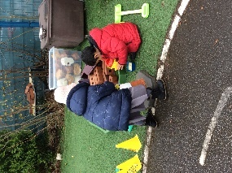

The development of children’s artistic and cultural awareness supports their imagination and creativity. It is important that children have regular opportunities to engage with the arts, enabling them to explore and play with a wide range of media and materials. The quality and variety of what children see, hear and participate in is crucial for developing their understanding, self-expression, vocabulary and ability to communicate through the arts. The frequency, repetition and depth of their experiences are fundamental to their progress in interpreting and appreciating what they hear, respond to and observe.

Early Learning Goals

The level of development children should be expected to have attained by the end of the EYFS is defined by the early learning goals (ELGs) as set out below.
The ELGs should not be used as a curriculum or in any way to limit the wide variety of rich experiences that are crucial to child development, from being read to frequently to playing with friends.
Instead, the ELGs should support teachers to make a holistic, best-fit judgement about a child’s development, and their readiness for Year 1.
When forming a judgement about whether an individual child is at the expected level of development, teachers should draw on their knowledge of the child and their own expert professional judgement. This is sufficient evidence to assess a child’s individual level of development in relation to each of the ELGs. Sources of written or photographic evidence are not required, and teachers are not required to record evidence.
Communication and Language

ELG: Listening, Attention and Understanding
Children at the expected level of development will:
- Listen attentively and respond to what they hear with relevant questions, comments and actions when being read to and during whole class discussions and small group interactions;
- Make comments about what they have heard and ask questions to clarify their understanding;
- Hold conversation when engaged in back-and-forth exchanges with their teacher and peers.
ELG: Speaking
Children at the expected level of development will:
- Participate in small group, class and one-to-one discussions, offering their own ideas, using recently introduced vocabulary;
- Offer explanations for why things might happen, making use of recently introduced vocabulary from stories, non-fiction, rhymes and poems when appropriate;
- Express their ideas and feelings about their experiences using full sentences, including use of past, present and future tenses and making use of conjunctions, with modelling and support from their teacher.
Personal, Social and Emotional Development

ELG: Self-Regulation
Children at the expected level of development will:
- Show an understanding of their own feelings and those of others, and begin to regulate their behaviour accordingly;
- Set and work towards simple goals, being able to wait for what they want and control their immediate impulses when appropriate;
- Give focused attention to what the teacher says, responding appropriately even when engaged in activity, and show an ability to follow instructions involving several ideas or actions.
ELG: Managing Self
Children at the expected level of development will:
- Be confident to try new activities and show independence, resilience and perseverance in the face of challenge;
- Explain the reasons for rules, know right from wrong and try to behave accordingly;
- Manage their own basic hygiene and personal needs, including dressing, going to the toilet and understanding the importance of healthy food choices.
ELG: Building Relationships
Children at the expected level of development will:
- Work and play cooperatively and take turns with others; -
- Form positive attachments to adults and friendships with peers;
- Show sensitivity to their own and to others’ needs.

Physical Development

ELG: Gross Motor Skills
Children at the expected level of development will:
- Negotiate space and obstacles safely, with consideration for themselves and others;
- Demonstrate strength, balance and coordination when playing;
- Move energetically, such as running, jumping, dancing, hopping, skipping and climbing.
ELG: Fine Motor Skills
Children at the expected level of development will:
- Hold a pencil effectively in preparation for fluent writing – using the tripod grip in almost all cases;
- Use a range of small tools, including scissors, paint brushes and cutlery;
- Begin to show accuracy and care when drawing.

Literacy

ELG: Comprehension
Children at the expected level of development will:
- Demonstrate understanding of what has been read to them by retelling stories and narratives using their own words and recently introduced vocabulary;
- Anticipate – where appropriate – key events in stories;
- Use and understand recently introduced vocabulary during discussions about stories, non-fiction, rhymes and poems and during role-play.
ELG: Word Reading
Children at the expected level of development will:
- Say a sound for each letter in the alphabet and at least 10 digraphs;
- Read words consistent with their phonic knowledge by sound-blending;
- Read aloud simple sentences and books that are consistent with their phonic knowledge, including some common exception words.
ELG: Writing
Children at the expected level of development will:
- Write recognisable letters, most of which are correctly formed;
- Spell words by identifying sounds in them and representing the sounds with a letter or letters;
- Write simple phrases and sentences that can be read by others.

Mathematics

ELG: Number
Children at the expected level of development will:
- Have a deep understanding of number to 10, including the composition of each number;
- Subitise (recognise quantities without counting) up to 5;
- Automatically recall (without reference to rhymes, counting or other aids) number bonds up to 5 (including subtraction facts) and some number bonds to 10, including double facts.
ELG: Numerical Patterns
Children at the expected level of development will:
- Verbally count beyond 20, recognising the pattern of the counting system;
- Compare quantities up to 10 in different contexts, recognising when one quantity is greater than, less than or the same as the other quantity;
- Explore and represent patterns within numbers up to 10, including evens and odds, double facts and how quantities can be distributed equally.

Understanding the World

ELG: Past and Present
Children at the expected level of development will:
- Talk about the lives of the people around them and their roles in society;
- Know some similarities and differences between things in the past and now, drawing on their experiences and what has been read in class;
- Understand the past through settings, characters and events encountered in books read in class and storytelling.

ELG: People, Culture and Communities
Children at the expected level of development will:
- Describe their immediate environment using knowledge from observation, discussion, stories, non-fiction texts and maps;
- Know some similarities and differences between different religious and cultural communities in this country, drawing on their experiences and what has been read in class;
- Explain some similarities and differences between life in this country and life in other countries, drawing on knowledge from stories, non-fiction texts and – when appropriate – maps.
ELG: The Natural World
Children at the expected level of development will:
- Explore the natural world around them, making observations and drawing pictures of animals and plants;
- Know some similarities and differences between the natural world around them and contrasting environments, drawing on their experiences and what has been read in class;
- Understand some important processes and changes in the natural world around them, including the seasons and changing states of matter.

Expressive Arts and Design

ELG: Creating with Materials
Children at the expected level of development will:
- Safely use and explore a variety of materials, tools and techniques, experimenting with colour, design, texture, form and function;
- Share their creations, explaining the process they have used;
- Make use of props and materials when role playing characters in narratives and stories.
ELG: Being Imaginative and Expressive
Children at the expected level of development will:
- Invent, adapt and recount narratives and stories with peers and their teacher;
- Sing a range of well-known nursery rhymes and songs;
Perform songs, rhymes, poems and stories with others, and – when appropriate – try to move in time with music.

The Impact of our Curriculum

The impact of the curriculum is seen in the progress the children make in all areas of the curriculum, regardless of background, disadvantage or SEND. The school is situated in an area of high deprivation and staff are acutely aware of the impact of this on children’s academic success and cultural capital. Early identification of children with SEND and those children who are disadvantaged enables staff to identify ways in which to support them. Interventions are quickly put in place to help children who are falling behind. All children are assessed via the WELLCOMM intervention in Nursery and graded on a traffic light system of need.
Our disadvantaged children perform in line or exceed others and a range of bespoke strategies are put in place for children ranging from therapeutic (Enrichment targeted small group support, to academic (Wellcomm, Phonic boosters and EAL intervention groups.) The broad and balanced curriculum we offer is there to support all children at a quality first teach level with adaptations where needed. The outdoor areas for Nursery and Reception ensure that the offer of outdoor provision was progressive from Nursery and Reception and that challenge is there for the children to progress. In addition we are aware of our children’s living accommodation and lack of access to outdoors space, from our home visits, therefore termly trips to the park/playground and access to the outback forest area are planned in to our curriculum as well as the significant importance placed on accessing the stimulating outdoors within school every day.

Assessment

Children in Reception and Nursery start the academic year with a baseline assessment. This identifies who needs extra support from the start. On the progression documents for the seven areas of learning, check points are identified at three points through the academic year. Teachers and key workers make best fit judgements as to the age bracket the child is working within. This system helps us quickly identify the children who are falling behind and to measure progress throughout the academic year. It also links to our assessment systems in Key Stage One and Two.

Please see Assessment Schedule and Long term plan.

On track through the year
Autumn | Spring | Summer

Nursery
Not on track - Birth to 1
Falling behind expected- 1-2 years
Just below expected –
2-3 years
Expected On track:
OE – secure 2/3 years
End of Aut/Spr/Sum working at 3-4 years

Reception
Not on track - 1-2 years
Falling behind expected –
2-3 years
Just below expected - working at 3-4 years

Expected on track:
OE – secure 3/4 years
End of Aut/Spr working at 4-5 years
End of Sum – ELG achieved
Exceeding the expected standard.

Safeguarding
“Children learn best when they are healthy, safe and secure, when their individual needs are met, and when they have positive relationships with the adults caring for them.”

We have a whole school safeguarding policy that is followed in the EYFS that clearly includes an explanation of the action to be taken when there are safeguarding concerns about a child and in the event of an allegation being made against a member of staff, and cover the use of mobile phones and cameras in the setting. It also includes guidance on suitable people and guidance on how to identify signs of possible abuse and neglect at the earliest opportunity, and to respond in a timely and appropriate way. Additionally, all new staff have induction training that includes safeguarding and makes clear staff are aware of their roles and responsibilities.

First Aid

All EYFS teachers and most teaching assistants are first aid trained. We ensure always one member of staff is present in the school premises that matches the criteria as set out in the Annex A of the EYFS statutory framework. Ratios- We have one adult to every 13 children.

A day in the life in Nursery & Reception

Visual Timeline
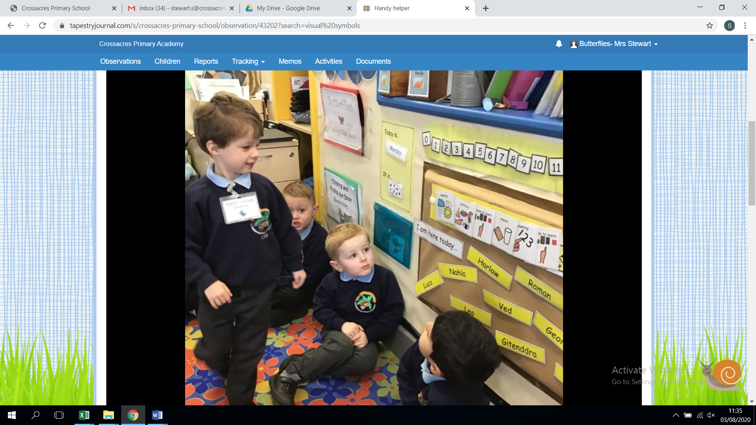

The timeline should be displayed prior to the children arriving at the start of the day. It is set up for the morning session and then set up for the afternoon session (before going for your lunch break).
Refer to the timeline throughout the day, point to the pictures to help the children become familiar with them, ask questions: what will we be doing next?

The usual morning timetable is:

Classes start the day with handwriting/name recognition and checking/hearing children read.
- Good morning and register time and choosing lunches and prayers
- Weather
- Phonics
- Group time/ whole class teaching English/Maths focuses
- Choose to learn
- Snack (story)
- Tidy up
- Rhyme time
- Lunchtime and prayers
- Outside

The usual afternoon time is:
- Good afternoon and prayers
- Group time/ whole class teaching EAD, PSE, UW
- Choose to learn
- Tidy up
- Story
- Prayers and Home time

Register to be completed on the laptop (SIMS) at 8.45am and 12.30pm by class teachers.

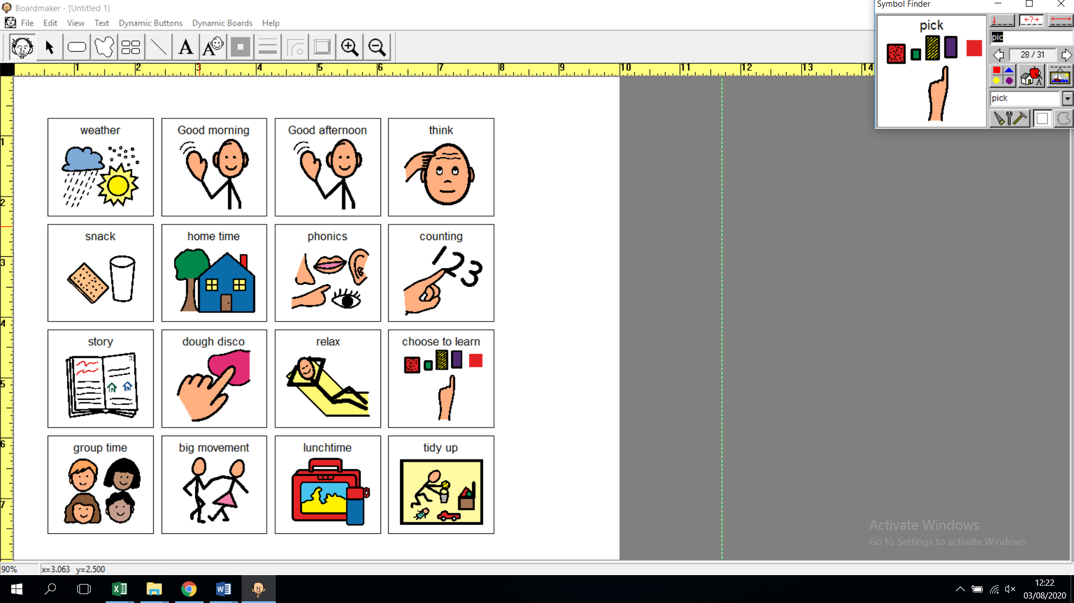 | Sing the weather song and use the Makaton actions to support, as you point to each visual symbol in turn.  Sing the ‘days of the week’ song, point to each day as you say it, adult to model “yesterday was …. So today is…”  (5 minutes)
 | Follow the planning.
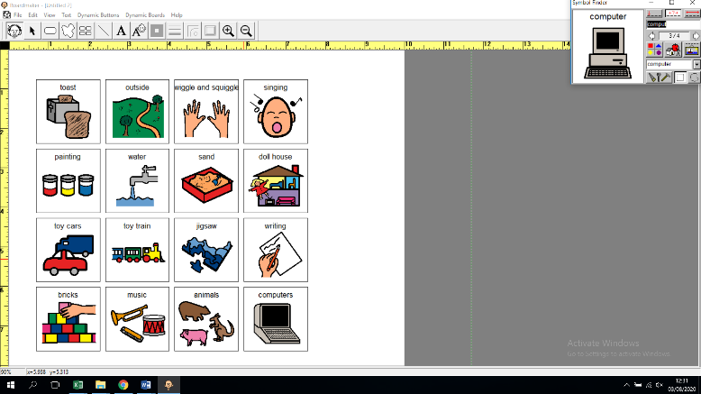 | Child initiated learning. Ask children individually where they are going to learn, to support them in making a decision allow time to explain what is on offer this week.  Some children may only need to be given the choice of 2 options ‘sand or water?’ Children to leave the carpet in a calm manner.  There should be 3 challenges within the Nursery environment based on skills/knowledge next steps from assessments and 5 of the challenges in Reception. It MUST always feature a Literacy/C.L and maths. These are to be introduced on a Monday and completed by the Friday where children earn pennies for each challenge and exchange their pennies for prizes from the lucky dip shop.
 | Children are prompted quietly (by adults) to tidy away where they are working or at their job and tidy up music is played to support the understanding of the routine and what time it is. At the end of the song children return to their keyworker carpet area to read a book from the basket. Adults will then choose children to finish the tidying in their areas if this needs doing.
 | Children to be taken to the toilet in turn, to be supervised by the staff on duty, children to sit at their tables for lunch in Nursery and access the canteen in Reception class.
Say good afternoon to each child in turn as the electronic register is completed.
(5 minutes)

 | Children to collect their coats in a calm manner. Adults to be mindful that some groups may still be listening to a story. Teachers will take responsibility for dismissing the children at the end of each day.

Birthdays
Each class area has a display with the months of the year and has each child’s name displayed accordingly. Birthdays are celebrated within the class.
Seasons / Months of the Year
Discussion about the seasons to take place naturally as they occur, this enables the children to use their senses. Reciting the months of the year as a learning activity is not appropriate, talking about the months in relation to the seasons, or a special occasion has meaning. For example “it is now October, I can see that it will soon be Emily’s birthday.”
The day of the week is recorded at the start of each session on the chart.
Self-Registration
At the start of each day in Nursery, the children find their name card and post it in the box.
Snacks
Children are to be encouraged to be as independent as possible, to help one another. Rubbish is to be placed into the bin.
Handwriting:
We follow the letter join handwriting sessions for specific handwriting lesson on timetable.
For name writing:
- Writing over each letter in turn, using the correct formation, then writing each letter in the box underneath correctly, finally writing their name on the line.

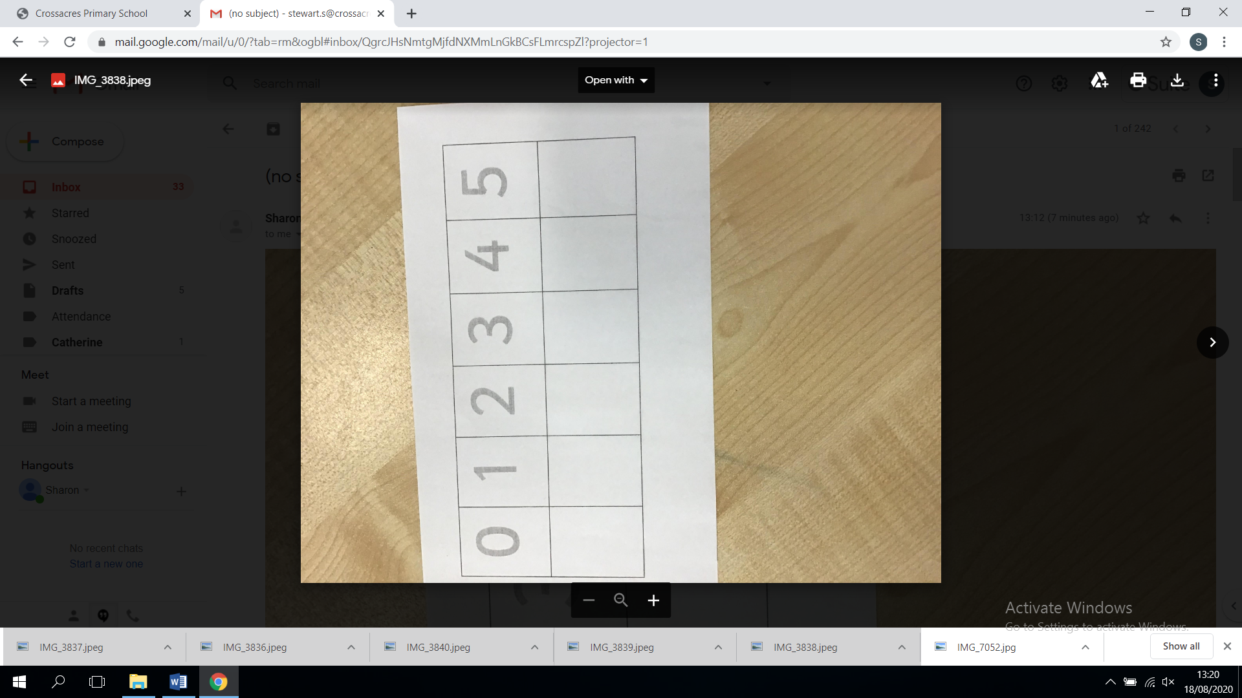
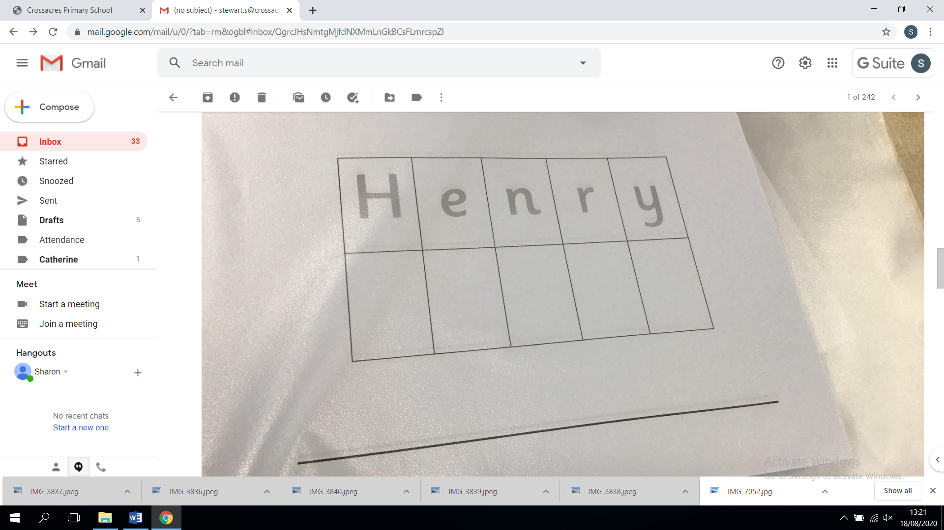

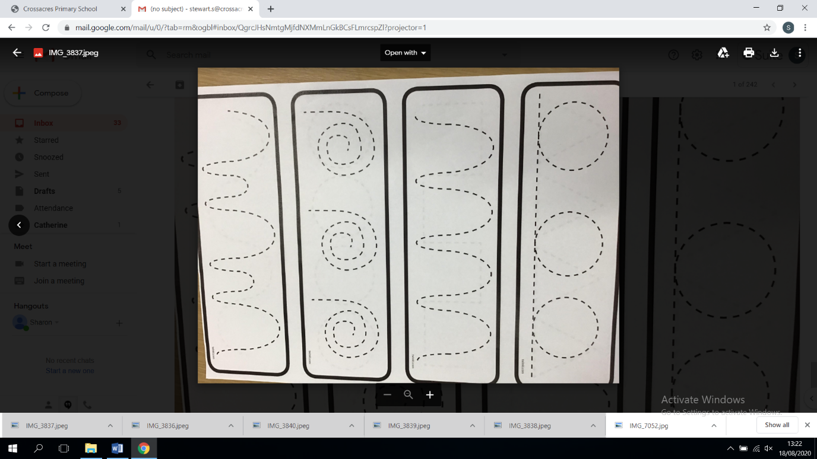

Thinking and Finding out Books
We use Thinking and finding out books, which is displayed and accessible to the children at all times. Any whole group activities and or events can be recorded in the book for example; making playdough, Chinese New Year, The bug ball, snow day, Christmas show. The books provide evidence of the experiences the children have had, progression in skills over a prolonged period of time, show coverage of the wider curriculum and cultural capital, they are used to enhance language skills and develop the children’s vocabulary. Photographs, drawings, captions relating to these activities are stuck into the book and the children’s ‘voice’ is written by the adults. These books are made available to the children at specific times and or in the reading areas. We have thinking and finding out books for EAD/UW/PSE and in Nursery additional books are used for CL and Maths activities/events.

Focused skills/challenges/activities
There will be a focus for each area, this may last for a week or 2weeks depending on the interest levels of the children and engagement. All children are expected to access the tasks at a level appropriate to them, but this is not to become a ‘production line’. The focus will be on developing emergent skills with the adult supporting new thinking by posing open questions; I wonder how we could…? How did you do that? What should we do next? There is an expectation the challenges will focus on embedding previous teaching or used as pre-requisite teaching needed for up and coming teaching.

Adult led teaching

Children receive discreet teaching in small Keyworker groups for Maths, Phonics and Communication and Language daily.
Teachers complete a focused activity with each child in their class each week.

Child Initiated Learning

The classroom areas are well resourced and children are encouraged to become involved in activities and tasks that interest them. This provides time for them to investigate and play with their peers. Adults will observe the children and support their thinking and learning as appropriate – observations of this learning are invaluable and can be recorded as WOW moments when skills and knowledge of attainment are shown. These are to be shared with parents through dojo system, verbally after school or at parent’s evenings.

WOW Wall

Wow moments from home are displayed on the wall in each classroom and are celebrated with the children. Parents can send in WOW moments to also go up on the board. These moments then go into a clear sleeve wallet as a collection of achievements by each individual child and staff can access and use them towards securing assessment judgements.

Celebrations

Each class has a birthday display with the months of the year and each child’s name displayed accordingly. Birthdays are celebrated as a whole class. If children wish to bring in a cake for their birthday or treats for their class they are welcome to do so to make their day as special as possible.
Weekly assemblies are held whereby all children’s achievements are celebrated together. This can be sporting achievements out of school, reading certificates, and attendance awards. Additionally, each Friday the class teacher chooses one child from their class to be the pupil of the week for the following week. There are numerous reasons a child can be chosen ranging from super work, kindness, good behaviour, perseverance and progress. Each class also has a WOW wall whereby children’s work they are proud of is displayed for all to see. Class dojo is also used to share children’s achievements with parents in the form of pictures, videos and individual notes home along with dojo points.

Work Books
In Reception children have individual Topic work, Writing, RE books and Maths folders. These books store focused and independent activities as well as photographs sometimes. We also have homework files in Reception class and each week a Literacy and Numeracy activity is sent home in this file for children to complete, return and be marked. These books provide evidence of progression in skills over a period of time and the Topic books show coverage of the wider curriculum. Staff also collate thinking and finding out floor books in Nursery and Reception class to record special events and activities linked to EAD, PSE, UW and cross curricular. Both EYFS classes take books home to read for pleasure from the library and once children begin the phonics scheme they take home a phonics reading book every night.

Observations/Assessment

Adults observe children and support their thinking and learning as appropriate during both focused and independent activities. As well as a record of achievements in work books, additional observations are recorded as WOW moments. Twice a year parent’s evenings are held to discuss children’s progress and a school report is written at the end of the year to provide parents/carers with a record of their child’s individual achievements.

Closing the Word Gap!

The department of Education states that:
“28% of four- and five-year-olds do not meet communication and literacy levels expected by the end of the Reception year”

“Teachers believe the word gap occurs when children don’t read for pleasure or have enough opportunity to practise vocabulary.”

Our bespoke curriculum is sequenced and enables children to gain knowledge and skills cumulatively. Topics the children learn about are ambitious and opportunities to develop children’s ‘cultural capital’ are seized!
Vocabulary acquisition is planned and sequenced (see Reading and CLL progression.) In addition to this, language is modelled and language is modelled just above where the children are to help them increase their vocabulary. Staff are experienced in deliberately creating communication opportunities.

Getting Year One Ready in Reception

Transition from Reception starts in the summer term before children start in Year One in the September. Firstly, moderation in Reading, Writing and Maths happens early on in the term, with staff from Reception and Year One becoming familiar with the standard needed to meet the Expected standard in reception and Year One. Staff take time to look at each other’s evidence and then Year One and Reception staff moderate a child’s evidence together to reach a judgement.
Next, Year One staff spend a day in Reception to watch the children in their setting and to become familiar with how the continuous provision works in Reception. This helps if some children need to continue some elements of this approach in the Autumn Term of Year One. Observations of children with SEN are observed with the Year One teacher and Reception teacher.
Assessment data is shared with Year One teachers in a meeting. Children who have not achieved GLD are identified and gaps in the areas of learning identified. Routines are shared between teachers and Class dojo is used to introduce the new teacher for Year One. Parents get to meet the new teacher in the first two weeks of the new term.
Reading in the Early Years
Working with the revised Early Years Foundation Stage: Principles into Practice
Julian Grenier- Early Adopter version
It is crucial for children to develop a lifelong love of Reading.
Reading consists of two dimensions: language comprehension and word Reading. Language comprehension (necessary for both Reading and Writing) starts from birth. It only develops when adults talk with children about the world around them and the books (stories and nonfiction) they read with them, and enjoy rhymes, poems and songs together. Skilled word reading, taught later, involves both the speedy working out of the pronunciation of unfamiliar printed words (decoding) and the speedy recognition of familiar printed words.
We recognise that language and communication are vital in all areas of a child’s development. We welcome children from culturally diverse backgrounds and many of our children are at an early stage of learning English as an additional language (EAL). Communication and language development are therefore a consistent focus. We support children’s development by providing a rich language environment, where conversations, singing and sharing stories become a regular part of the children’s day. Our Core curriculum is planned and sequenced carefully, demonstrating skilled progression of knowledge and understanding. We use Read Write Inc to teach phonics. (See Phonics Section.)
At St Joseph’s RC we have identified three main strands that run through our Reading Curriculum.
In the EYFS, reading is carefully planned and leaders have identified a range of non-negotiable texts that are planned over the academic year and broken down into Autumn, Spring and Summer. Texts are progressive throughout the year and from Nursery to Reception. They are texts that have been selected because they highlight/demonstrate effectively one of the strands of our Reading Curriculum - Reading Behaviours / Structure of texts / Rhythm and Rhyme. We have also delivered training on how to deliver texts in an exciting way that engages and enthrals. (See reading Curriculum.) The reading curriculum ensures that children are exposed to lots of varied vocabulary and this is seen in the strand ‘Structure of texts’ in our EYFS reading progression.

1. Early rhyme and rhythm, Non-negotiable Nursery Rhymes are agreed for both Nursery and Reception so that at the end of Reception children should be able to recite nursery rhymes.
Music sessions are also taught across EYFS on a weekly basis and instruments are available outside in Nursery and outside in Reception. During Nursery phonics sessions, children are taught to listen carefully and describe what they can hear. In EYFS songs are taught and sung on a daily basis to support the class routines.

2. Early Comprehension – Comprehension is the understanding and interpretation of what is read. To be able to accurately understand written material children in EYFS are taught to decode what they read during RWI phonics sessions which then enables them to apply their knowledge when reading independently. Staff are passionate about ensuring children can talk about and make connections between what has been read to them or what they have read and what they already know. Children are also encouraged to think deeply about what has been read to them or what they have read. This is achieved by careful questioning, extending and developing children’s ideas, quality conversations and listening carefully.
3. Reading behaviours- The early reading behaviours of children can tell us so much about a child’s learning styles and abilities. They also look at the developing progress of how children respond to books and reading. In Nursery, book handling behaviours refer to page turning and identifying the front and back cover, the spine and the blurb. In Reception, children begin to understand basic concepts of reading a book, such as reading from top to bottom, left to right and knowing the difference between text and illustration. How children react and engage with books, such as laughing at pictures and responding to the way an adult reads a book is another important reading behaviour promoted in EYFS. Picture and story comprehension is a child’s understanding of the pictures and characters within a book. A Nursery child might show understanding by copying an action from a picture book. A Reception child might tell us some extra information or a personal thought. Story reading refers to a child’s verbal interactions with books. Younger children start with babbling and repeating sounds. Older children, such as those in Reception progress to reading alone and expressing opinions about the books they have read.
Non-negotiable texts have been identified for Nursery and Reception and these books are separated into the above strands to ensure the best texts are being used to promote each strand as well as being progressive through the strands and from Nursery to Reception. Teachers also have suggested nonfiction books linked to their topics and non-negotiable Nursery rhymes for the children to learn.
How do we develop at love of Reading in EYFS?
Within EYFS reading routines are developed as soon as children begin Nursery. This is continued throughout EYFS and beyond. Staff read books that children are interested about as well as those that reflect children’s daily experiences. Children are encouraged to select books for adults to read, returning to and re-reading familiar favourites. Children in EYFS are encouraged to be storytellers in continuous play provision as well as in familiar groups. Having fun whilst reading is at the heart of what we do in EYFS and books are rotated and changed on a regular basis ensuring children have access to engaging texts. Reading aloud fosters a love of books in children and helps children get hooked on books as they associate reading with pleasure. In EYFS there are comfortable vibrant and engaging reading spaces for reading as well as time set aside for leisure reading. The freedom we give children to select their own books leads to a more positive reading experience and positive attitude towards reading. Instilling a love of reading in EYFS gives children a head start on expanding their vocabulary, building independence and self-confidence. It also helps children learn to make sense not only of the world around them but also people, building social-emotional skills and of course, imagination. Children also visit the school and local library within EYFS.

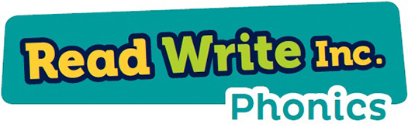

Phonics Scheme and how we assess progress in Phonics?
At St Joseph’s RC Primary we put the teaching of reading at the heart of our school and ensure all teachers have the knowledge and determination to teach every child, regardless of age, background or need. We have consistently taught using an accredited phonics scheme, Read Write Inc. This programme is taught from Nursery/Reception to Year 2 on a daily basis for 30 minutes per day four times a week. The children are initially assessed using RWI documentation and grouped homogenously. Set 1 Speed sounds are taught for the first four weeks and then the children are reassessed and regrouped according to their stage before moving on to the next stage of RWI using the structured lesson plans. Assessment of every child is carried out each half term. In Nursery, children are taught Phase 1 environmental sounds as well as oral blending and segmenting and in the summer term staff teach RWI so that children are well prepared for moving into Reception. In Reception, we emphasise the alphabetic code. Children rapidly learn sounds and the letter, or groups of letters they need to represent them. Simple mnemonics help them to grasp this quickly. This is especially useful for pupils at risk of making slower progress. This learning is consolidated daily. Children have frequent practice in reading high frequency words with irregular spellings (common exception words).
What happens if children are falling behind in Phonics?
We assess all pupils following Read Write Inc. Phonics using the Entry and Assessment 1, at least half termly and the Reading Leader arranges groups accordingly. Regular assessments ensure that children receive targeted support quickly according to their needs. Those children who are at risk of falling behind the programme’s pace and expectations are given additional support. These children are taken for an additional booster session with a trained member of staff in order for them to keep up rather than catch up. In Nursery, communication and language interventions take place with the class teacher on a weekly basis. In addition in reception and into Year 1 we use the read write inc virtual classrooms and target children to access this throughout the day for targeted support.
What training do your staff have in the teaching of reading? (Ta’s and teachers.)
A key element of the Read Write Inc. Programme is consistent whole-school practise. This is underpinned by continued professional development. At St Joseph’s RC Primary, we ensure that all teachers and teaching assistants are trained in this approach to teach reading. All staff receive regular Development Days throughout the school year supported by a consultant from the Ruth Miskin team. The Reading Leader/English lead and Head teacher observe and monitor the teaching and have access to training videos and additional support materials via the Ruth Miskin school portal which staff can be directed to for additional training as needed. The Reading Leader ensures that the RWI phonics programme is taught with consistency and fidelity.

Reading Routines in EYFS
Nursery | Reception
- All children have a home/school story book.  - A text a week that is used to support language and communication and follow on work links to that text  - Read daily stories – non-negotiable texts linked to teaching and additional stories selected by the teacher/TA.  - There is a dedicated reading space within the classroom that has texts linked go teaching, floor books, pleasure stories and phonics books.  - Access to additional texts that have been shared during taught sessions linked to current topic are on display in continuous provision areas  - Bookstart provide all children in Nursery with a free book to take home and keep.  - All children visit the local library and are encouraged to sign up and become a library member. | - All children have their books changed at least once a week and teachers write in their reading records.  - The lowest 20% of the class readers are heard read every day with their class teacher.  - Children are given HFW as well as tricky words and sounds to support with their blending and segmenting.  - Read daily stories – non-negotiable texts linked to teaching and additional stories selected by the teacher/TA.  - There is a dedicated reading space within the classroom that has texts linked go teaching, floor books, pleasure stories and phonics books.  - When teaching Literacy, each half term a book is chosen to support the children’s learning. This book is read for a maximum of two weeks so that children can recite the story and develop their comprehension and vocabulary skills.  - Each class has an inviting and comfortable book area whereby books that have been read previously are displayed so that children can choose to read independently. These books are changed on a termly basis.  - All children visit the local library and school library and are encouraged to sign up and become a library member.

