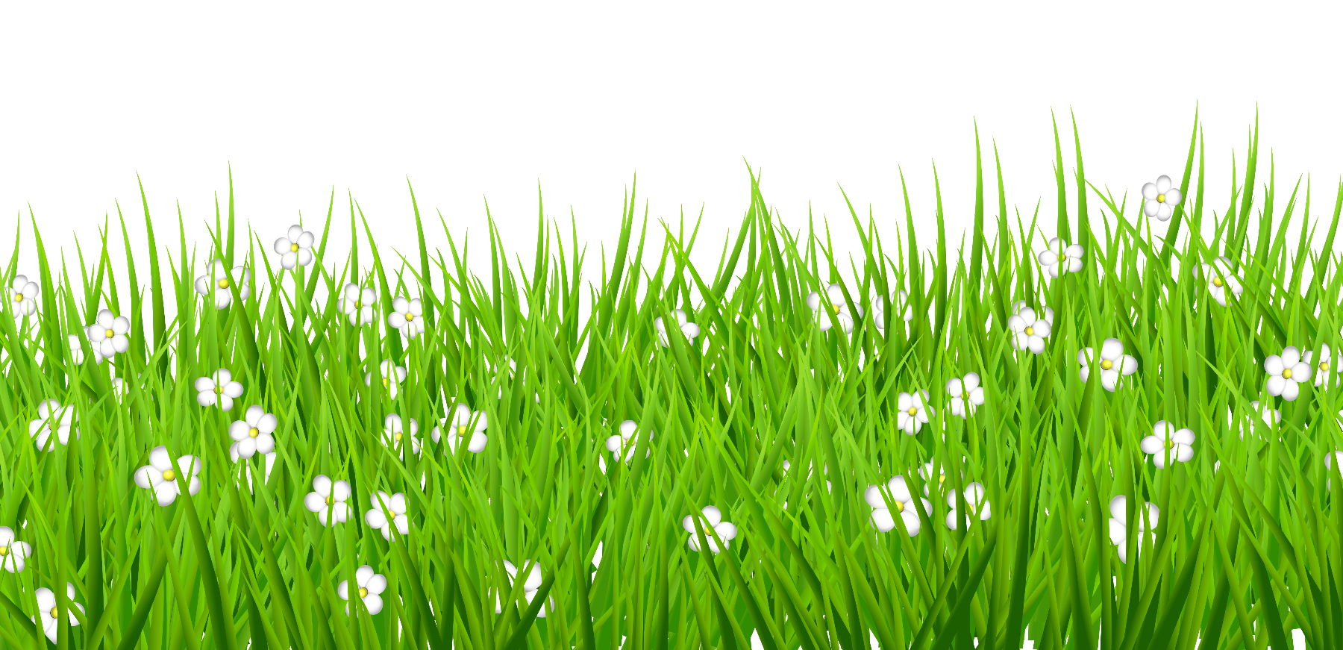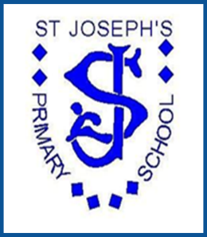

**Be the best that you can be**

***St Joseph’s Primary School***

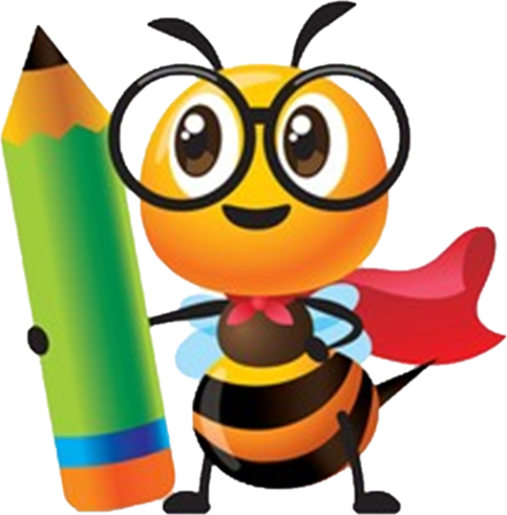

**English**

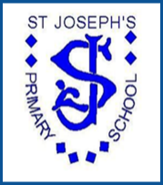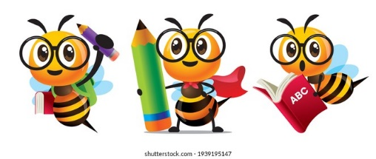

English at St Joseph’s

**Intent**

At St Joseph’s RC Primary School our curriculum intends to give children in our care the opportunity to’ be the best that they can be’ ensuring they have fantastic memorable visits/experiences both in and out of the classroom. We want our children to develop a love of learning which enhances their knowledge and skills but also develop a lifelong curiosity for English. We aim to do this in a learning environment where all feel welcome, safe and secure so that they can live life to the full.

In English we intend that our pupils will:

* We aim for children to love reading and value reading.
* read, write, spell and speak at age-appropriate levels following age-related expectations.
* be exposed to a variety of literature, genres and audiences.
* write for a variety of purposes and audiences; clearly, accurately and coherently, adapting their language and style as required.
* be confident when writing and read fluently and with good understanding.
* develop an understanding of grammar and punctuation and acquire a wide vocabulary and use these appropriately.
* develop a love of reading for pleasure, as well as for information, by reading widely and often.
* acquire strategies to enable them to become independent learners in English (spelling rules and patterns and how to tackle unfamiliar words when reading).
* enter into discussion and present their ideas to each other by talking, being able to elaborate and explain themselves clearly, make presentations and participate in debates.
* take pride in their writing and present their work to a high standard.

**Implementation**

All pupils have daily English lessons each week. In addition, in EYFS and Key Stage 1 pupils have daily phonics lessons using the Read, Write, Inc scheme of work. The quality of teaching and learning in phonics is monitored every half term through observations, analysis of data and regular meetings with staff delivering the sessions to arrange groups and levels.

We create a positive culture where reading and writing are both are promoted, enjoyed and considered ‘a pleasure’ for all pupils.

The teaching of spelling is consistent across Year groups 1-6 as we use the Rising Stars spelling scheme which includes spelling homework and weekly assessments.

Reading

Guided reading lessons take place 4 times a week and include whole class reading with a focus on one of the domain skills, (using Complete Comprehension) as well as opportunities for independent comprehensions and guided reading sessions in small groups. All pupils to take home an Oxford Reading Tree book and library book every day and their reading records are signed by parents/carers. We strongly encouraged our pupils to read for pleasure and to use the class libraries. Pupils read each week/daily in school with an adult. The ECHO technique is used to develop pupils’ fluency and confidence in reading aloud. Teachers read to children on a daily basis.

Our children need to develop their vocabulary as many have English as a second language. As a result, all classrooms have vocabulary displayed to support learning in all curriculum areas. Teachers are encouraged to develop pupils’ vocabulary by embedding throughout daily lessons. In addition, there are vocabulary mats, thesauruses and dictionaries that are easily accessible and available for pupils to use. We also have the school library available everyday.

Writing

We use Cracking Writing from Year 1 as the basis for teaching writing. We plan and teach units of work that cover a variety of genres and literacy styles and use the following teaching sequence:

1. Read and respond to a model reading text
2. Analyse the text content
3. Analyse the text structure
4. Plan the writing
5. Independent writing
6. Improve, edit, review and share the writing

Each unit of work includes a guided write and independent write using success criteria. When children’s writing has been marked. They are asked to respond to the teachers ‘Can you questions’ in green pen to show that they understand how to edit and improve their writing. Marking provides positive support and directs the pupil to complete the ‘Can you…’ to improve their writing and respond to feedback.

Teachers and teaching assistants support ALL pupils on a regular basis; providing intervention, support and challenge, which groups and individuals require to advance their learning in all areas of English.

Grammar and punctuation are taught within writing units and year 6 have an extra standalone lesson. **Letter Join** to be used and staff to model in weekly lessons.

We also encourage and promote the enjoyment of reading though regular events such as World Book Day. We also provide parents with support through meetings, stay and play and resources on our website and phonics specific workshops.

Assessment in reading and writing is formative in that it is used as part of the on-going teaching process to inform planning and identify pupils’ next steps. Teachers moderate pupils’ writing in school to ensure accurate assessments are made. Teachers track pupils’ progress in Years 1-6 each term in Reading, Writing, Spelling, Punctuation and Grammar using the Rising Stars tests. This tracking informs planning and any interventions which may be needed.

Senior leaders and the subject leader conduct learning walks, lesson observations, pupil interviews and book monitoring throughput the year. These inform future areas for improvement and the impact of new initiatives.

The subject leader monitors books, lessons and data to address areas for development and improvement,

**Impact**

Phonics majority expectations by end of Year 1, develop comprehension skills in Year 2 and to be fluent readers for KS2.

Our pupils make very good progress in reading and writing and the majority are ready for Key Stage 3 by the end of Year 6.

Pupils enjoy reading daily, for information and for enjoyment. They discuss books with excitement and interest. Pupils know and use different strategies that are linked to the reading domains to answer comprehension questions successfully in daily reading and termly assessments.

Pupils enjoy writing and use the different genres and styles. There can write for different purposes and audiences. Pupils are proud of their writing and are pleased that their writing is displayed and shared with their class. Pupils’ presentation is of a high standard through following the school handwriting scheme.

Pupils’ good progress can be seen in grammar and punctuation throughout the school in writing books, other subjects and termly assessments.

Pupils build a wide vocabulary and many are adventurous with vocabulary choices in their speaking and writing, which is taught in all subjects.

Pupil progress meeting with Headteacher and teachers are held each term to ensure that different groups and individuals are making good progress and to inform interventions which are organised to support pupils whose progress is not good and they are not keeping up with their peers and achieving age related expectations.

Standards being met at the end of EYFS, Phonic Screening Check, KS1 and KS2 are broadly in line with and often above local and national averages. Each year data is analysed and any areas for improvement identified and addresses.