**Be the best that you can be**

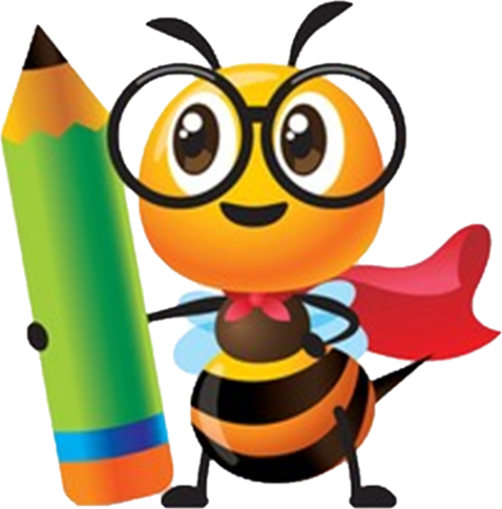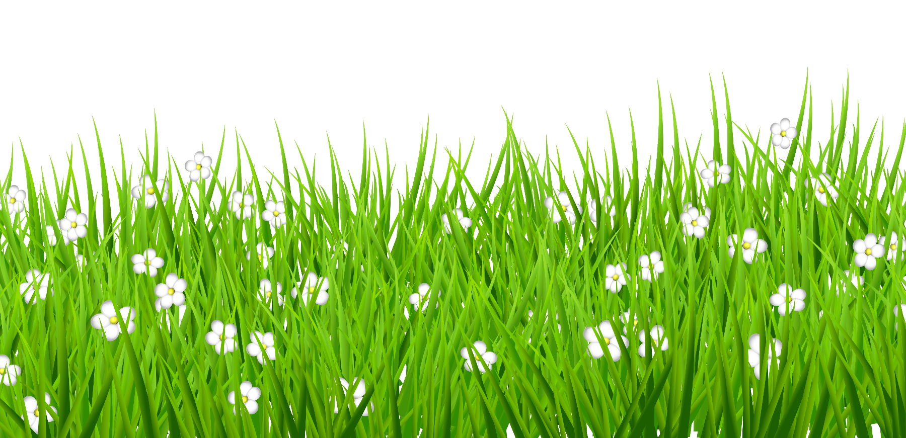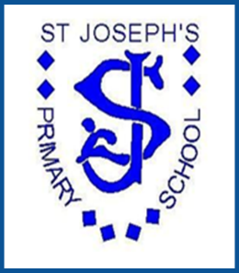

**History**

***St Joseph’s Primary School***

***St Joseph’s Primary School***

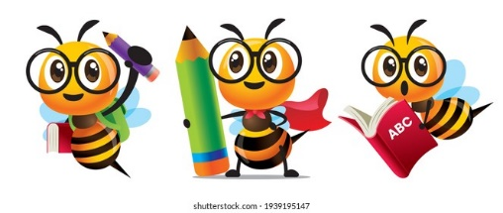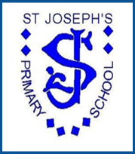

**Context**

History at St Joseph’s

St. Joseph’s R.C Primary is situated in the top 10% of the most deprived areas in England and the number of children that receive Pupil Premium funding is 10% above the national average. With this in mind, our history curriculum has been designed to help tackle the effects of deprivation, whilst equipping all children with the knowledge and cultural capital they need to succeed in life.

**Purpose of Study/ Rationale**

**(See page 188 and 189 in the National Curriculum)**

We intend to provide an ambitious History curriculum which inspires children to show curiosity about the past by asking perceptive questions, thinking critically, assessing evidence and developing clear perspectives and judgements about the past. We endeavour to open their eyes to the best that has been thought and said and help them to engender an appreciation of human creativity and historical achievements.

Beginning in **Early Years,** children begin to acknowledge that as they grow they are able to do more for themselves. They show an understanding of themselves and the world around them. The children become increasingly aware of the changes in routine during different times of the day and seasons in the year and that these changes impact what they can do.

Within **Key Stage 1,** our History curriculum helps our pupils to understand the lives of significant people from the past, as well as events beyond living memory and the process of change and similarities and differences.

We believe that in **Key Stage 2** all children will know and understand history as a chronological narrative; from the earliest times to the present day. Children will continue to understand the process of change, the diversity of societies, relationships between different groups and the cause and effect.

Pupils will become aware of how Britain has influenced and been influenced by the wider world. The History curriculum is designed to develop their historical enquiry, knowledge, understanding and communication. This is progressive from Early Years to Year 6, ensuring children gain an increasingly mature and informed historical perspective on their world.

|  |  |  |  |  |  |  |
| --- | --- | --- | --- | --- | --- | --- |
|  | Autumn | | Spring | | Summer | |
|  | **Autumn 1** | **Autumn 2** | **Spring 1** | **Spring 2** | **Summer 1** | **Summer 2** |
| **Nursery** | **Magical Me**  I understand who is older and younger than me in my family | **Animal Magic**  I can understand the terms: today, now, before | **Transport**  I can recognise older and newer in buildings, cars, buses and my environment |  | **How Does Your Garden Grow?**  I can ask questions about what my parents/ grandparents did when they were young | **Toys**  **Let’s Play!**  I am beginning to make sense of my own life-story and family history |
| **Reception** |  | **Dark days, Cosy nights!**  I can talk about familiar situations from the past, looking at photos | **People Who Help Us**  I can talk about the roles people have in the community | **Dragon Tales**  I can tell you about traditional stories from the past | **Mini Beasts**  I can talk about some similarities and differences between things in the past and now | **Animals of the World**  I understand the past through characters and events in books and story telling |
| **Year 1** |  | **Toys Old and New**  How have toys changed from the past? |  | **Moon Landing**  Why was the first ever moon landing important? |  | **L S Lowry**  How has Lowry helped us learn about the past? |
| **Year 2** |  | **The Great Fire of London**  What happened on 2nd September 1666 and how did it change London? |  | **Beatrix Potter**  How has Beatrix Potter helped us understand the past? |  | **Florence Nightingale**  How have Florence Nightingale and Mary Seacole contributed to how we live our lives today? |

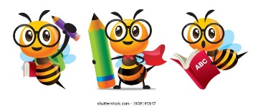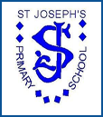

**History Curriculum – EYFS & KS1**



**History Curriculum – KS2**

|  |  |  |  |  |  |  |
| --- | --- | --- | --- | --- | --- | --- |
|  | Autumn | | Spring | | Summer | |
|  | **Autumn 1** | **Autumn 2** | **Spring 1** | **Spring 2** | **Summer 1** | **Summer 2** |
| **Year 3** |  | **Stone Age**  How do we know about pre-historic Britain? How did pre-historic Britain change from the Stone Age to the Iron Age? Why did pre-historic Britain end? |  | **Ancient Greeks**  How have the Ancient Greeks influenced our lives today? How has life changed since the Ancient Greek period? How did the Greeks help us understand the world? |  | **Ancient Greeks**  How have the Ancient Greeks influenced our lives today? How has life changed since the Ancient Greek period? How did the Greeks help us understand the world? |
| **Year 4** | **Ancient Egyptians**  Why was the finding of Tutankhamun so important and what did it tell us about the Egyptians? What influence did the Egyptians have on society today? |  |  | **Romans**  How did the Romans impact on Modern Britain? What influence did the Romans have on Britain? Why were the Romans such an important part of British history? |  | **Romans**  How did the Romans impact on Modern Britain? What influence did the Romans have on Britain? Why were the Romans such an important part of British history? |
| **Year 5** |  | **Anglo-Saxons**  How does the Sutton Hoo burial site help us find out about Anglo-Saxon Britain? What changed in Britain after the Romans? |  | **Vikings**  Did the Vikings have an impact on Britain as much as the Anglo-Saxons? What impact did the Vikings have on Britain? |  | **Vikings**  Did the Vikings have an impact on Britain as much as the Anglo-Saxons? What impact did the Vikings have on Britain? |
| **Year 6** |  | **Impact of war** |  | **Victorians**  How did the Victorians impact the way in which we live our lives today? |  | **Victorians**  How did the Victorians impact the way in which we live our lives today? |

**Implementation**

It is crucial that children understand the methods of historical enquiry; including how evidence is used to make historical claims valid. Therefore, at St Joseph’s, we begin every lesson with a historical enquiry or key question. Following this, the pupils then develop their knowledge, from the earliest times to the present day.. They gain knowledge of how people’s lives have shaped this nation. In KS2 children learn how Britain has influenced and been influenced by the wider world including ancient civilisations. Children are then able to begin to develop their understanding of historical concepts such as; continuity and change, cause and consequence, similarities/differences and significance. Pupils then communicate their growing knowledge into different contexts, by understanding connections, contrasts and trends over time. We want young people to gain an increasingly mature and informed historical perspective of their world and to do this is it is crucial that all four historical strands are embedded within our history curriculum.

At St Joseph’s we start each lesson with a line of historical enquiry that will create intrigue and the learning grows over a sequence of lessons

*Taken from the Historical Association - Jamie Byrom*

**Historical Enquiry**

**Communication**

Always plan for children to communicate what they have learnt. Children should use their understanding of the history learnt to help them decide how to organise and present their ideas most effectively

What new knowledge will the children learn for the time period in question? Ensure knowledge from previous learning strengthens new learning

These elements are linked to the line of enquiry and are intended to develop the children’s understanding

**Understanding of:**

* Evidence
* Interruptions
* Cause
* Change
* Similarity/Difference
* Significance

**Knowledge of:**

* People, events, situations and developments
* Chronology and characteristics features
* Historical terms

**How is the Subject Content from the National Curriculum covered?**

(see page 189 of the National Curriculum)

At St Joseph’s, the Key Stage 1 curriculum ensures pupils develop awareness of the past and how things changes over time (Toys; Old and New). Pupils know about historical figures and events that they study and can identify similarities and differences between ways of life in different time periods.

They are taught about the lives of significant individuals in the past who have contributed to national and international achievements (Beatrix Potter and Florence Nightingale). Furthermore, pupils are taught about events beyond living memory that are significant nationally and globally (Great Fire of London and the Moon Landing). Pupils also study significant historical places in their own locality (Salford and L S Lowry).

Our Key Stage 2, curriculum has been divided into British, local and world history. The British history is taught to develop a chronologically secure knowledge and understanding to show clear progression and understanding of how Britain has changed throughout these periods. It enables children to clearly see the cause and effect.

Children are to become aware of connections, contrasts and trends over time. Each topic in British history will be split into 5 aspects. Each aspect focuses on gaining historical perspective by placing their growing knowledge into different contexts and understanding the connections between society, economic, religious, military, and civilisation in history. (Stone Age, Romans, Vikings Anglo-Saxons)

In addition to British history, the Key Stage 2 curriculum will also explore the achievements of early civilisation through the study of Ancients Egypt (Egyptians), the study of Greek life and their influences (Greeks), the study of a non-European society that provides contrast with British history (Maya), and a local history study that extends pupils’ chronological knowledge beyond 1066 (The Industrial Revolution).



Subject Content

National Curriculum Coverage

**Key Stage 1**

|  |  |  |
| --- | --- | --- |
| **Year Group** | **Topic** | **National Curriculum Strand** |
| **Year 1** | L S Lowry | -the lives of significant individuals in the past who have contributed to national and international achievements. Some should be used to compare aspects of life in different periods [for example, Elizabeth I and Queen Victoria, Christopher Columbus and Neil Armstrong, William Caxton and Tim Berners-Lee, Pieter Bruegel the Elder and LS Lowry, Rosa Parks and Emily Davison, Mary Seacole and/or Florence Nightingale and Edith Cavell]  -significant historical events, people and places in their own locality. |
| Toys Old and New | -changes within living memory. Where appropriate, these should be used to reveal aspects of change in national life |
| The Moon Landing | -changes within living memory. Where appropriate, these should be used to reveal aspects of change in national life |
| **Year 2** | The Great Fire of London | -events beyond living memory that are significant nationally or globally [for example, the Great Fire of London, the first aeroplane flight or events commemorated through festivals or anniversaries] |
| Florence Nightingale and Mary Seacole | -the lives of significant individuals in the past who have contributed to national and international achievements. Some should be used to compare aspects of life in different periods [for example, Elizabeth I and Queen Victoria, Christopher Columbus and Neil Armstrong, William Caxton and Tim Berners-Lee, Pieter Bruegel the Elder and LS Lowry, Rosa Parks and Emily Davison, Mary Seacole and/or Florence Nightingale and Edith Cavell] |
| Beatrix Potter | -the lives of significant individuals in the past who have contributed to national and international achievements. Some should be used to compare aspects of life in different periods [for example, Elizabeth I and Queen Victoria, Christopher Columbus and Neil Armstrong, William Caxton and Tim Berners-Lee, Pieter Bruegel the Elder and LS Lowry, Rosa Parks and Emily Davison, Mary Seacole and/or Florence Nightingale and Edith Cavell] |

**Key Stage 2**

|  |  |  |
| --- | --- | --- |
| **Year Group** | **Topic** | **National Curriculum Strand** |
| **Year 3** | Stone Age | -changes in Britain from the Stone Age to the Iron Age |
| Ancient Greeks | -Ancient Greece – a study of Greek life and achievements and their influence on the western world |
| **Year 4** | Ancient Egyptians | -the achievements of the earliest civilizations – an overview of where and when the first civilizations appeared and a depth study of one of the following: Ancient Sumer; The Indus Valley; Ancient Egypt; The Shang Dynasty of Ancient China |
| Romans | -the Roman Empire and its impact on Britain |
| **Year 5** | Anglo-Saxons | - Britain’s settlement by Anglo-Saxons and Scots |
| Vikings | - the Viking and Anglo-Saxon struggle for the Kingdom of England to the time of Edward the Confessor  -a local history study  -a study of an aspect or theme in British history that extends pupils’ chronological knowledge beyond 1066 |
| **Year 6** | The impact of war | -a local history study |
| Victorians | -a study of an aspect or theme in British history that extends pupils’ chronological knowledge beyond 1066 |

**National Curriculum Aims**

(see page 188 of the National Curriculum)

At St Joseph’s, our curriculum ensures that pupils in Key Stage 1:

* Understands the methods of historical enquiry, including how evidence is used rigorously to make historical claims, and discern how and why contrasting arguments and interpretations of the past have been constructed (L S Lowry, Moon Landing, Toys; Old and New, The Great Fire of London, Beatrix Potter, Florence Nightingale and Mary Seacole)

In Key Stage 2 our curriculum ensures pupils:

* Know and understand the history of these islands as a coherent, chronological narrative, from the earliest times to the present day: how people’s lives have shaped this nation and how Britain has influenced and been influenced by the wider world. (Stone Age to Iron Age, Romans, Anglo-Saxons, Vikings and Industrial Revolution)
* Gain and deploy a historically grounded understanding of abstract terms such as ‘empire’, ‘civilisation’, ‘parliament’, and ‘peasantry’. (Stone Age to Iron Age, Romans, Anglo-Saxons, and Vikings)
* Understand historical concepts such as continuity and change, cause and consequence, similarity, difference and significance and use them to make connections, draw contrasts, analyse trends, frame historically-valid questions and create their own structured accounts, including written narratives and analyses. (Stone Age to Iron Age, Romans, Anglo-Saxons, Vikings and Industrial Revolution)
* Gain historical perspective by placing their growing knowledge into different contexts, understanding the connections between local, regional, national, and international history; between cultural, economic, military, political, religious and social history; and between short and long term timescales. (Stone Age to Iron Age, Romans, Anglo-Saxons, and Vikings)
* Know and understand significant aspects of the history of the wider world; the nature of ancient civilisations; the expansion and dissolution of empires; characteristic features of past non-European societies; achievements and follies of mankind. (Ancient Greeks, Ancient Egyptians and Maya)



**Units of Work – History Overview**

|  |  |  |  |  |  |  |
| --- | --- | --- | --- | --- | --- | --- |
|  | Autumn | | Spring | | Summer | |
|  | **Autumn 1** | **Autumn 2** | **Spring 1** | **Spring 2** | **Summer 1** | **Summer 2** |
| **Nursery** | **Magical Me**  I understand who is older and younger than me in my family | **Animal Magic**  I can understand the terms: today, now, before | **Transport**  I can recognise older and newer in buildings, cars, buses and my environment |  | **How Does Your Garden Grow?**  I can ask questions about what my parents/ grandparents did when they were young | **Toys**  **Let’s Play!**  I am beginning to make sense of my own life-story and family history |
| **Reception** |  | **Dark days, Cosy nights!**  I can talk about familiar situations from the past, looking at photos | **People Who Help Us**  I can talk about the roles people have in the community | **Dragon Tales**  I can tell you about traditional stories from the past | **Mini Beasts**  I can talk about some similarities and differences between things in the past and now | **Animals of the World**  I understand the past through characters and events in books and story telling |
| **Year 1** |  | **Toys Old and New**  How have toys changed from the past? |  | **Moon Landing**  Why was the first ever moon landing important? |  | **L S Lowry**  How has Lowry helped us learn about the past? |
| **Year 2** |  | **The Great Fire of London**  What happened on 2nd September 1666 and how did it change London? |  | **Beatrix Potter**  How has Beatrix Potter helped us understand the past? |  | **Florence Nightingale**  How have Florence Nightingale and Mary Seacole contributed to how we live our lives today? |
| **Year 3** |  | **Stone Age**  How did pre-historic Britain change from the Stone Age to the Iron Age? |  | **Ancient Greeks**  How have the Greeks influenced our lives today? |  | **Ancient Greeks**  How have the Greeks influenced our lives today? |
| **Year 4** |  | **Ancient Egyptians**  Why was the finding of Tutankhamun so important and what did it tell us about the Egyptians? |  | **Romans**  How did the Romans impact on Modern Britain? |  | **Romans**  How did the Romans impact on Modern Britain? |
| **Year 5** |  | **Anglo-Saxons**  How does the Sutton Hoo burial site help us find out about Anglo-Saxon Britain? |  | **Vikings**  Did the Vikings have an impact on Britain as much as the Anglo-Saxons? |  | **Vikings**  Did the Vikings have an impact on Britain as much as the Anglo-Saxons? |
| **Year 6** |  | **The Impact of War** |  | **Victorians**  How did the Victorians impact the way in which we live our lives today? |  | **Victorians**  How did the Victorians impact the way in which we live our lives today? |



**Bridging from EYFS into Year 1**

Beginning in **Early Years,** children begin to acknowledge that as they grow they are able to do more for themselves. They show an understanding of themselves and the world around them. The children become increasingly aware of the changes in routine during different times of the day and seasons in the year and that these changes impact what they can do.

Within **Key Stage 1,** our History curriculum helps our pupils to understand the lives of significant people from the past, as well as events beyond living memory and the process of change and similarities and differences.

We believe that in **Key Stage 2** all children will know and understand history as a chronological narrative; from the earliest times to the present day. Children will continue to understand the process of change, the diversity of societies, relationships between different groups and the cause and effect.

|  |  |  |  |
| --- | --- | --- | --- |
| **History Strands** | **End of Nursery** | **ELG**  **End of Reception** | **Year 1** |
| **Enquiry**  **Image result for magnifying glass cartoon** | * I can ask questions about what my parents/ grandparents did when they were young.   *(How does your garden grow?)*   * I am beginning to make sense of my own life-story and family’s history   *(Toys! Let’s Play!)* | * I can talk about some similarities and differences between things in the past and now.   *(Mini beasts)* | * Ask and answer questions.   *(For example, ask questions about why toys have changed over time)*   * Identify different ways in which the past is represented.   *(For example, question how we know about the Moon Landing and explore different sources)* |
| **Image result for brain cartoonKnowledge** | * I can recognise older and newer buildings, cars, buses and my immediate environment.   *(Transport – How will you get there?)* | * I can talk about familiar situations from the past, looking at photos of the school and locality.   (*Darks days, Cosy nights!)* | * Recount the life of someone famous from Britain who lived in the past.   *(For example, explore the life of L S Lowry and identify key significant events and understand why they were significant)* |
| **Understanding**  **Image result for lightbulb cartoon** | * I understand who is older and younger than me in my family   *(Magical Me!)* | * I understand the past through characters and events in books and storytelling.   *(Animals of the World)* | * I can answer questions using books and the Internet and understand what a source is.   *(For example, use books to learn about key events and people such as L S Lowry, the Moon Landing and Toys)* |
| **Image result for speech bubble cartoonCommunication** | * I understand the terms: today, now, before.   (*Animal Magic)* | * I can talk about the roles people have in my community.   *(People who Help Us)*   * I can tell you about traditional stories from the past.   (Dragon Tales) | * Using words and phrases like; old, new and a long time ago to explain how things changed. * *(For example, explain how the pupils know a toy is old or new by using key words and phrases)* |



**History Skills Progression – KS1**

|  |  |  |  |
| --- | --- | --- | --- |
| **History Strands** | **Year 1** | **Year 2** | **Expectation at end of key stage** |
| **Enquiry**  **Image result for magnifying glass cartoon** | * Ask and answer questions.   *(For example, ask questions about why toys have changed over time)*   * Identify different ways in which the past is represented.   *(For example, question how we know about the Moon Landing and explore different sources)* | * Use stories and other sources to ask questions about the past.   *(For example, read a story about Florence Nightingale and then explore additional sources to show how she impacted on hospitals in history and ask questions to deepen understanding)* | * Ask and answer questions, choosing and using parts of stories and other sources to how that they know and understand key features of events. |
| **Image result for brain cartoonKnowledge** | * Recount the life of someone famous from Britain who lived in the past.   *(For example, explore the life of*  *L S Lowry and identify key significant events and understand why they were significant)* | * Know where people/ events fit into a chronological framework.   (*For example, place The Great Fire of London onto a timeline and understand when it happened, why it happened and what happened.)* | * Know where the people and events they study fit within a chronological framework and identify similarities and differences between ways of life in different periods. |
| **Understanding**  **Image result for lightbulb cartoon** | * I can answer questions using books and the Internet and understand what a source is.   *(For example, use books to learn about key events and people such as L S Lowry, the Moon Landing and Toys)* | * Research the life of a famous person from the past using different sources of evidence.   *(For example, find out about Florence Nightingale using different sources and see what is similar and different.)* | * Understand some ways in which we found out about the past and identify different ways in which it is represented. |
| **Image result for speech bubble cartoonCommunication** | * Using words and phrases like; old, new and a long time ago to explain how things changed.   *(For example, explain how the pupils know a toy is old or new by using key words and phrases)* | * Using words and phrases like; before, after, past, present, then and now to explain how things changed.   *(For example, explore the life of Beatrix Potter and use key words and phrases to show how life has changed and how it has stayed the same.)* | * Develop an awareness of the past, using common words and phrases relating to the passing of time. * Use a wide vocabulary of everyday historical terms. |



**History Skills Progression – KS2**

|  |  |  |  |  |  |
| --- | --- | --- | --- | --- | --- |
| **History Strands** | **Year 3** | **Year 4** | **Year 5** | **Year 6** | **Expectation at end of key stage** |
| **Image result for magnifying glass cartoonEnquiry** | * Question how knowledge from the past is constructed from a range of sources.   *(For example, look carefully at different sources from the Ancient Greeks and ask questions to help conclude their findings.)* | * Question and evaluate the validity of relevant historical sources.   *(For example, use a number of different sources to help identify how the Romans lived and use the sources to ask questions.)* | * Test out a hypothesis to answer questions about the past using sources. * To use sources to deduce a hypothesis.   *(For example, ask questions about how the Anglo-Saxons came to Britain based on a number of different sources/ theories.)* | * Question that different versions of the past may exist and give reasons for this. * Describe a key event from Britain’s past and use sources to infer causation and consequence. | * Regularly address and sometimes devise historically valid questions about change, cause, similarity and difference, and significance. |
| **Knowledge**  **Image result for brain cartoon(British History)** | * Develop understanding of the chronology of British History.   *(For example, understand how the way of life changed from the Stone Age to the Iron Age.)* | * Note differences, similarities and developments between different time periods in British History   *(For example, refer to knowledge of the Stone Age and Iron Age and how the way of life developed for the Romans when they invaded Britain)* | * Note differences, similarities and developments between different time periods in British History with greater sophistication.   *(For example, identify how religious beliefs changed from the Romans to the Anglo-Saxons)* | * Note differences, similarities and developments between different time periods in British History with greater sophistication. | * Construct informed responses that involve thoughtful selection and organization of relevant historical information. |
| **Knowledge**  **Image result for brain cartoon(Ancient and Local History)** | * Develop an awareness of the chronology of ancient history.   *(For example, understand the time difference between the lives of the Ancient Greeks and the pre-historic period)* | * Note differences and similarities between two periods of ancient history   *(For example, identify differences and similarities between the Ancient Egyptians and the Ancient Greeks)* | * Identify how our locality had changed over time. | * Note similarities and differences between two or more periods of ancient history. | * Construct informed responses that involve thoughtful selection and organization of relevant historical information. |
| **Image result for lightbulb cartoonUnderstanding** | * Use research skills to find answers to specific historical questions. * Research to find similarities and differences between the Stone Age, Bronze Age and Iron Age.   *(For example, use a variety of sources to explore the changes that occurred between the Stone Age and the Iron Age)* | * Research two versions of an event and explain how they differ.   *(For example, research how Boudicca rebelled against the Romans and discuss how there are different versions of the event)* | * Refer back to previous historical knowledge to understand how Britain stayed the same and changed.   *(Refer back to the Romans and compare how Britain has changed and stayed the same from when the Anglo-Saxons came into power)* | * Identify causation, consequence, contrasts and trends over time | * Understand how our knowledge of the past is constructed from a range of sources. |
| **Image result for speech bubble cartoonCommunication** | * Describe events from the past using dates when things happened.   *(For example, use a timeline to identify the length of the Stone Age to the Iron Age in British History)* | * Communicate how an event from the past has influenced our lives today.   *(For example, explore how big of an impact the Romans had on our lives today and communicate these findings)* | * Communicate how and why our locality and Britain has changed over time. | * Communicate developments, causation and change throughout British History up to the Vikings through the 6 strands. | * Note connections, contrasts and trends over time and develop appropriate use of historical terms. |