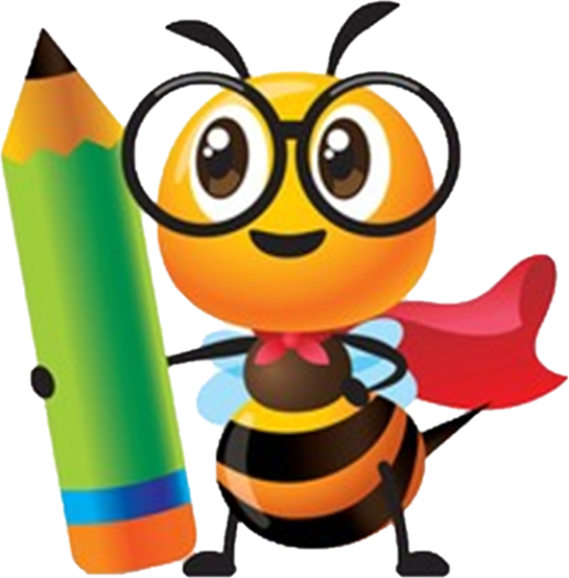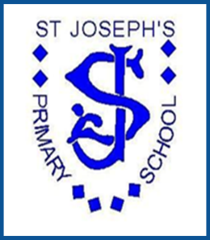

**Be the best that you can be**

***St Joseph’s Primary School***

**Religious**

**Education**

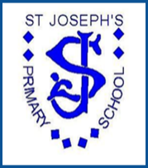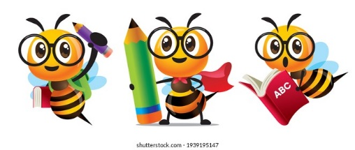

R.E. at St Joseph’s

**St Joseph’s Primary School – Mission statement**

*St Joseph’s is proud to be a Catholic School.  Everything we aim to achieve will be based on the teaching and practice of the Catholic Church.  Through this Catholic ethos we strive to develop in the school community respect and care for everyone.*

*In partnership between staff, children, parents, parish and the wider community we want to give every child the opportunity to fulfil their potential by developing their own gifts and talents.  We aim to create a successful learning environment where all feel welcome, safe and part of the community.  We wish through the whole life of our school for every child to realise their own worth and value.*

**Intent**

At St Joseph’s we will:-

We are a proud Catholic school, committed to teach and practice everything based on the teaching of the Catholic faith. We value each person as an individual, in the image and likeness of God. We are loved by Him, therefore special and unique in His eyes. At St Joseph’s, each person is respected, and we promote each child’s capacity for wonder, awe, reverence and spirituality.

Our Religious Education curriculum is based on the *Catechism of the Catholic Church* and the *Religious Education Curriculum Directory for Catholic Schools*, which leads children to grow and learn in their faith, to respond to its invitation with growing faith and generosity. Children are provided with a wide range of experiences for Prayer and Worship in church, their classrooms and the school chapel. They also experience Catholic traditions and celebrations in school. Children learn to be respectful and understanding of people from other faiths and traditions. Through Religious Education, our children learn about their unique place and responsibility within their home, school and community.

* Our principal aim is that children leave St Joseph’s School with a wide range of happy and rich memories in RE formed through interesting and exciting experiences driven through an engaging and comprehensive curriculum which is the basis of knowledge and understanding of the Catholic faith, enabling them to develop a living and personal faith in Jesus Christ, to know and love God.
* RE is the foundation of the entire education process and permeates all areas of the curriculum and school life.
* Children will meet the Diocesan Standards for Primary Religious Education, which will be taught by highly qualified staff who will engage children’s intellect, heart and imagination, inspiring enthusiasm and interest in RE.
* Children will develop an awareness of God’s presence in their lives and the lives of others, developing the spiritual life of each child through prayer and reflection.
* Children will develop a well-formed conscience allowing them to make sound moral judgements in the light of personal commitment to God.
* Parents, family members, friends of any faith and parishioners will be invited to attend Masses, Exposition Days and religious celebrations within the school and pupils will participate in parish activities outside of school time, promoting good links with St. Joseph’s church.
* Children, and their parents, will develop the knowledge, understanding and appreciation of the Sacraments, preparing them with the parish and school.
* RE will play a central role in the school’s work on spiritual, moral, vocational, social and cultural education.
* Children will be prepared for life in a multi faith society by fostering respect for and understanding of rich cultural diversity.
* RE is a core subject of the curriculum and all children will study RE for 2hrs 30 mins per week, including Prayer and Worship time, in class and in the school chapel.
* Children will attend Mass in St. Joseph’s church on main feast days of the Church and with their class.
* Key stage 2 children will take part in Lent and Advent retreats, with the opportunity to go to confession
* year 6 children will actively take part as Mini-Vinnies, in the school and local community, including inviting elderly people at Christmas and interacting with them
* Children will know the social doctrine of the Catholic Church through actively participating in school CARITAS days, twice a term.
* Each class will take part and present assemblies to the school as they learn about Jesus’ teachings, lives of saints and the different events in the Church’s liturgical calendar
* Opportunities will exist for children of all ages to experience learning beyond the classroom.  This will allow them to enrich their knowledge by, for example, visiting different places of worship, local parish church, Salford Catholic Cathedral, including other faiths
* Children will develop a deep understanding of the RE unit they are studying. They will increasingly use their prior knowledge to develop into religiously literate young people.
* In RE, children will develop the skills to make links and connections, engage and respond, analyse and evaluate using sources of evidence.
* Skills in other subjects will be applied in RE and children will be encouraged to investigate the faith with enthusiasm and rigour.
* Children will develop a real understanding and appreciation of the world learning from a range of sources and experiences.

**Implementation**

* The curriculum hours in RE are non-negotiable and will be followed by all staff in the school.  Fixed timetables will be set before the academic year and monitored by the Senior Leadership Team of the school.
* RE specialists from our partner secondary school, St Peter’s, are and will continue to be integral to the planning process.  This will aid transition to Key Stage 3.
* The Subject Leader for RE will meet the Senior Leadership Team on a monthly basis to evaluate provision in order to ensure that teaching and learning in RE is outstanding.  Where necessary, staff will receive coaching and training in RE.
* The Subject Leader for RE will attend termly CPD with Salford Diocese and feedback to staff in staff meetings, resources, assessments to fine tune or implement or agree as a team whole school events, such as launching the Year of the Word.
* Carefully designed schemes of learning in RE ensure consistency and progress of all learners. We follow the agreed syllabus ‘The Way, the Truth and the life’.
* Each year group will study a number of units over the year.  The units are developmental, building on previous knowledge and experience and taking into account of the children’s age and understanding.
* The topics covered by each year group are as detailed on the curriculum overview.
* The RE curriculum will include participation in fundraising for charities such as the St. Joseph’s Penny and CAFOD.
* RE is taught individually but plays a central role in all areas of school life.
* Success criteria in every RE lesson are set in order to guide children to achieve their potential. This ensures work is demanding and matches the aims of the curriculum.
* High quality teaching responds to the needs of children.  Spiral learning is a key focus of all formative and summative assessment with teachers actively marking work in lessons in order to identify misconceptions early.
* Children will be highly engaged in RE lessons through the use of a variety of sources such as religious stories, scripture, religious artwork, songs, drama, music and religious signs and symbols.
* The life and work of key figures in the History of the people of God will be studied for example, lives of the saints.
* Approaches will include whole class teaching, group activities and individual work. Children will have opportunities to work individually as well as cooperatively and collaboratively, developing their own knowledge and expertise as well as sharing experiences with others.
* High quality input from experts and educational resources complement the delivery of specialist learning admirably. The idea of vocation will be developed in all year groups.
* Pupils will participate in Mass, feast days, Holy days. Collective worship which will involve children involved in planning, their prayers, religious actions and worship including the celebration of the sacraments. Children attend Exposition of the Blessed Sacrament in the parish church during their class’ holy week and write a summary of their learning, for the parish newsletter.
* Reception children perform a Nativity play each Christmas for the school, parents, friends, parishioners and local community
* year 4 re-enact the Easter story for the school, parents, friends, parishioners and local community
* The use of visits and visitors in school will enhance the RE curriculum.

**Impact**

* Children are happy learners within RE.  They experience a wide-ranging number of learning challenges in RE and know appropriate responses to them.
* Through RE, children deepen their appreciation of their faith and fulfil their God-given talents
* Visits within RE have enriched the lives of the children and they are able to discuss how the experience impacted their knowledge and understanding.
* Children of all abilities and backgrounds achieve well in RE, reflected in outstanding progress that reveals a clear learning journey.  Children talk enthusiastically about their learning in RE and are eager to further their learning in the next stages of their education.
* Children learn from each other’s religious teaching and experience at home, and it is recognised in class and throughout the school
* There is a proven track record of success in assessments that reflects the impact of deep learning.
* Clear outcomes focus and guide all RE development plans and drive improvement.
* Fundamental British Values are evident in RE and children understand how RE can celebrate difference.
* Children will understand the Catholic teaching which will be focussed on each half term and how these relate to their personal life and to British Values
* The children will grow to know and love God, develop their moral and spiritual nature and deepen their faith.
* Children will live their faith in an active and positive way, always aware of the presence and love of Christ guiding them.
* Children will develop their relationship with God and become religiously literate.
* Through religious practice, the church’s traditions of prayer and worship will be upheld.
* Faith plays a central role in the lives of the children and the decisions they make.
* Children are confident, resilient and actively engaged in the wider society.
* The school environment will reflect and celebrate our Catholic faith.
* Children will be able to define, describe and discuss areas of RE. They will confidently use skills such as retelling, describing, comparing, giving reasons, explaining the meaning of biblical stories and considering the impact of beliefs.
* Children will be able to reflect and consider important questions about RE.
* Through wider reading in RE, children will know about a wide variety of Saints, how we can learn from their example, and historical religious events and figures. They will be able to make links between Jesus’ life and teaching and link it to their own lives, making links between different forms of Christian action, such as in rituals and charitable acts.

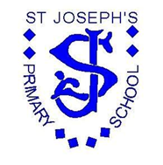

Religious Education

Progression Map and End Points

|  |  |  |
| --- | --- | --- |
|  |  |  |

[Type the company name]

**St Joseph’s RC Primary School**

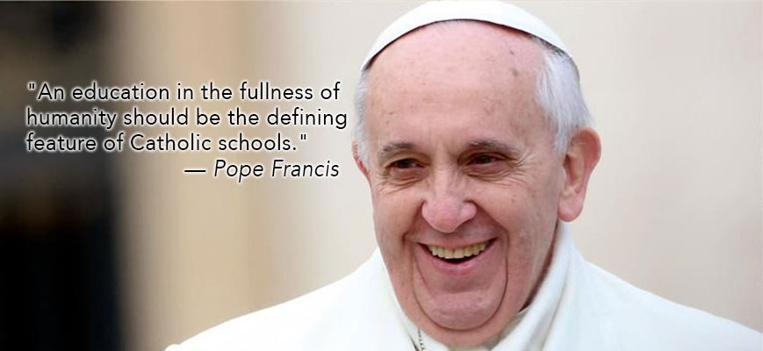

|  |  |  |  |  |
| --- | --- | --- | --- | --- |
| **St Joseph’s RC Primary School**  **RE Curriculum Progression** | | | | |
|  | **End of EYFS** | **End of KS1** | **End of Lower KS2** | **End of Upper KS2** |
| **Know about and understand**  *A1. Describe, explain and analyse beliefs, and practices, recognising the diversity which exists within and between communities;* | * Explore some different beliefs and practices, including festivals e.g. Christmas, Diwali to begin to find out about the meanings behind them | * Recall and name some different beliefs and practices, including festivals, worship, ritual and ways of life, in order to find about the meanings behind them; | * Describe and make growing connections between different features of the religions and world views they study, discovering aspects about celebrations, worship, pilgrimages and the rituals which mark important points in life in order to begin to reflect   on their ideas; | * Describe and make connections between different features of the religions and world views they study, discovering more about celebrations, worship, pilgrimages and the rituals which mark important points in life in order to reflect thoughtfully on their ideas; |
| *A2. Identify, investigate and respond to questions posed by, and responses offered by some of the sources of wisdom found in religions and world views;* | * Talk about some religious and moral stories and identify their own feelings in the stories they hear. Explore some sacred writings and sources of wisdom and the different communities they come from | * Retell and suggest meanings to some religious and moral stories, exploring and discussing sacred writings and sources of wisdom and recognising the communities from which they come | * Describe and understand growing links between stories and other aspects of the communities they are investigating, responding to a range of sources of wisdom and to beliefs and teachings that arise from them in different communities | * Describe and understand links between stories and other aspects of the communities they are investigating, responding thoughtfully to a range of sources of wisdom and to beliefs and teachings that arise from them in different communities |
| *A3. Appreciate and appraise the nature,*  *significance and impact of different ways of life and ways of expressing meaning;* | * Be introduced to some different symbols and actions which show a way of life for a specific community | * Recognise some different symbols and actions which express a community’s way of life, appreciating some similarities between communities | * Explore and describe a range of beliefs and symbols and actions so that they can begin to understand different ways of life and begin to determine ways of expressing meaning; | * Explore and describe a range of beliefs and symbols and actions so that they can understand different ways of life and ways of expressing meaning; |
| *Express and Communicate*  *B1. Explain reasonably their ideas about how*  *beliefs, practices and forms of expression influence individuals and communities;* | * Begin to ask their own questions about belonging to different communities and what that might mean to the individual | * Ask and respond to questions about what communities do, and why, so that they can identify what difference belonging to a community might make | * Observe and understand some examples of religions and world views so that they can begin to explain, with some reasons, their meanings and significance to individuals and communities; | * Observe and understand varied examples of religions and world views so that they can explain, with reasons, their meanings and significance to individuals and communities; |
| *B2. Express with increasing discernment their personal reflections and critical responses to questions and teachings about identity, diversity, meaning and value;* | * Engage in discussions on belonging and how they express their identity in an age appropriate way | * Observe and recount different ways of expressing identity and belonging, responding sensitively for themselves; | * Understand some of the challenges of commitment to a community of faith or belief, suggesting some reasons why belonging to a community may be valuable, both in the diverse communities being studied and in their own lives; | * Understand the challenges of commitment to a community of faith or belief, suggesting why belonging to a community may be valuable, both in the diverse communities being studied and in their own lives; |
| *B3. Appreciate and appraise varied dimensions of religion;* | * Develop understanding that there are similarities and differences between different religions and views | * Notice and begin to respond sensitively to some similarities between different religions and world views; | * Observe and consider some different dimensions of religion, so that they can begin to explore and show some understanding of similarities and differences between different religions and world views; | * Observe and consider different dimensions of religion, so that they can explore and show understanding of similarities and differences between different religions and world views; |
| ***Gain & deploy skills***  *C1. Find out about and investigate key concepts and questions of belonging, meaning, purpose and truth, responding creatively;* | * Discuss questions about belonging and explore their ideas through talk, play and creativity | * Explore questions about belonging, meaning and truth so that they can express their own ideas and opinions in response using words, music, art or poetry; | * Discuss and present their own and others’ views on challenging questions about belonging, meaning, purpose and truth, applying some ideas of their own thoughtfully in different forms including (e.g.) music, art and poetry; | * Discuss and present thoughtfully their own and others’ views on challenging questions about belonging, meaning, purpose and truth, applying ideas of their own thoughtfully in different forms including (e.g.) reasoning, music, art and poetry; |
| *C2. Enquire into what enables different*  *communities to live together respectfully for the wellbeing of all;* | * Explore how and talk about the idea of people who are different co-operating | * Find out about and respond with ideas to examples of co-operation between people who are different; | * Consider and apply some ideas about ways in which diverse communities can live together for the well-being of all, responding to ideas about community, values and respect; | * Consider and apply ideas about ways in which diverse communities can live together for the well-being of all, responding thoughtfully to ideas about community, values and respect; |
| *C3. Articulate beliefs, values and*  *commitments clearly in order to explain*  *reasons why they may be important in their own and other people’s lives* | * Develop their understanding of right and wrong and encourage listening and expressing an opinion | * Find out about questions of right and wrong and begin to express their ideas and opinions in response | * Discuss and apply their own and others’ ideas about simple ethical questions, including ideas about what is right and wrong and what is just and fair, and express their own ideas in response | * Discuss and apply their own and others’ ideas about ethical questions, including ideas about what is right and wrong and what is just and fair, and express their own ideas clearly in response |

|  |  |  |  |  |  |  |
| --- | --- | --- | --- | --- | --- | --- |
| **St Joseph’s RC Primary School**  **Religious Education Long Term Plan** | | | | | | |
|  | **Autumn 1** | **Autumn 2** | **Spring 1** | **Spring 2** | **Summer 1** | **Summer 2** |
| **Nursery** | God’s Wonderful World | My Family | The Holy Family | Sorrow and Joy | New Life | Our Church Family |
| **Reception** | God’s World | God’s Family | Getting to know Jesus | Joy and Sorrow | New Life | Our Church Family |
| **Year 1** | God’s Great Plan | Mary, Mother of God | Families and Celebrations | Following Jesus | The Resurrection | Miracles |
| **Year 2** | The Chosen People | Mysteries | The Good News | The Mass | Eastertide | The Church is Born |
| **Year 3** | The Christian Family | Mary, Mother of God | Sacrament of Reconciliation | Celebrating the Mass | Celebrating Easter and Pentecost | World Religion  Judaism |
| **Year 4** | The Bible | Trust in God | Jesus the Teacher | Jesus the Saviour | The Early Christians | World Religions  Hinduism |
| **Year 5** | Creation | God’s Covenants | Inspirational People | Reconciliation | Life in the Risen Jesus | World Religions  Islam |
| **Year 6** | The Kingdom of God | Justice | Exploring the Mass | Jesus the Messiah | The Transforming Spirit | World Religion  Buddhism |