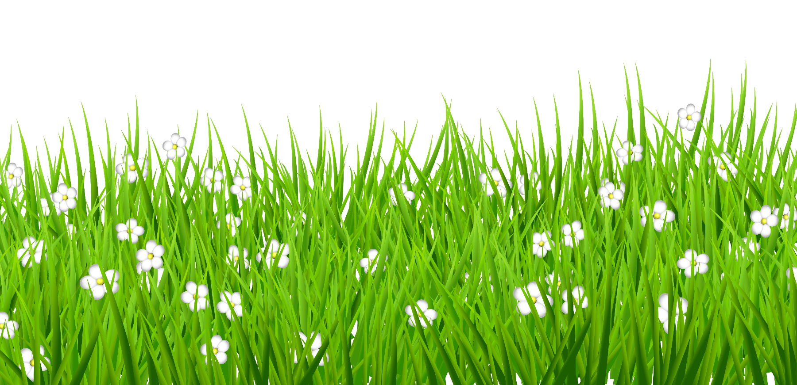

**Be the best that you can be**

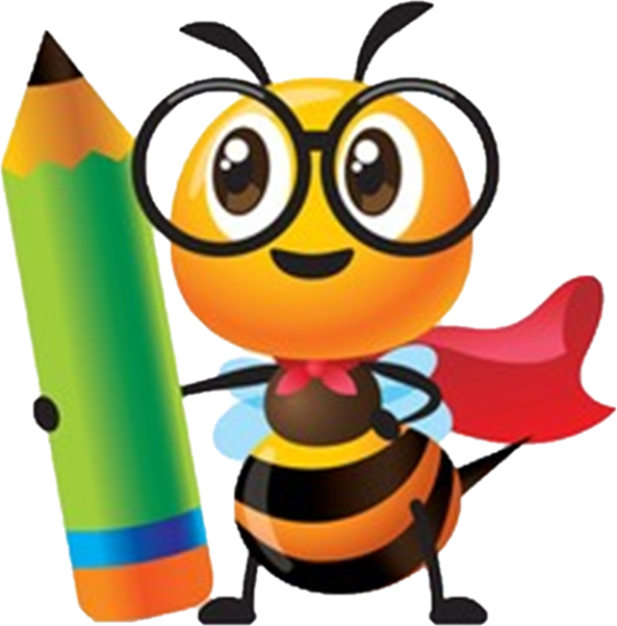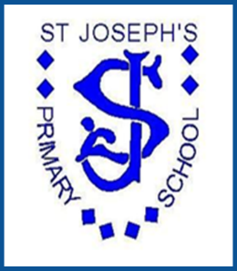

**Science**

***St Joseph’s Primary School***

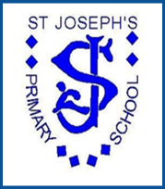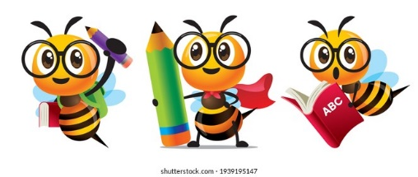

Science at St Joseph’s

**Context**

St. Joseph’s R.C Primary is situated in the top 10% of the most deprived areas in England and the number of children that receive Pupil Premium funding is 10% above the national average. This has been at the forefront when designing our Science Curriculum, aiming to tackle the effects of deprivation, to inspire our children to achieve to their full potential and to open their eyes to natural curiosity and wonder of the modern world we live in.

**Purpose of Study/Rationale**

(See page 144 and 146 in the National Curriculum)

We intend to provide a high-quality science education which establishes the foundations for understanding the world through the specific disciplines of biology, chemistry and physics. Science has changed our lives and is vital to the world’s future prosperity, and all pupils are taught essential aspects of the knowledge, methods, processes and uses of science.

Through building up a body of key foundational knowledge and concepts, pupils should be encouraged to recognise the power of rational explanation and develop a sense of excitement and curiosity about natural phenomena. They should be encouraged to understand how science can be used to explain what is occurring, predict how things will behave, and analyse causes.

**Rationale**

Our curriculum is designed to develop knowledge and skills that are progressive, enabling children to deepen their understanding of both the world and the ways in which things work.

‘Working scientifically’ specifies the understanding of the nature, processes and methods of science for each year group. It should not be taught as a separate strand and therefore ‘working scientifically’ is embedded within the content of biology, chemistry and physics, focusing on the key features of scientific enquiry, so that pupils learn to use a variety of approaches to answer relevant scientific questions.

These types of scientific enquiry include: observing over time; pattern seeking; identifying, classifying and grouping; comparative and fair testing (controlled investigations); and using research from secondary sources. Pupils should seek answers to questions through collecting, analysing and presenting data.

Beginning in the **Early Years**, children use their senses to explore and investigate the world around them to develop their knowledge and skills, using cause and effect. The EYFS curriculum is designed to develop the characteristics of effective learning. Children are encouraged to create and think critically. They have and develop their own ideas, make links between ideas and develop strategies for doing things. Children are encouraged to be active learners. They keep on trying if they encounter difficulties, and enjoy their achievements. Finally, children are encouraged to play and explore. They investigate and experience things, and ‘have a go’.

The principal focus of science teaching in **Key Stage 1** is to enable pupils to experience and observe phenomena, looking more closely at the natural and humanly-constructed world around them. They should be encouraged to be curious and ask questions about what they notice. They should be helped to develop their understanding of scientific ideas by using different types of scientific enquiry to answer their own questions, including observing changes over a period of time, noticing patterns, grouping and classifying things, carrying out simple comparative tests, and finding things out using secondary sources of information. They should begin to use simple scientific language to talk about what they have found out and communicate their ideas to a range of audiences in a variety of ways. Most of the learning about science should be done through the use of first-hand practical experiences, but our curriculum ensures use of appropriate secondary sources, such as books, photographs and videos.

The lower **key stage 2** science curriculum should enable pupils to broaden their scientific view of the world around them. Our curriculum enables this through exploring, talking about, testing and developing ideas about everyday phenomena and the relationships between living things and familiar environments, and by beginning to develop their ideas about functions, relationships and interactions. They should ask their own questions about what they observe and make some decisions about which types of scientific enquiry are likely to be the best ways of answering them, including observing changes over time, noticing patterns, grouping and classifying things, carrying out simple comparative and fair tests and finding things out using secondary sources of information. They should draw simple conclusions and use some scientific language, first, to talk about and, later, to write about what they have found out.

In **Upper Key Stage Two**, the principal focus of our science teaching is to enable pupils to develop a deeper understanding of a wide range of scientific ideas. Our curriculum enables this through exploring and talking about their ideas; asking their own questions about scientific phenomena; and analysing functions, relationships and interactions more systematically. At upper key stage 2, they should encounter more abstract ideas and begin to recognise how these ideas help them to understand and predict how the world operates. Our curriculum supports pupils’ ability to recognise that scientific ideas change and develop over time. They should select the most appropriate ways to answer science questions using different types of scientific enquiry, including observing changes over different periods of time, noticing patterns, grouping and classifying things, carrying out comparative and fair tests and finding things out using a wide range of secondary sources of information. Pupils should draw conclusions based on their data and observations, use evidence to justify their ideas, and use their scientific knowledge and understanding to explain their findings.

In all Key Stages, there is an emphasis for children to observe changes in all aspects of nature overtime.

**Spoken Language**

The national curriculum for science reflects the importance of spoken language in pupils’ development across the whole curriculum – cognitively, socially and linguistically. The quality and variety of language that pupils hear and speak are key factors in developing their scientific vocabulary and articulating scientific concepts clearly and precisely. Focus on language is key, with half of our children having E.A.L. They must be assisted in making their thinking clear, both to themselves and others, and teachers should ensure that pupils build secure foundations by using discussion to probe and remedy their misconceptions. Our curriculum ensures that key vocabulary is at the forefront of lessons.

**National Curriculum Aims**

**(See page 144 in the National Curriculum)**

Our science curriculum ensures that all pupils:

* develop **scientific knowledge and conceptual understanding** through the specific disciplines of biology, chemistry and physics.

*It is vitally important that they develop secure understanding of each key block of knowledge and concepts in order to progress to the next stage. Pupils should be able to describe associated processes and key characteristics in common language, but they should also be familiar with, and use, technical terminology accurately and precisely. They should build up an extended specialist vocabulary. They should also apply their mathematical knowledge to their understanding of science, including collecting, presenting and analysing data.*

* develop understanding of the **nature, processes and methods of science** through different types of science enquiries that help them to answer scientific questions about the world around them.

*‘Working scientifically’ specifies the understanding of the nature, processes and methods of science for each year group. It should not be taught as a separate strand. The notes and guidance give examples of how ‘working scientifically’ might be embedded within the content of biology, chemistry and physics, focusing on the key features of scientific enquiry, so that pupils learn to use a variety of approaches to answer relevant scientific questions. These types of scientific enquiry should include: observing over time; pattern seeking; identifying, classifying and grouping; comparative and fair testing (controlled investigations); and researching using secondary sources. Pupils should seek answers to questions through collecting, analysing and presenting data.*

* are equipped with the scientific knowledge required to understand the **uses and** **implications** of science, today and for the future.

**Implementation**

We are committed to implementing our vision by providing exciting, hands on and practical experiences for all children in the school. ‘Memorable experiences’ are built into units of work where possible. Our curriculum aims to provide children with experiences they otherwise might not have. In turn this will help promote independent learning, curiosity and a love for enquiry and knowledge. Throughout the science curriculum, children will cover topics to develop a greater understanding within Physics, Chemistry and Biology, building upon this as they progress through the school. All of this is underpinned through working scientifically and developing practical enquiry and investigation skills. This is implemented by weekly science lessons across the whole school, which are planned to be exciting, practical and engaging for all children. In every science lesson, children will build upon their existing scientific knowledge and skills, whilst creating links to the world around them and exploring ‘real life’ situations. They are challenged to question and explain their understanding to others using scientific vocabulary.

Once a year, the whole school works off timetable and participates in a ‘science week’. This enables children to immerse themselves in science and its vocabulary for the week. They will learn about scientists, make real life links and work through the steps of a scientific investigation. At the end of the week, all classes share their findings with the rest of the school and their parents through a ‘science fayre’.

It is the school’s intent that the implementation of high quality science teaching will have a positive impact on attainment levels, but also result in children who are curious about the world in which we live. The impact of science teaching is regularly monitored and updated with resources to help reach the high levels of which we strive to achieve. Through offering a practical, engaging and vocabulary rich science curriculum, the impact will be in children who are confident, lifelong learners who continue to explore the world around them long after they leave St. Joseph’s R.C Primary.

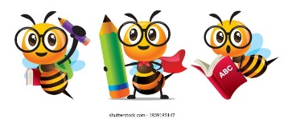

**Science Curriculum EYFS, KS1 & KS2**

|  |  |  |  |  |  |  |
| --- | --- | --- | --- | --- | --- | --- |
|  | Autumn | | Spring | | Summer | |
|  | **Autumn 1** | **Autumn 2** | **Spring 1** | **Spring 2** | **Summer 1** | **Summer 2** |
| **Nursery** | **Magical Me**  Noticing detailed features of objects in their environment. Using our senses to explore. | **Animal Magic**  Can talk about some of the things they observe: animals.  Showing care and concern for living things. | **Transport**  Talk about why things happen and how things work. | **Once Upon a Time**  Talk about why things happen and how things work. | **How does your garden grow?**  Showing care and concern for living things and the environment. | **Toys**  Developing an understanding of growth, decay and changes over time. |
| **Reception** | **Getting to know you**  Exploring our senses and the world around us. | **Dark days and cosy nights**  Investigating light and dark | **People who help us** | **Dragon Tales**  Developing an understanding of decay and changes over time. | **Lifecycles**  Finding out and exploring lifecycles of bees, frogs. | **Living and working together**  Talking about different animals and their habitats. |
| **Year 1** | **Everyday materials**  (Naming materials and properties) | | **Animals including humans**  (Names and types; Carnivores/Herbivores) | | **Plants**  (Identify and compare) | |
| **Year 2** | **Living things and their habitats**  (living things, dead and never lived; habitats) | **Uses of everyday materials**  (Suitability and changing shape) | **Animals including humans**  (Offspring, basic needs, exercise, food and hygiene) | | **Plants**  (Seeds and bulbs) | |
| **Year 3** | **Rocks, Fossils & Soils**  (Properties of rocks, fossils and soils) | | **Forces & Magnets**  (Attract and repel) | **Light**  (Lights, shadows & reflections) | **Plants**  (Functions and Life-cycles) | **Animals including humans**  (Nutrition and skeletal system) |
| **Year 4** | **Animals including humans**  (Teeth and digestive system) | **States of matter**  (Solids, liquids and gasses) | **Living things and their habitats**  (Classifications) | **Animals including humans**  (Food chains) | **Electricity**  (Simple circuits) | **Sound**  (Vibrations, pitch and volume) |
| **Year 5** | **Earth and Space**  (Sun, Earth and Moon) | **Forces**  (Gravity, air/water resistance and friction) | **Properties & Changes of materials**  (Dissolving and evaporating; reversible and irreversible) | | **Living things and their habitats**  (Life cycles and reproduction) | **Animals including humans**  (Growing and changing) |
| **Year 6** | **Living things and their habitats**  (Classifying and micro-organisms) | **Evolution and Inheritance**  (Changes to living things/adaptation) | **Animals including humans**  (Circulatory System, diet & health) | **Light**  (How we see) | **Electricity**  (Changes in components; circuit functions) | **STEM projects** |



**Progression of Working Scientifically Skills**

|  |  |  |  |  |  |  |
| --- | --- | --- | --- | --- | --- | --- |
|  | **Questioning and enquiring planning** | **Observations** | **Identifying, grouping and classifying** | **Investigating** | **Recording and reporting findings** | **Reviewing and Conclusions** |
| **Nursery** | ask simple questions about the world around them. | comments and asks questions about aspects of their familiar world such as the place where they live or the natural world.  talk about some of the things they have observed such as plants, animals, natural and found objects. | group and sort. | talk about the features of their own immediate environment and how environments might vary from one another. | gather and record data, in a way they can verbally explain, to answer their own questions. | talk about what they found out. |
| **Reception** | ask simple questions about the world around them. | observe similarities and differences in relation to places, objects, materials and living things.  make observations of animals and plants and explain why some things occur, and talk about changes | group and sort with increasing confidence. | talk about the features of their own immediate environment and how environments might vary from one another. | gather and record data, in a way they can verbally explain, to answer their own questions. | talk about what they found out. |
| **Year 1** | ask simple questions. | observe closely, using simple equipment. | identify and classify.  use observations and ideas to suggest answers. | perform simple tests. | gather and record data to answer questions | talk about what they found out and how they found it out. |
| **Year 2** | ask more complex questions and look at different points of view. | make refined observations through use of equipment.  observe, identify, classify, compare and describe.  use observations and ideas to suggest a variety of answers. | group, sort and classify. | perform simple tests with increasing independence and confidence. | gather and record data accurately to answer questions confidently. | talk about what they found out, how they found it out and suggest simple changes to the investigation. |
| **Year 3** | ask relevant questions and use different types of scientific enquiries to answer them. | make systematic and careful observations through use of equipment. | group, sort, compare and classify using simple keys. | set up simple practical enquiries, comparative and fair tests. | gather, record, classify and present data to answer questions.  record findings using simple scientific language, diagrams, and charts.  take accurate measurements, using a range of equipment. | report on findings - including results and conclusions.  use results to draw simple conclusions, predictions and suggest improvements and raise questions.  identify differences, similarities or changes.  use straightforward scientific evidence to answer questions. |
| **Year 4** | ask relevant questions and begin to use different types of scientific enquiries to answer them. | make systematic and careful observations through use of equipment, with increasing independence and confidence. | use own criteria to group, sort, compare and classify using a key. | set up simple practical enquiries, comparative and fair tests, with increasing independence and confidence. | gather, record, classify and present data to answer questions, including diagrams and charts, and oral and written explanations. | report on findings - including results and conclusions.  use results to draw simple conclusions, predictions and suggest improvements; identify new questions that arise from data, making new predictions. |
| **Year 5** | plan different types of scientific enquiries to answer questions. | observe and take measurements, using a range of equipment, with increased accuracy. | use and develop keys and other information records to identify, classify and describe. | use test results to make predictions and set up further comparative and fair tests. | record data and results of increasing complexity using diagrams and graphs, etc. | report and present findings from enquiries, including conclusions, explanations of results.  identify scientific evidence that has been used to support or refute ideas.  use results to make predictions to set up further comparative tests. |
| **Year 6** | ask questions and develop a line of enquiry based on observations.  make predictions using scientific knowledge and understanding. | observe and make accurate measurements using a range of methods for different investigations. | use and develop keys and other information records to identify, classify and describe with increased accuracy. | select, plan and carry out the most appropriate types of scientific enquiries to test predictions.  suggest improvements to plans and explain the reasons why. | present observations and data using appropriate methods | interpret observations and data, including identifying patterns and data to draw conclusions.  present and evaluate reasoned explanations, including data in relation to predictions and hypotheses.  identify further questions arising from results to make predictions to set up further comparative tests. |



**Progression of Science NC Objectives – Physics and Chemistry**

|  |  |  |
| --- | --- | --- |
|  | **Year 4**  **Simple Circuits** | **Year 6**  **Changes to components; Functions in Circuits** |
| **Electricity** | * Explain what electricity is. * Identify machines which need electricity to work. * Identify situations when electricity can be dangerous. * Investigate the properties of some conductors and insulators. * Investigate which materials are conductors and which are insulators. * Identify and name the basic parts of an electrical circuit: cells, wires, bulbs, switches and buzzers. * Construct a simple series electrical circuit. * Draw a simple circuit. * Explore how different conductors can be added to a circuit. * Predict whether a circuit will work and how it can be fixed. * Draw a simple circuit. * Explain how an electrical switch works * Explore how to use a switch in a simple circuit. * Explore what happens to a bulb when more cells are added. | * Describe the function of electrical components and match them to their symbols. * Investigate the effect of changing the number and voltage of cells in an electrical circuit. * Investigate the effect of changing the number and voltage of cells in an electrical circuit. * Use recognised symbols when representing a simple circuit in a diagram. * Create an electrical burglar alarm and explain how it works. * Use recognised symbols when representing a simple circuit in a diagram. * Create a set of electrical traffic lights and explain how they function. * Predict whether an electrical circuit will function and suggest ways of improving it. |

|  |  |  |
| --- | --- | --- |
|  | **Year 3**  **Magnets: attract and repel** | **Year 5**  **Gravity, air/water resistance and friction** |
| **Forces** | * Explore different types of forces. * Compare how different objects move on a variety of surfaces. * Describe magnets as having two poles. * Notice that some forces need contact between two objects, but magnetic forces can act at a distance. * Predict whether two magnets will attract or repel each other, depending on which poles are facing. * Observe how magnets attract or repel each other and attract some materials and not others. * Explore the properties of magnetic and non-magnetic materials. * Compare and group together a variety of everyday materials on the basis of whether they are attracted to a magnet, and identify some magnetic materials. * Compare and group together a variety of everyday materials on the basis of whether they are attracted to a magnet, and identify some magnetic materials. * Explore the strength and behaviours of different types of magnets. | * Learn why objects fall to Earth. * Explain what gravity is and how it affects our everyday life. * Identify and describe the effects of friction that acts between moving surfaces. * Explore how parachutes work. * Identify and explain the effects of air resistance that acts between moving surfaces. * Investigate the effects of air resistance. * Identify and explain when objects are experiencing high or low water resistance. * Describe and explain how water resistance is created. * Explain how a pulley works and what it can be used for. * Recognise that some mechanisms allow force to have a greater effect. |

|  |  |  |
| --- | --- | --- |
|  | **Year 3**  **Light, shadows and reflection** | **Year 6**  **How the eye sees; how light travels** |
| **Light** | * Learn that dark is the absence of light. * Recognise that they need light in order to see things. * Recognise different sources of light. * Notice that light is reflected from surfaces. * Understand the difference between transparent and opaque objects. * Recognise that shadows are formed when the light from a light source is blocked by an opaque object. * Recognise that shadows are formed when the light from the sun is blocked by an opaque object. * Find patterns in the way that the size of shadows change. | * Explain what is already known about light. * Learn about the main parts of the eye. * Recognise that light appears to travel in straight lines. * Explain that we see things because light travels from light sources to our eyes. * Explain that we see things as light travels from light sources to objects and then to our eyes. * Explore how light appears to travel in straight lines. * Explore how objects reflect light. * Use the idea that light travels in straight lines to explain that objects are seen because they give out or reflect light into the eye. * Use the idea that light travels in straight lines to explain why shadows have the same shape as the objects that cast them. * Use the idea that light travels in straight lines to explain why shadows have the same shape as the objects that cast them. |

|  |  |  |  |  |
| --- | --- | --- | --- | --- |
| **Chemistry** | **Year 1**  **Identifying and naming** | **Year 2**  **Suitability & changing shape** | **Year 4**  **Solids, liquids and gases.** | **Year 5**  **Dissolving/evaporating; reversible/irreversible** |
| **Materials & Properties**  Image result for solids, liquids and gas | * Describe the properties of wood. * Sort objects that are made from wood and objects not made from wood. * Describe the properties of plastic. * Sort objects that are made from plastic and objects not made from plastic. * Describe the properties of metal. * Sort objects that are made from metal and objects not made from metal. * Name an object and the material that it is made from. * Describe the properties of in a variety of everyday materials. * Compare and group together a variety of everyday materials based on their simple properties. * Investigate whether plastic, wood and metal floats or doesn’t float. * Investigate which materials are bendy and which are not. * Investigate which materials are easily broken or not. * Investigate which materials are absorbent and which are not. * Investigate which materials are waterproof and which are not. * Investigate which materials are transparent and which are not. | * Discuss the uses of metal, wood, plastic, glass, brick, rock, paper and cardboard and their properties. * Compare the suitability of a variety of materials for particular uses. * Investigate the changes in wooden, plastic, metal and glass objects when they are squashed. * Investigate the changes in wooden, plastic, metal and glass objects when they are bent. * Investigate the changes in wooden, plastic, metal and glass objects when they are twisted. * Investigate the changes in wooden, plastic, metal and glass objects when they are stretched. | * Learn about the properties of solids, liquids and gases. * Identify what a solid, a liquid and a gas is. * Compare and group together materials according to whether they are solids, liquids or gases. * Observe water as a solid, a liquid and a gas and note the changes to water when it is heated and cooled. * Investigate the changes in various materials state, including water, chocolate and butter, when they are heated. * Measure the temperature at which this happens. * Investigate the changes in various materials state, including water, chocolate and butter, when they are cooled. * Measure the temperature at which this happens. * Learn about the stages of the water cycle. * Learn what evaporation and condensation is in the water cycle and associate the rate of evaporation with temperature. | * Compare, group and explain materials based on the properties of solubility, conductivity and responses to magnets. * Understand how knowledge of material properties has helped people create new items to solve a problem. * Explore how solids and liquids can be separated efficiently. * Report and present findings from enquiries, including conclusions, explanations of results. * Research how clean water can be contaminated. * Explore the materials needed to clean water. * Investigate how dirty water can be made cleaner. * Learn the difference between soluble and insoluble. * Explore and explain how some materials will dissolve in liquid to form a solution. * Describe how to recover a substance from a solution. * Soluble and Insoluble Investigation. * Observe and take measurements, using a range of equipment, with increasing accuracy. * Record data and results of increasing complexity using diagrams and graphs, etc. * Demonstrate that dissolving, mixing and changes of state are reversible changes. * Use knowledge of solids, liquids and gases to decide how mixtures might be separated, including through filtering, sieving and evaporating. * Demonstrate that dissolving, mixing and changes of state are reversible changes. * Explore and explain how some changes result in the formation of new materials, and that this kind of change is not usually reversible, including changes associated with burning and the action of acid on bicarbonate of soda |



**Progression of Science Objectives - Biology**

|  |  |  |  |
| --- | --- | --- | --- |
| **BIOLOGY** | **Year 1** (Sum 1 & 2)  **Identify, name and describe plants.** | **Year 2** (Sum 1 & 2)  **Seeds and bulbs** | **Year 3** (Sum 1)  **Life & growth; function & life cycle** |
| **Plants**  Image result for daffodil | * Discuss what a plant seed is and what it grows into. * Plant a seed (flowering plants and vegetables) and observe the changes in the plant over time. * Identify and name common garden plants. * Compare and contrast two different common plants. * Describe how the growth of a plant changes over time. * Identify and name common wild plants (provide food). * Compare and contrast two different common wild plants. * Describe how the growth of a plant changes over time. * Identify and name wild plants that * Compare and contrast two different plants that provide food. * Label and describe the petals, stem, leaf and root of a plant. * Discuss how the seeds planted have changed. * Compare and contrast how different plants change over time. * Identify and label the roots, trunk, branches and leaves of a tree. * Identify and name some deciduous trees. * Compare and contrast two different deciduous trees. * Record how a deciduous tree has changed over time. * Compare and contrast two different deciduous trees. * Identify and name some evergreen trees. * Identify and describe the main differences between evergreen and deciduous trees. * Compare and contrast how plants change over time. * Compare and contrast how trees change over time. | * Plant a variety of seeds and bulbs to investigate their growth. * Predict how the seeds and bulbs will grow. * Explore what bulbs need to grow into mature plants. * Observe and describe how the growth in different plants changes over time. * Observe and describe the early growth points in a variety of plants. * Compare the early growth points in two or more plants. * Observe the life cycle of a dandelion. * Learn about the life cycle of a variety of plants. * Describe the basic stages for a plant’s life cycle. * Evaluate and conclude the growth of plants with different conditions. * Find out and describe how plants need water, light and warmth to grow well. * Investigate how plants need: water, light and warmth for growth. * Record how the height of a plant changes over time. * Find out about the different needs for different types of plants. * Compare and contrast how some plants grow better in different conditions. | * Identify and describe the functions of the roots, stem, leaves and flowers for flowering plants. * Explore and explain what plants need to survive. * Compare and contrast the requirements of plants for life and growth in different types of plants. * Investigate how much light and water plants need. * Learn how seeds how seeds are formed and dispersed. * Explore how seeds are dispersed in a variety of plants, fruit and trees. * Explore how pollination in flowers happens. * Identify and describe the part that flowers play in the life cycle of flowering plants. * Investigate the way in which water is transported within different plants. |

|  |  |  |  |  |
| --- | --- | --- | --- | --- |
| **BIOLOGY** | **Year 2** (Aut 1)  Differences in living/dead; living things in habitats | **Year 4** (Spr 1)  Classifications | **Year 5** (Sum 2)  Life cycles & Reproductions | **Year 6** (Aut 1)  Classify into broad groups |
| **Living Things & Their Habitats**  Image result for woodlice | * Explore and compare the differences between things that are living, dead, and things that have never been alive. * Find out what different habitats provide. * Identify that most living things live in habitats to which they are suited. * Describe how different habitats provide for the basic needs of different kinds of animals and plants, and how they depend on each other. * Identify and name a variety of plants and animals in their habitats, including micro-habitats. * Identify, name and describe different sources of food for animals. * Describe how animals obtain their food from plants and other animals, using the idea of a simple food chain. | * Group animals according to whether they are fish, amphibians, reptiles, birds or mammals. * Describe common similarities and differences for fish, amphibians, reptiles, birds or mammals. * Identify whether an animal is a vertebrate or an invertebrate. * Explore and use a classification key to identify vertebrates and invertebrates. * Use a classification key to identify familiar: animal-based organisms.   plant-based organisms.   * Investigate how a habitat changes throughout the year. * Research and explain the reasons for deforestation and its negative effects on the environment. * Research and explain the positive impact nature reserves have on the environment. | * Name and label the reproductive parts (stamen, stigma, ovary, ovule, sepal, anther, filament and petal) of a flower. * Describe and explain how flowering plants reproduce. * Find out about different types of reproduction, including sexual and asexual reproduction in plants. * Explore how to grow new plants from different parts of the parent plant, for example, seeds, stem and root cuttings, tubers, bulbs. * Compare the life cycles of plants in different parts of the world. * Compare and describe the differences in life cycles between a mammal and an amphibian. * Compare and describe the differences in life cycles between a birds and insects. * Describe the life process of reproduction in some animals. * Compare how different animals reproduce and grow. | * Learn how Carl Linnaeus developed a classification system. * Learn how broad groups: micro-organisms, plants and animals can be subdivided. * Describe how living things are classified into broad groups based on observable characteristics; similarities and differences. * Create an animal classification system with a key whilst explaining reasons why. * Classify animals as vertebrates and invertebrates into broad groups in the local area, describing reasons why. * Create a plant classification system with a key whilst explaining reasons why. * Classify plants into broad groups in the local area based on similarities and difference, whilst giving reasons why * Create a tree classification system with a key whilst explaining reasons why. * Classify trees in the local area into broad groups based on similarities and differences, whilst giving reasons why. * Learn about microorganisms. * Identify and describe microorganism (fungus) in the local area. * Investigate the best conditions for fungus (Micro-organism) to thrive * Classify micro-organisms in the local area into broad groups based on similarities and differences.      * Conclude microorganism test results. |

|  |  |  |  |  |  |  |
| --- | --- | --- | --- | --- | --- | --- |
| **BIOLOGY** | **Year 1** (Spr1/2)  Identify common animals; carnivores/herbivores | **Year 2** (Spr1/2)  Offspring, basic needs, exercise, food & Hygiene | **Year 3** (Sum2)  Nutrition & Skeletal system | **Year4** (Au/Su1)  Digestive system; food chains | **Year 5** (Sum 1)  Changes through age | **Year 6** (Spr1)  Circulatory system |
| **Animals including humans**  Image result for food chains | * Identify, draw and label the basic parts of the human body. * Learn about the five senses and how we use them. * Identify, draw and Label which sense is associated with which body part. * Identify and name a variety of common animals in their habitats. * Compare the appearance of common animals. * Identify and sort fish, birds, and mammals. * Compare the appearance of fish, birds and mammals. * Identify and sort amphibians and reptiles. * Compare the appearance of amphibians and reptiles. * Identify and understand what a fish is. * Describe the structure of a fish. * Identify and understand what a bird is. * Describe the structure of different birds. * Identify and understand what a mammal is. * Describe the structure of different mammals. * Identify and understand what a reptile is. * Describe the structure of different reptiles. * Identify and understand what an amphibian is. * Describe the structure of different amphibians. * Compare the structure of fish, birds, mammals, reptiles and amphibians. * Explore what animals eat certain type of food. * Compare and contrast animals according to what they eat. | * Find out about and describe the basic needs of humans, for survival (water, food and air). * Describe the importance of eating the right types of food. * Describe the importance of eating the right amounts of different foods. * Describe the importance of hygiene. * Describe the importance of exercise. * Explore how my body reacts to exercise over time. * Notice that humans have offspring which grow into adults. * Name the different stages of growing up. * Notice that animals have offspring which grow into adults. * Name the stages development. * Find out about the life cycle of a chicken. * Find out about the life cycle of different animals. | * Explain how humans get the right amount of nutrition. * Identify what food animals eat and why. * Identify that animals, including humans, need the right types and amount of nutrition. * Compare and contrast the diets of humans and some animals. * Explain the functions of the human skeleton and identify the main bones. * Identify bones in animals. * Compare the bones and functions in humans and animals. * Identify which type of skeleton an animal has and why. * Identify and explain the functions of the main muscles in humans. * Compare the muscles in humans and animals. | * Identify the different types of teeth in humans and their simple functions. * Identify and compare the different types of teeth in humans and animals and explain their functions. * Explain the structure of a tooth. * Explain how we can look after our teeth. * Investigate how different foods and liquids harm our teeth. * Explain the functions of the mouth and tongue. * Identify and locate the main organs of the human digestive system. * Explain how the human digestive system works. * Explain what an organism is. * Find out about consumers and producers. * Produce a simple food chain. * Identify and describe predators and prey. * -Explain why some predators are attracted to different prey. * -Explore producers, predators and prey in the Forest area. * -Construct a variety of food chains, identifying producers, predators and prey. * -Interpret a variety of food chains, identifying producers, predators and prey. | * Learn about the gestation periods in humans and animals. * Compare the gestation periods in animals and humans. * Learn how the foetus develops in humans. * Compare foetus development in humans and animals. * Explore how the length and mass of a baby changes as it grows. * Explain and describe the stages of child development. * Create a timeline of child development. * Describe and explain the effects of puberty on children. * Explain the differences between the bodies of men and women. * Explain some of the difficulties involved with old age. * Describe the changes as humans develop to old age * Create a timeline of the main stages of human growth. | * Describe the functions of the heart, blood vessels and blood. * Identify, name and describe the main parts of the human circulatory system. * Describe the ways in which nutrients and water are transported within animals, including humans. * Recognise the impact of diet on the way the body functions. * Recognise the impact of exercise on the way the body functions. * Recognise the impact of drugs and lifestyle on the way the body functions. |