

**Be the best that you can be**

***St Joseph’s Primary School***

**Computing**

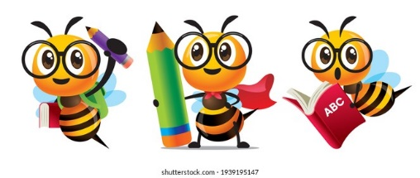

Computing at St Joseph’s

**Intent**

At St Joseph’s RC Primary School, we understand the immense value that technology plays not only in supporting the Computing and whole school curriculum but overall in the day-to-day life of our school. Our aims are to fulfil the requirements of the National Curriculum for Computing whilst also providing enhanced collaborative learning opportunities, engagement in rich content and supporting pupil’s conceptual understanding of new concepts which support the needs of all our pupils.

“A high-quality computing education equips pupils to use computational thinking and creativity to understand and change the world…core of computing is computer science, in which pupils are taught the principles of information and computation, how digital systems work, and how to put this knowledge to use through programming. Building on this knowledge and understanding, pupils are equipped to use information technology to create programs, systems and a range of content.” National Curriculum

Our Computing curriculum (developed with MGL) aims to develop the heart and mind of every child. Computing teaching at has links with mathematics, science and design and technology and our aim is to provide a broad and balanced curriculum whilst ensuring that pupils become digitally literate and digitally resilient. Technology is ever evolving and we aim to develop pupils who can use and express themselves, develop their ideas through, information and communication technology at a suitable level for the future workplace and as active participants in a digital world.

The aims of our Computing curriculum are to develop pupils who:

* Are responsible, competent, confident and creative users of information and communication technology.
* Know how to keep themselves safe whilst using technology and on the internet and be able to minimise risk to themselves and others.
* Become responsible, respectful and competent users of data, information and communication technology.
* Can evaluate and apply information technology, including new or unfamiliar technologies, analytically to solve problems.
* Can analyse problems in computational terms, and have repeated practical experience writing computer programs in order to solve such problems.
* Can understand and apply the fundamental principles and concepts of computer science, including abstraction, logic, algorithms and data representation.
* Become digitally literate and are active participants in a digital world.
* Are equipped with the capability to use technology throughout their lives.
* Have a ‘can do’ attitude when engaging with technology and its associated resources.
* Utilise computational thinking beyond the Computing curriculum.
* Understand and follow the SMART E-Safety rules.
* Understand the E-Safety messages can keep them safe online.
* Know who to contact if they have concerns.
* Apply their learning in a range of contexts, e.g. at school and at home

**Implementation**

To ensure high standards of teaching and learning in computing, we implement a curriculum that is progressive throughout the whole school. Our implementation of the computing curriculum is in line with 2014 Primary National Curriculum requirements for KS1 and KS2 and the Foundation Stage Curriculum in England. This provides a broad framework and outlines the knowledge and skills taught in each key stage.

Computing teaching will deliver these requirements through our half-termly units. Our Computing progression model is broken down into three strands that make up the computing curriculum. These are Computer Science, Information Technology and Digital Literacy. Computer Science underlines the knowledge and skills relating to programming, coding, algorithms and computational thinking. Information Technology underlines the knowledge and skills relating to communication, multimedia and data representation and handling. Digital Literacy underlines the knowledge and skills relating to online safety and technology uses all of which are covered weather combined or discreetly.

We use and follow MGL’S scheme of work from EYFS and Year 1-6, ensuring consistency and progression throughout the school.

We recognise that computing is a specialist subject and not all teachers are computing specialists. Computing lessons are taught by our teaching staff and a member of staff from MGL. Our scheme of work enables clear coverage of the computing curriculum whilst also providing support and CPD for less confident teachers to deliver lessons.

Lessons are broken down into fortnightly sessions, with one unit taught per half-term. Units are practical and engaging and allow computing lessons to be hands on. Units cover a broad range of computing components such as coding, spreadsheets, Internet and Email, Databases, Communication networks, touch typing, animation and online safety.

When teaching computing teachers can follow the children’s interests to ensure their learning is engaging, broad and balanced. Teachers should ensure that ICT and computing capability is also achieved through core and foundation subjects and where appropriate and necessary ICT and computing should be incorporated into work for all subjects using our wide range of interactive ICT resources.

Computing teaching is practical and engaging and a variety of teaching approaches and activities are provided based on teacher judgement and pupil ability. We have a wide range of resources to support our computing teaching. Pupils may use laptops or iPads independently, in pairs, alongside a IT support or in a group with the teacher. Teachers and pupils are also aware of the importance of health and safety and pupils are always supervised when using technology and accessing the internet.

We provide a variety of opportunities for computing learning inside and outside the classroom. Computing and safeguarding go hand in hand and a we provide a huge focus on internet safety inside and outside of the classroom. Additional to all pupils studying an online safety unit through their computing lessons, every year we also take part in National Safer Internet Day in February. The Computing co-ordinator alongside class teachers will plan additional internet safety lessons and activities to take part in following a specific yearly theme. Internet Safety assemblies are also held as well as parent internet safety workshops and parent home activities.

**Impact**

Our Computing Curriculum is high quality, well thought out and is planned to demonstrate progression and build on and embed current skills. We focus on progression of knowledge and skills in the different computational components and alike other subjects discreet vocabulary progression also form part of the units of work.

If children are keeping up with the curriculum, they are deemed to be making good or better progress.

We measure the impact of our curriculum through the following methods:

* Pupil discussions and interviewing the pupils about their learning (pupil voice).
* Computing Ambassadors – Year 5 & 6
* Monitoring with our subject computing lead visits.
* Opportunities for dialogue between teachers.
* Photo evidence and images of the pupils practical learning – ***Learning Journey PowerPoint***.
* A reflection on standards achieved against the planned outcomes.
* Learning walks and reflective staff feedback (teacher voice).
* Staff Questionnaire (March 2021)
* Dedicated Computing leader time.
* Monitoring of children’s work.

Computing

Progression Map and End Points

|  |  |  |
| --- | --- | --- |
|  |  |  |

[Type the company name]



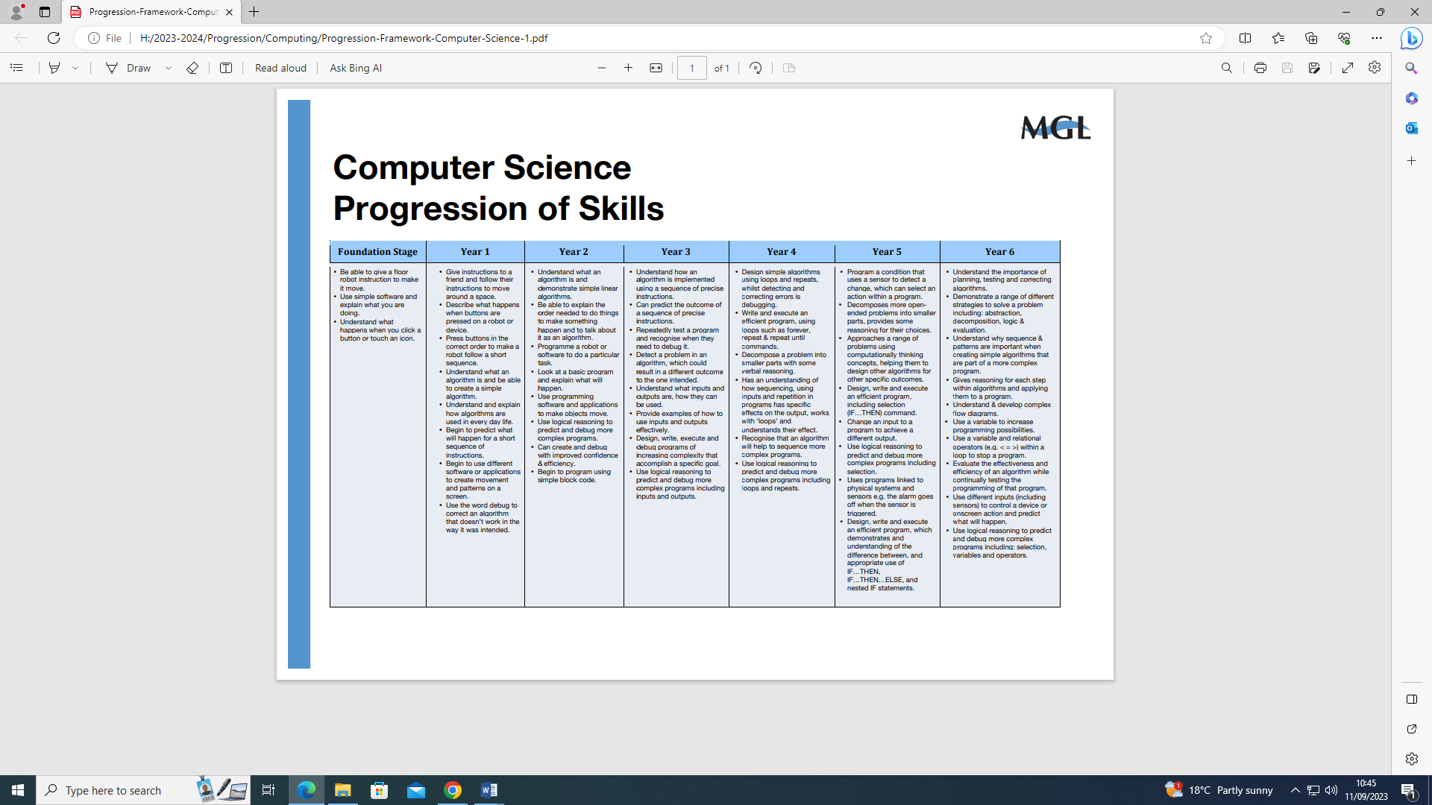

**St Joseph’s RC Primary School**

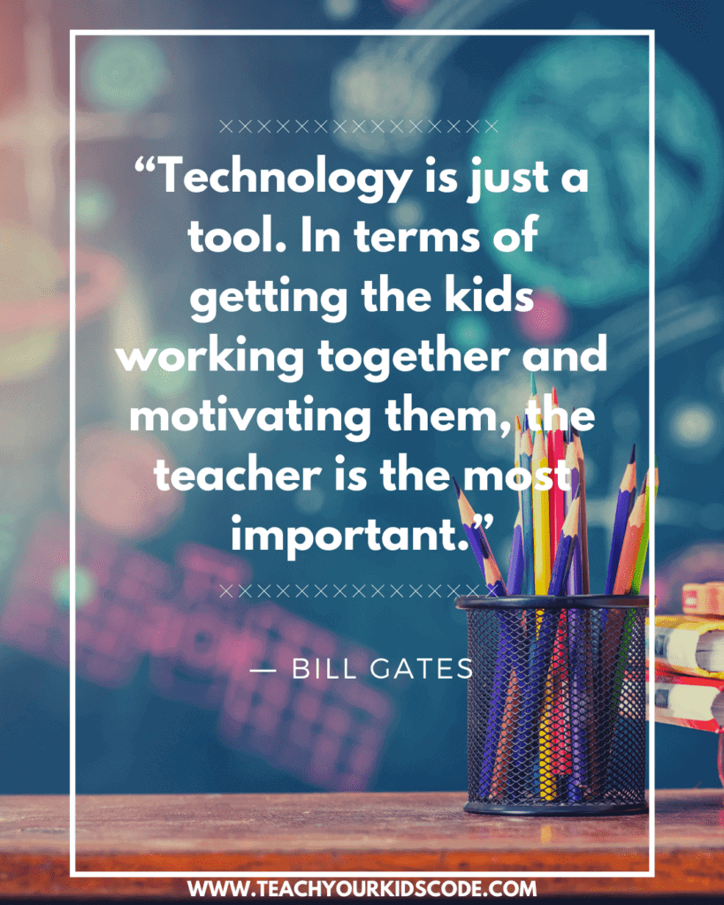

|  |  |
| --- | --- |
| **Computer Science**  **Progression of Skills** | |
| **Foundation Stage** | * Be able to give a floor robot instruction to make it move. * Use simple software and explain what you are doing. * Understand what happens when you click a button or touch an icon. |
| **Year 1** | * Give instructions to a friend and follow their instructions to move around a space. * Describe what happens when buttons are pressed on a robot or device. * Press buttons in the correct order to make a robot follow a short sequence. * Understand what an algorithm is and be able to create a simple algorithm. * Understand and explain how algorithms are used in everyday life. * Begin to predict what will happen for a short sequence of instructions. * Begin to use different software or applications to create movement and patterns on a screen. * Use the word debug to correct an algorithm that doesn’t work in the way it was intended. |
| **Year 2** | * Understand what an algorithm is and demonstrate simple linear algorithms. * Be able to explain the order needed to do things to make something happen and to talk about it as an algorithm. * Programme a robot or software to do a particular task. * Look at a basic program and explain what will happen. * Use programming software and applications to make objects move. * Use logical reasoning to predict and debug more complex programs. * Can create and debug with improved confidence & efficiency. * Begin to program using simple block code. |
| **Year 3** | * Understand how an algorithm is implemented using a sequence of precise instructions. * Can predict the outcome of a sequence of precise instructions. * Repeatedly test a program and recognise when they need to debug it. * Detect a problem in an algorithm, which could result in a different outcome to the one intended. * Understand what inputs and outputs are, how they can be used. * Provide examples of how to use inputs and outputs effectively. * Design, write, execute and debug programs of increasing complexity that accomplish a specific goal. * Use logical reasoning to predict and debug more complex programs including inputs and outputs. |
| **Year 4** | * Design simple algorithms using loops and repeats, whilst detecting and correcting errors is debugging. * Write and execute an efficient program, using loops such as forever, repeat & repeat until commands. * Decompose a problem into smaller parts with some verbal reasoning. * Has an understanding of how sequencing, using inputs and repetition in programs has specific effects on the output, works with ‘loops’ and understands their effect. * Recognise that an algorithm will help to sequence more complex programs. * Use logical reasoning to predict and debug more complex programs including loops and repeats |
| **Year 5** | * Program a condition that uses a sensor to detect a change, which can select an action within a program. * Decomposes more openended problems into smaller parts, provides some reasoning for their choices. * Approaches a range of problems using computationally thinking concepts, helping them to design other algorithms for other specific outcomes. * Design, write and execute an efficient program, including selection (IF…THEN) command. * Change an input to a program to achieve a different output. * Use logical reasoning to predict and debug more complex programs including selection. * Uses programs linked to physical systems and sensors e.g. the alarm goes off when the sensor is triggered. * Design, write and execute an efficient program, which demonstrates and understanding of the difference between, and appropriate use of IF…THEN, IF…THEN…ELSE, and nested IF statements. |
| **Year 6** | * Understand the importance of planning, testing and correcting algorithms. * Demonstrate a range of different strategies to solve a problem including: abstraction, decomposition, logic & evaluation. * Understand why sequence & patterns are important when creating simple algorithms that are part of a more complex program. * Gives reasoning for each step within algorithms and applying them to a program. * Understand & develop complex flow diagrams. * Use a variable to increase programming possibilities. * Use a variable and relational operators (e.g. < = >) within a loop to stop a program. * Evaluate the effectiveness and efficiency of an algorithm while continually testing the programming of that program. * Use different inputs (including sensors) to control a device or onscreen action and predict what will happen. * Use logical reasoning to predict and debug more complex programs including: selection, variables and operators |

|  |  |
| --- | --- |
| **Digital Literacy**  **Progression of Skills** | |
| **Foundation Stage** | * Can identify a device that uses technology. * Ask permission before using the Internet. * Tell an adult if something worrying or unexpected happens whilst using technology |
| **Year 1** | * Understand why we need passwords. * Understand that we must keep passwords private. * Explain what personal information is. * Understand that we must keep personal information private. * Communicate safely and respectfully online. * Know what to do when concerned about online content. * Know what to do if someone tries to contact you online. |
| **Year 2** | * Understand the need to keep a password private. * Understand the need to keep personal information private. * Demonstrate the use of technology responsibly in terms of how we use it and the time we spend using it. * Know how to report inappropriate content or contact online |
| **Year 3** | * Children consider their responsibilities and actions to others online. * Children consider that all of the media they see could have been altered. * Understand how to use a search engine responsibly and safety |
| **Year 4** | * Understand that media can be edited online for advertising and other purposes. * Recognise what is acceptable and unacceptable behaviour when using technology and online services. * Children understand how effective a strong password is and what a strong password looks like. |
| **Year 5** | * Be aware of their digital footprint. * Understand the dangers of building online relationships. * Explain what the consequences might be to using technology inappropriately or accessing inappropriate content intentionally |
| **Year 6** | * Be aware of fake news and how to dissect it. * Understand the difference between misinformation and disinformation. * Understand what Copywriting is and using someone else’s work responsibly. * Manage their conduct and contact appropriately and safely when using technology and online services |
| **ICT Beyond School**  **Progression of Skills** | |
| **Foundation Stage** | * Talk about technology that is used at home, in school and in the world around them. * Use a safe part of the Internet to explore, play and learn. |
| **Year 1** | * Recognise that a range of digital devices and products can be considered computers. * Recognise the ways in which technology is used in their homes and community. * Understand that computers have no intelligence and can do nothing without being programmed. * Begin to identify some of the benefits to using technology. |
| **Year 2** | * Children can explain why they use technology in the classroom, in their homes and in the community. * Identify the benefits of using technology, such as creating content and communicating efficiently. * Can identify a computer by knowing that it has inputs, a processor and outputs. * Can identify parts of a computer including what an input and output is. |
| **Year 3** | * Save and retrieve work online, on the school network and their own device. * Tell you ways to communicate with others online. * Knows how navigate the web responsibly. * Can carry out effective web searches to collect digital content. * Think about whether they can use images that they find online in their own work. |
| **Year 4** | * Understand the difference between the Internet and online services such as the World Wide Web, instant messaging and email. * Tell you whether a resource they are using is from the World Wide Web, the school network or their own work. * Identify key words to use when searching safely on the World Wide Web. * Show an awareness of a range of Internet services such as the World Wide Web, email and instant messaging. * Explain how to check who owns photos, text and clipart |
| **Year 5** | * Use different online tools for different purposes. * Use a search engine effectively to find appropriate information and check the reliability of a website. * Understand how search results are selected and ranked and the algorithms they use. * Recognise and evaluate different types of information they find on the World Wide Web. * Think about the reliability of information they read on the World Wide Web or other Internet services (Fake News) |
| **Year 6** | * Explain the Internet services they need to use for different purposes. * Describe the different parts of a webpage. * Understands how to construct a website using basic HTML tags. * Explain what copyright is and acknowledge the sources of information that they find online. * Understands how data is transmitted across a network. * Understand what IP is and how it’s used. * Can explain how networks use the Internet to send and receive data. |

|  |  |
| --- | --- |
| **Information Technology**  **Progression of Skills** | |
| **Foundation Stage** | * Talk about different kinds of information such as pictures, videos, text and sound. * Use a mouse and touch screen to move objects on a screen. * Create shapes and text on a screen |
| **Year 1** | * Talk about the different ways in which information can be shown. * Use technology to collect information, including photos, videos and sound. * Sort different kinds of information and present it to others. * Add information to a pictogram and talk about their findings. * Use software with support, to create, store and edit digital content using appropriate file and folder names. * Use the keyboard or a word bank on a device to enter text into a program. * Understand some of the basic functions on a keyboard (Backspace, Caps Lock, Enter) * Save information in a specific place and retrieve it again. * Use technology to collect information, including photos, videos and sounds |
| **Year 2** | * Create a graph or chart using data collected on a specific topic area. * Talk about the data that is shown in their chart or graph. * Explain how investigating data can be used to answer a question. * Use a variety of software to manipulate and present digital content in different ways with increasing independence. * Talk about the different ways to use technology to collect information, including a camera or sound recorder. * Use the keyboard on their device to add, delete, edit and format text. * Talk about an online tool that will help them to share their ideas with other people. * Save and open files on the device they use from a specific file location. |
| **Year 3** | * Understand the difference between data and information. * Talk about the different ways data can be converted into information. * Search a ready-made database to answer specific questions. * Collect data to help answer questions about a specific topic or theme.7 * Add to and edit an existing database. * Combine a mixture of text, graphics and sound to share ideas and learning. * Use appropriate keyboard commands to amend text. * Be able to effectively use a spell checker. * Evaluate their work and improve its effectiveness. * Use an appropriate tool to share their work online. |
| **Year 4** | * Demonstrate the different ways data can be organised. * Demonstrate the different ways data can be converted into information. * Make a branching database. * Collect data and identify where it could be inaccurate. * Plan, create and search a database. * Select the best way to present data to a specific audience. * Log data using a device. * Use photos, video and sound to create an atmosphere when presenting to different audiences. * Be confident to explore new media to extend what they can achieve. * Change the appearance of text to increase its effectiveness depending on the audience or mood. * Create, modify and present documents for a particular purpose and audience. * Use a keyboard confidently and make use of a spellchecker to write and review their work. * Use an appropriate tool to share their work and collaborate online. * Be able to evaluate other people’s work and give them constructive feedback to help them improve their work. |
| **Year 5** | * Choose an appropriate tool to help them collect data. * Present data in an appropriate way depending on the theme or audience. * Use a spreadsheet and database to collect, record and evaluate data. * Search a database using different operators to refine a search. * Talk about errors in data and suggest how it could be checked. * Use text, photo, sound and video editing tools to evaluate and refine their work. * Be able to use a variety of familiar and unfamiliar software by using a pre-existing skill set. * Select, use and combine the appropriate technology tools to create effects in media. * Select an appropriate online or offline tool to create and share ideas. * Evaluate and improve their own work and support others in improving their work. * Acknowledges sources of information appropriately. |
| **Year 6** | * Select the most effective tool to collect data for their investigation. * Check the data they collect for accuracy and plausibility, * Plan the process needed to investigate a set environment or setting. * Interpret and present the data they collect. * Use the skills developed to interrogate a database. * Use a range of strategies to increase the accuracy of keyword searches. Makes confident inferences about their effectiveness. * Talk about audience, atmosphere and structure when planning a particular media outcome. * Combine a range of media, recognising the contribution of each to achieve a particular outcome. * Confidently identify the potential of unfamiliar technology and how it can be used effectively. * Explain why they select a particular online tool for a specific purpose. * Be digitally discerning when evaluating the effectiveness of their own work and the work of others. * Recognise the importance of copyright and how to acknowledge the sources of information. |

|  |  |  |  |  |  |  |
| --- | --- | --- | --- | --- | --- | --- |
| **St Joseph’s RC Primary School**  **MGL Computing Long Term Plan**  DL=Digital Literacy CS=Computer Science IT=Information Technology | | | | | | |
|  | **Autumn 1** | **Autumn 2** | **Spring 1** | **Spring 2** | **Summer 1** | **Summer 2** |
| **Nursery** | I Am a Super Surfer | I Am a Super Surfer | Look at What I Can do | Look at What I Can do | I am a Computer Scientist | I am a Computer Scientist |
| **Reception** | I Am a Super Surfer | I Am a Super Surfer | Look at What I can Do | Look at What I can Do | I am a Computer Scientist | I am a Computer Scientist |
| **Year 1** | Basic Computing Skills  (IT) | Using text-based programs to process and format text and images  (DL) | Data collection and representation using Pictograms  (IT) | Presenting Information  (IT) | Unplugged Algorithms  (CS) | Programming, coding & robotics  (CS) |
| **Year 2** | What is a computer?  (IT) | Modifying text and images  (IT) | Presenting information  (IT/DL) | Storing and Presenting Data  (DL) | Unplugged Algorithms  (CS) | Programming using Scratch Jr  (CS) |
| **Year 3** | Publishing Online Content  (IT/DL) | Inside a computer  (CS) | Introduction to Scratch  (CS) | Prediction and Debugging  (CS) | Altering Media  (IT) | Composing Emails  (IT) |
| **Year 4** | Smarter Searching and Online Safety  (DL) | Pixel Art  (IT) | Repetition and Forever Loops  (CS) | Designing a Game  (CS) | Branching Databases  (IT) | Making a special effects movie  (IT) |
| **Year 5** | Using Variables  (CS) | Coding using Micro:Bits  (CS) | Create and search databases  (IT) | Stop motion animation  (IT) | 3D modelling  (IT) | The Internet & The World Wide Web  (CS) |
| **Year 6** | Programming a Game  (CS) | Edublocks – Introduction to Python  (CS) | Creating Formula in Excel  (IT) | Social Media & Being Safe Online  (IT/DL) | Creating a Podcast  (IT) | HTML  (IT) |