**Be the best that you can be**

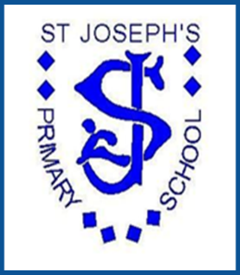

**French**

***St Joseph’s Primary School***

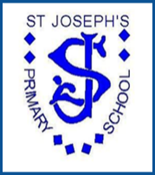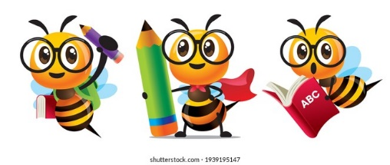

MFL - French at St Joseph’s

*At St Joseph’s RC Primary School, we intend to build a French curriculum which develops the children’s learning and results in acquisitions of knowledge and skills. This will be achieved through a carefully thought out scheme and memorable experiences.*

**Intent**

Learning another language gives children an understanding of other cultures in our multi-cultural society, promoting an understanding and inclusive approach to the world around them. Learning a language develops children’s confidence and their comprehension of grammar, and it gives them a chance to foster their curiosity and deepen their understanding of the world around them.

The National Curriculum for languages states that all pupils should aim to:

1. understand and respond to spoken and written language from a variety of authentic sources
2. speak with increasing confidence, fluency and spontaneity, finding ways of communicating what they want to say, including through discussion and asking questions, and continually improving the accuracy of their pronunciation and intonation
3. can write at varying length, for different purposes and audiences, using the variety of grammatical structures that they have learnt
4. discover and develop an appreciation of a range of writing in the language studied.

At St Joseph’s, the learning of French is introduced to children in EYFS and KS1 through songs, basic commands and whole school events. Children in Key Stage 2 have weekly lessons in French using the scheme of work from Primary Languages Network. This is a carefully planned sequence of lessons that ensures progressive coverage of the skills required by the National Curriculum. Children will learn about different facets of French life such as schooling, celebrations, food and health. This knowledge will be built on year upon year. We also intend to immerse children in French language and culture through whole school events such as the annual Bastille Day celebrations, and the use of French in the classroom outside of French lessons. This whole school approach allows children to grow in curiosity and confidence, to become capable and confident language speakers with a solid foundation on which to build, as well as a greater understanding of the world around them and other cultures. This will allow them to grow in their language learning as they progress to Secondary School.

**Implementation**

Children in EYFS and KS1 are introduced to the French language through songs, basic commands and whole school events.

Children in KS2 have weekly French lessons delivered by the class teacher. These lessons are sequenced to ensure both progression through the introduction of new skills and regular recapping of prior knowledge. Lessons progress through the year groups, ensuring that children have a strong skill set and knowledge of French by the time they move on to Secondary School. Lessons are delivered through the Primary Languages Network scheme of work, which entwines French culture with French language, allowing children to learn about the culture of French-speaking countries and communities as well as the French language itself. All lessons are delivered with a native French speaker demonstrating pronunciation as well as the class teacher. Vocabulary relevant to each topic is displayed in KS2 classrooms.

The MFL Subject lead monitors the delivery of French throughout the school, alerts teachers to relevant CPD and supports them in the delivery of the scheme of work. The subject lead monitors the impact of the scheme through book scrutinies, lesson observations and staff meetings.

**Impact**

The impact of our curriculum is measured through the following methods:

* pupil self-assessment using tracking clouds which takes place every lesson
* teacher led assessment throughout each topic through key questioning
* observation of children speaking to other children in French during lessons
* marking of French workbooks
* annual reports to parents

The whole school approach to MFL including whole school events raises the profile of languages across the school in tangent with the learning environment displaying French vocabulary.

|  |  |  |  |  |  |  |
| --- | --- | --- | --- | --- | --- | --- |
| **French Long Term Plan** | | | | | | |
|  | **Autumn 1** | **Autumn 2** | **Spring 1** | **Spring 2** | **Summer 1** | **Summer 2** |
| **Year 3**  **Stage 1** | A new start | Calendar and celebrations | Animals I like and Don’t like | Carnival and playground games | Breakfast, fruit nouns and a hungry giant | Going on a picnic |
| **Year 4**  **Stage 2** | Welcome to school – super learners | My local area, your local area | Family tree and faces | Celebrating carnival & body parts | Feeling unwell & jungle animals | Summer time |
| **Year 5**  **Stage 2** | Welcome to school – super learners | My local area, your local area | Family tree and faces | Celebrating carnival & body parts | Feeling unwell & jungle animals | Summer time |
| **Year 6**  **Stage 2** | Welcome to school – super learners | Bonfire night, classroom commands, places in town, Christmas shopping | Epiphany, Alien family tree and faces | Face and body parts | Feeling unwell & jungle animals | The weather, ice cream and language puzzle |