**Be the best that you can be**

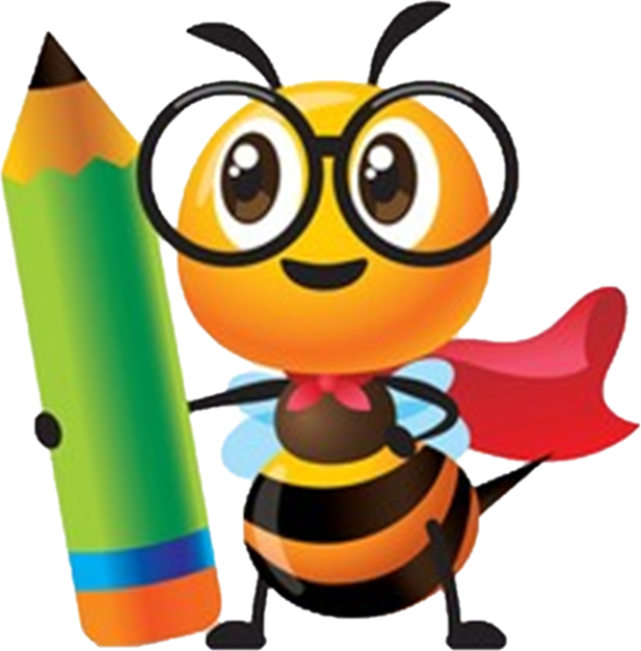

**Art**

**Curriculum**

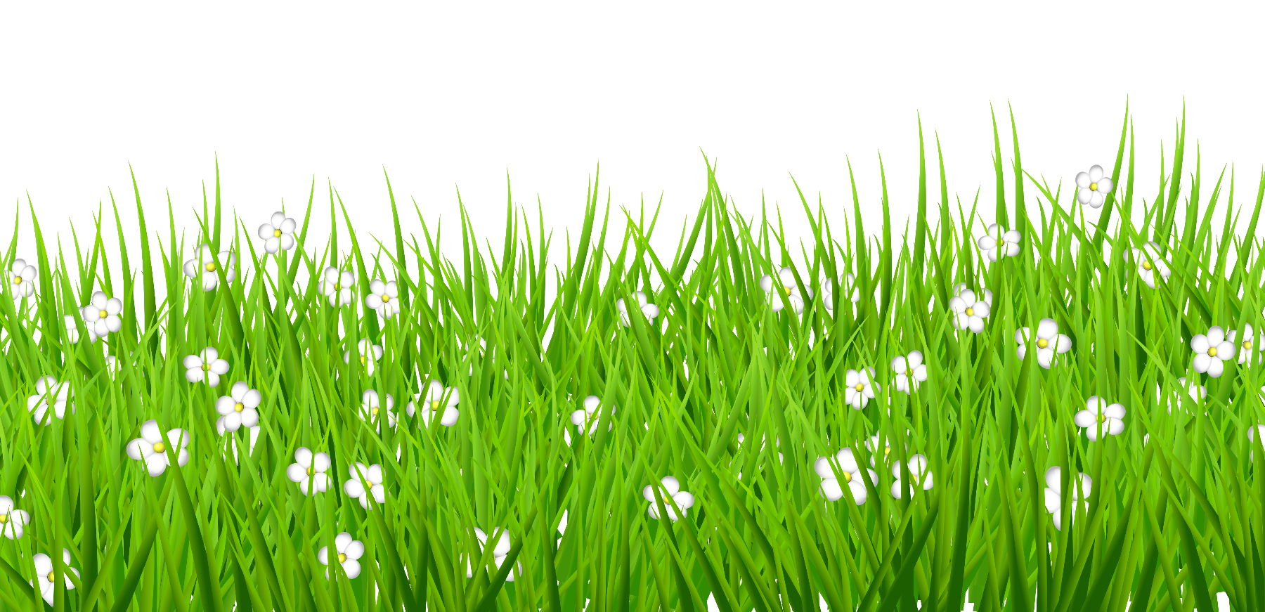

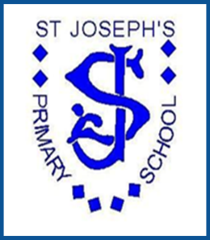

***St Joseph’s Primary School***

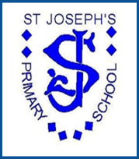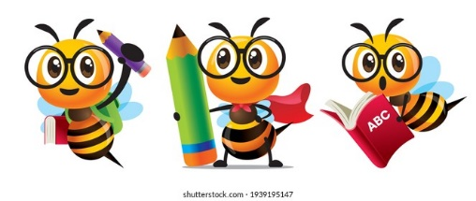

Art at St Joseph’s

**Context**

St Joseph’s is in the top 20% of deprived areas in England. The number of children receiving the pupil premium funding is almost double the national figure. With this in mind, our Art curriculum has been personalised and designed to help tackle the effects of deprivation, whilst equipping all children with the knowledge, skills and cultural capital they need to succeed in all areas life.

**Purpose of Study / Rationale**

Art, craft and design embodies some of the highest forms of human creativity. High quality Art education should engage, inspire and challenge pupils, equipping them with the knowledge and skills to experiment, invent and create their own works of art and design. As pupils progress, they should be able to think critically and develop a more rigorous understanding of art and design. They should also know how art and design both reflect and shape our history, and contribute to the culture, creativity and wealth of our nation.

**Aims**

The national curriculum for Art, Craft and Design aims to ensure that all pupils:

* Produce creative work, exploring their ideas and recording their experiences
* Become proficient in drawing, painting, sculpture and other art, craft and design techniques
* Evaluate and analyse creative works using the language of art, craft and design
* Know about great artists, craft makers and designers, and understand the historical and cultural development of their art forms.

**Rationale**

Our bespoke Art and Craft curriculum is designed to develop knowledge and skills that are progressive, enabling children to strengthen both critical thinking and problem solving skills. The process of creating art gives children choices and urges them to make decisions – a crucial skill that translates into all other aspects of life. Art is a language that allows children to express and develop their ideas and emotions; artistic activities are full of processes that help children to grow and stimulate their creativity while nurturing the soul. Art stimulates both sides of the brain increasing the capacity of memory, attention and concentration. It introduces children to new vocabulary and concepts and generates memories and images which enriches their intellect and imagination. Children also improve and acquire social skills, their self-esteem is promoted and Art gives children a way to express themselves and their ideas. Through Art children will build a progressive skill set enabling them to be persistent and consistent.

Our Art and Craft curriculum is divided into three main strands:

* 2D - Drawing and Painting
* 3D - Developing a Perception of Depth
* Print and Mixed Media

(Textiles is also covered within the D&T curriculum)

Throughout the children's Art education at St Joseph’s, their skills through each strand are progressive and build upon prior learning, showing a clear development and comprehensive knowledge so developing mastery. Mastery enables children to spend greater time going into depth about Art as opposed to racing through the things that all children 'should' know.

Our curriculum planning for every unit of work follows a seven session structured plan;

* Session 1 - Exploring and evaluating
* Session 2, 3 & 4 - Gathering Ideas/learning skills
* Session 5 & 6 - Create
* Session 7 - Evaluation

Gathering Ideas / Sketchbook Work

Skills / Techniques / Evaluation

Composition – Which Medium?

Exploring, / Looking at Different Artists / Knowledge / Historical and Cultural Development

**PROCESS**

**Curriculum Overview**

The focus of our Art and Craft Curriculum is all about individual learnt processes not prescribed outcomes.

***"The role of an artist is to take whatever you believe in and put it out there so that others can see it" David Le Batard***

***"Art is not what you see but what you make others see" Edgar Degas***

***"You can't use up creativity, the more you use the more you have" Maya Angelou***

***"We don't make mistakes, just happy little accidents" Bob Ross***

Early Years children will learn about exploring and using media and materials, they will safely use and explore a variety of materials, tools and techniques experimenting with colour, design, texture, form and function. (Early Learning Goal)

They will also learn how to be imaginative. Children will use what they have learnt about media and materials in original ways, thinking about uses and purposes. They will represent their own ideas, thoughts and feelings through design and technology, art, music, dance, role play and stories. (Early Learning Goal)

**Key Stage 1** children will learn how to use a range of materials. They will have ample opportunity to draw, paint and sculpt, developing techniques of colour, pattern, texture, line, shape, form and space. Additionally, they will learn about a range of artists, craftsmen and designers.

**Key Stage 2** children will use sketchbooks to collect, record and evaluate ideas. They will improve mastery of techniques such as drawing, painting and sculpture with varied materials. They will also learn about great artists, architects and designers.

**National Curriculum Subject Content**

**Key Stage 1 pupils should be taught:**

* to use a range of materials creatively to design and make products
* to use drawing, painting and sculpture to develop and share their ideas, experiences and imagination
* to develop a wide range of art and design techniques in using colour, pattern, texture, line, shape, form and space
* learn about the work of a range of artists, craft makers and designers, describing the differences and similarities between different practices and disciplines, and making links to their own work

**Key stage 2 Pupils should be taught:**

* to develop their techniques, including their control and their use of materials, with creativity, experimentation and an increasing awareness of different kinds of art, craft and design
* to create sketch books to record their observations and use them to review and revisit ideas
* to improve their mastery of art and design techniques, including drawing, painting and sculpture with a range of materials [for example, pencil, charcoal, paint, clay] about great artists, architects and designers in history

**Attainment** T**argets**

By the end of each key stage, pupils are expected to know, apply and understand the matters, skills and processes specified in the relevant programme of study.

**Curriculum Intent**

**Artist Choice**

Cultural capital is the accumulation of knowledge, behaviour and skills that children can draw upon which demonstrates their cultural awareness knowledge and competence. It is a key ingredient that children will use in later life to be successful in society, their future careers and the world of work.

Throughout the study of our Art and Craft curriculum children will learn and understand the contribution that both artists and art have made to society and culture. Through our careful choice of artists study we will prepare the children to look within themselves and ask thoughtful questions, create enquiring minds and give them real choices to respond to their own feelings, ideas and interests. It will enable children to self-discover and learn as they have control over their subject matter, medium and approach. Ultimately, we have created a choice based curriculum which encourages freedom, risk taking, critical thinking and mastery.

We have chosen a wealth of great Artists and Craftspeople both past and present, male and female, local and worldwide so that the children are learning about a wide range and variety of not only artists but their multiple approaches and styles. They will begin to understand the History of Art and respond with individual interpretation and critical judgement.

**Progression through the elements of Art – Skills**

Throughout our Art and Craft curriculum we have carefully considered and included the seven main elements of Art;

* Line
* Colour
* Shape
* Space
* Form
* Tone
* Texture

Every year group will cover all elements throughout the year and drawing is included through all strands building on prior knowledge and skills as they move throughout school developing mastery by the time the reach Key Stage 2.

The planned sessions are designed to begin with a 'Start Point' for each unit of work. Within this section critical dialogue is a vital component in order for children to gain a deeper understanding of the seven elements of art. It is a conversation using targeted vocabulary that inspires insight on a particular topic so that children can participate in discussion and collective thinking as a group. It is not a presentation of 2 artists, it is designed to be a dialogue of creative exploration and analysis.

**Progression through the Three Strands**

|  |  |  |  |  |  |  |
| --- | --- | --- | --- | --- | --- | --- |
|  | **Strand 1** | | **Strand 2** | | **Strand 3** | |
| **Year Group** | **2D Drawing and Painting** | **Art Elements** | **3D Perception of Depth** | **Art Elements** | **Print and Mixed Media** | **Art Elements** |
| **Year 1** | Spirals | Mark-making  Colour  Line  Shape  Tone | Making Sculptural Birds | Line  Value  Colour  Texture  Space  Form | Simple Printmaking | Line  Shape  Colour  Texture  Space |
| **Year 2** | Explore and Draw | Colour  Line  Shape  Tone  Texture | Be an architect | Line  Value  Colour  Texture  Space  Form  Shape | Exploring the World Through Mono Print | Mark-making  Line  Shape  Value  Colour  Texture |
| **Year 3** | Gesturial Drawing with Charcoal | Mark-making  Line  Shape  Space  Tone  Value | Telling Stories Through Drawing and Making | Form  Texture  Colour | Working with Shape and Colour | Line  Colour  Shape  Space  Texture  Value |
| **Year 4** | Storytelling Through Drawing | Colour  Line  Shape  Space  Tone | Sculpture, Structure, Inventiveness and Determination | Mark-making  Line  Shape Colour  Form  Texture | Exploring Pattern | Line  Shape  Colour  Texture  Space |
| **Year 5** | Typography and Maps | Mark-making  Lines  Form  Line  Space  Tone | Architecture:  Dream Big or Small? | Line  Form  Shape  Texture  Space | Making Monotypes- Printmaking | Mark-making  Line  colour  Texture  Shape  Space  Value |
| **Year 6** | Exploring Identity | Colour  Line  Shape  Space  Tone  Value | 2-D Drawing to 3-D Making | Mark- making Line  Value Shape Colour  Space | Brave the Colour | Colour  Form  Shape  Space  Tone  Texture |

The chosen three strands of our Art Curriculum identify the skills, knowledge and understanding that children develop through learning in the arts. The strands outline ways in which learning contributes to developing key competencies, principles and values of the national curriculum.

By building on and revisiting learning in previous years the Art scheme of work constructs progression in learning in all three strands. This process ensures children's learning is relevant, in depth and meaningful. The three strands define key areas of learning for each discipline. They are by their nature, intertwined. Learning experiences may originate from any one of the strands and will often integrate learning from all three. Teachers will connect and weave learning and skills holistically across all strands by implementing our bespoke scheme of work. Each Unit of Work follows the same structure for every session divided into a clear detailed starting point, class activity, sketchbook input, endpoint, skills and vocabulary learnt.

**The Definitions of the Seven Elements of Art**

**Line** - A line is a distance between two points and can be straight or curved continuous, broken, vertical, horizontal or jagged. They can be 2-Dimensional or 3-Dimensional and can be used to create shape and form, as well as give a sense of depth and structure. Lines are the foundation of drawing.

**Shape** - Shape is 2-Dimensional flat enclosed space such as geometric shapes like triangles, squares and circles.

**Space** - Space includes the background, foreground and middle ground, and refers to the distances or area around, between, and within things. There are two kinds of space: negative space and positive space. Negative space is the area in between, around, through or within an object that is not being used/no purpose. Positive spaces are the areas that are occupied by an object and/or form and have purpose/function.

**Colour** - There are three properties to colour. The first is hue, which simply means the name we give to a colour (red, yellow, blue, green, etc). The second property is intensity, which refers to the vividness of the colour- bold bright vivid. The third property of colour is its value, meaning how light or dark it is.

**Texture** - Texture is how something feels or looks. For example; furry, bumpy, brittle, smooth, rough, soft or hard.

**Form** - The form of a piece is its 3-Dimensional shape, its volume or perceived volume. Form has depth as well as width and height.

**Tone** - Tone is how light or dark something is. Adding white/lighter colours or black/darker colours.