St Joseph’s RC Primary School
CLASS: | AUTUMN TERM 1: The Dignity Of The Human Person | SCRIPTURE LINKS: | House Saint
NURSERY | - God made me and loves me  - God made me and all my friends very beautiful | Genesis 1:26-31  Deuteronomy 10:17-19  Psalm 139:13-16  Proverbs 22:2  Luke 10:25-37  John 4:1-42  Acts 17:26  Romans 12:9-18  1 Corinthians 3:16  Galatians 3:27-28  James 3:1-2  1 John 3:1-2  1 John 4:7-12 | 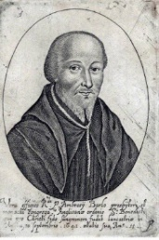  Ambrose Barlow
RECEPTION | - We show our love for each other  - We thank God for loving us and our love for each other
YEAR 1 | - God loves us equally as His children  - We are all different and amazing
YEAR 2 | - We love and look after each other because we are brothers and sisters  - Loving each other makes us stronger
YEAR 3 | - We are all equal in God’s eyes and loved
YEAR 4 | - I have been given a special gift for the world
YEAR 5 | - Each person is unique and irreplaceable – everyone matters
YEAR 6 | - People matter more that possessions

CLASS: | AUTUMN TERM 2: Family and Community | SCRIPTURE LINKS: | Other
NURSERY | - My family at home  - My school family | Genesis 2:18  Genesis 4:8-15  Leviticus 25:23-43  Jeremiah 7:5-7  Micah 6:6-8  John 15:12-17  Acts 2:43-47  Romans 12:4-8  Hebrews 10:24-25  James 2:14-17  1 Peter 4:8-11  1 John 3:16-18  1 John 4:19-21 | Poppy display      
RECEPTION | - We are all different and we love and care for each other  - We love and look after each other because we are all brothers and sisters in God’s family
YEAR 1 | - We are all part of a community  - We look after and care for each other
YEAR  Pg 58 | - I belong to my family and community  - My community needs me
YEAR 3 | - What makes a community?
YEAR 4 | - Who is in my community?
YEAR 5 | - Building up the community
YEAR 6 | - Building up the Kingdom of God

CLASS: | SPRING TERM 1: The dignity of work | SCRIPTURE LINKS: | House Saint
NURSERY | - We are helping to do God’s work  - We use our gifts for each other | Genesis 2:15  Genesis 2:1-3  Deuteronomy 5:13-15  Deuteronomy 14:28-29  Sirach 34:20-23  Isaiah 58:3-7  Jeremiah 22:13  Matthew 20:1-16  Mark 2:27  Luke 3:10-14  Luke 12:13-21  James 5:1-6 | Margaret Clitherow  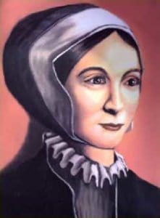
RECEPTION | - Everybody’s gifts are needed to build God’s world  - When we build together, we can do much more
YEAR 1 | - Everybody’s work is valuable and important for the community  - Working together to build up our school family
YEAR 2 | - Finding my special job – my gift to the world  - Working hard to be the best you can be
YEAR 3 | - How does work build us up?
YEAR 4 | - The many sides of working together to build up community
YEAR 5 | - Recognising and helping others to find their gift and share it
YEAR 6 | - Enabling each other to aim high

CLASS: | SPRING TERM 2: Rights and Responsibilities | SCRIPTURE LINKS: | House Saint
NURSERY | - God wants everyone to be happy  - God gives us all we need to be happy | Leviticus 25:35  Ruth2:2-23  Tobit 4:5-11  Proverbs 31:8-9  Isaiah 1:16-17  Jeremiah 22:13-16  Jeremiah 29:4-7  Matthew 25:31-46  Luke 16:19-31  Acts 4:32-35  2 Corinthians 9:6-15  James 2:14-16 | Thomas More  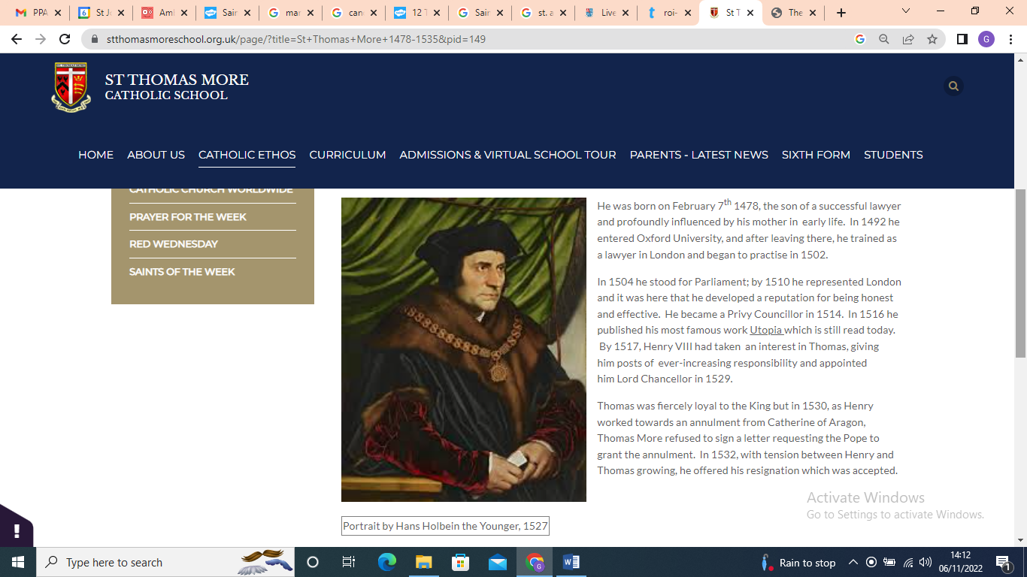
RECEPTION | - Making the right choices  - We share all God’s gifts
YEAR 1 | - Happiness is? Exploring what makes us happy  - Finding happiness with each other
YEAR 2 | - Helping each other to make the right choices  - Fair share for all
YEAR 3 | - Barriers to happiness
YEAR 4 | - Exploring our responsibilities for each other
YEAR 5 | - Recognising the difference between rights and responsibilities
YEAR 6 | - Happiness comes in sharing and giving

CLASS: | SUMMER TERM 1: Option for the poor and vulnerable | SCRIPTURE LINKS: | House Saint
NURSERY | - God’s gifts are for everyone  - Learning to share our toys and food with our friends so everybody has enough | Exodus 22:20-26  Leviticus 19:9-10  Job 34:20-28  Proverbs 31:8-9  Sirach 4:1-10  Isaiah 25:4-5  Isaiah 58:5-7  Matthew 25:34-40  Luke 4:16-21  Luke 6:20-23  1 John 3:17-18 | John Fisher  
RECEPTION | - Helping everybody to be happy by playing, sharing and learning together  - Using our gifts to help others
YEAR 1 | - Some of God’s family have plenty of food, toys and clothes. Some don’t  - Exploring the feelings of those who have little
YEAR 2 | - Working together to make our family happy. Exploring fairness and happiness  - Who needs our help? How can we help?
YEAR 3 | - Why are some parts of our area richer or poorer than others?
YEAR 4 | - What are the needs of those in a poor area compared with those in a rich area?
YEAR 5 | - Helping others to see brothers and sisters, not strangers in need
YEAR 6 | - Being Christ’s voice inour area for those who need us the most

CLASS: | SUMMER TERM 2: Solidarity and the Common Good | SCRIPTURE LINKS:
NURSERY | - We are friends  - We play together in love and peace | Genesis 12:1-3  Psalms 72  Psalms 122  Zechariah 8:16  Matthew 5:9  Matthew 5:21-26  1 Corinthians 12:12-26  Colossians 3:9-17  1 John 3:16-18
RECEPTION | - We help each other  - We thank God for each other
YEAR 1 | - We are brothers and sisters –one family-one world  - We learn together
YEAR 2 | - We build together a community of peace  - We celebrate together
YEAR 3 | - I listen to you with my ears, eyes, heart and mind
YEAR 4 | - We walk together as a people of peace
YEAR 5 | - We face challenges together
YEAR 6 | - Building our mission team

