St Joseph’s RC Primary School
CLASS: | AUTUMN TERM 1: The Dignity Of The Human Person | SCRIPTURE LINKS: | House Saint
NURSERY | - God made me and loves me  - God made me and all my friends very beautiful | Genesis 1:26-31  Deuteronomy 10:17-19  Psalm 139:13-16  Proverbs 22:2  Luke 10:25-37  John 4:1-42  Acts 17:26  Romans 12:9-18  1 Corinthians 3:16  Galatians 3:27-28  James 3:1-2  1 John 3:1-2  1 John 4:7-12 | 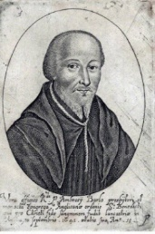  Ambrose Barlow
RECEPTION | - We show our love for each other  - We thank God for loving us and our love for each other
YEAR 1 | - God loves us equally as His children  - We are all different and amazing
YEAR 2 | - We love and look after each other because we are brothers and sisters  - Loving each other makes us stronger
YEAR 3 | - We are all equal in God’s eyes and loved
YEAR 4 | - I have been given a special gift for the world
YEAR 5 | - Each person is unique and irreplaceable – everyone matters
YEAR 6 | - People matter more that possessions

